Smart course Management
System in cloud
Software Requirement Specification

By
Mr. Chaichan Suttee 542115016
Mr. Tanadol Parn-ong 542115021

Department of Software Engineering
College of Arts, Media and Technology
Chiang Mai University

Project Advisor

________________________

Mrs. Yun Rim Park

Document History

Document Name | Version | Status | Date | Viewable | Reviewer | Responsible
Documents
Smart course management system in the cloud – Requirement_v1.0.docx | Create  Chapter One – Introduction  Chapter Two– Overall Description & Requirement  Chapter Three – Specific Requirement  Chapter Four – Use case description | Draft | 17 May 2014 | CS, TP, YP | CS,TP | TP
Smart course management system in the cloud – Requirement_v1.1.docx | Fix  - use case diagram  - add web application document. | Draft | 17 May 2014 | CS, TP, YP | CS,TP | TP

*CS = Chaichan Suttee
*TP = Tanadol Parn-ong
*YP = Yun Rim Park

Contents

Chapter One | Introduction 4
Chapter Two | Overall Description & Requirement 6
Chapter Three | Specific Requirement 23
Chapter Four | Use case description 28

Chapter One | Introduction

Purpose
The purpose of this Software Requirement Specification (SRS) is used to describe the functional requirement. The functional requirement depends on the stakeholder e.g. Lecturer, Student. They have current problems that meet. The requirements in this document explain how to use the system. This document will encourage the users, developers, and who read this document to understand the detail of each requirement.

Software Scope
The scope of application use designated by the user’s requirements. Smart course management system in the cloud that supports both iOS technology and web browser in order to provide convenient to lectures and student. Moreover web browser can provide convenient to Administrator. Working of the system can divide by 3 users:
- Administrator handle user registration and course management (e.g. create courses, add a lecturer and students in the course, and create semesters).
- Lecturer handle score management, assignment and quiz management, course material sharing, and take to notify to student.
- Student handle taking assignment and quiz, viewing score, download course material sharing, and receive notification from Lecturer.
The users must register before operating the activities in the system. The users who use this system must be the member user of the system. Also, the status of users can be changed when they login to the system via a web application or mobile application.

Operation Environment
Smart course management system in the cloud is developing in form of web application and iOS mobile application. The users have to connect to the internet and use with Firefox browser or iPhone 5 (iOS 7.1.1).

Definition, Acronyms and Abbreviation

Key Definition

Requirement (1) A condition or capability needed by a user to solve a problem or achieve an objective. (2) A condition or capability that must be met or possessed by a system or system component to satisfy a contract, standard, specification, or other formally imposed document. (3) A documented representation of a condition or capability as in definition (1) or (2). [IEEE90]

Feature Transformation of input parameters to output parameters based on a specified algorithm. It describes the functionality of a product in the language of the product. Used for requirements analysis, design, coding, testing or maintenance. [IEEE90]

Use Case (1) Concept to describe a system based on usage of system resources by its environment. Characterized by an objective set of interactions within and at the borders of that system. (2) Notation from UML for describing a scenario (Usage approach, operational scenario) from the perspective of tis users. [IEEE90]

Key Acronyms and Abbreviation

URS XX.Y User Requirement Specification number XX.Y

SRS XX.Y Software Requirement Specification number XX.Y

UC XX.Y Use Case Description number XX.Y

AD XX.Y Activity Diagram number XX.Y

*** XX is mean the number of items
Y is mean the number of devices. 1 = web application, 2 = mobile application

Chapter Two | Overall Description & Requirement

2.1 Product Perspective
Smart course management system in the cloud that supports both iOS technology and web browser in order to provide convenient to users. The system is a tool for Lecturer and student interact in studying together. The system help to Lecturer manage his/her course is easily. Also, it help to Student access to some information or take activities about course is easily.

2.2 User Characteristics
Users have 3 users:
- Administrator handle user registration and course management (e.g. create courses, add a lecturer and students in the course, and create semesters).
- Lecturer handle score management, assignment and quiz management, course material sharing, and take to notify to student.
- Student handle taking assignment and quiz, viewing score, download course material sharing, and receive notification from Lecturer.

2.3 Features

There are three types of users:
- Administrator
- Lecturer
- Student

Feature#1 User registration
Description: This feature supports registration of users for using the system.
Users: Lecturer, Student, Administrator
Details:
1-1 Lecturer/Student: Lecturer/Student can request to register in the system..
1-2 Administrator: Administrator can approve registration requests from Lecturers and Students.

Feature#2 Login to the system
Description: This feature supports access to the system.
Users: Lecturer, Student, Administrator
Details:
2-1 Lecturer/Student/Administrator: User can login to the system.
2-2 Lecturer/Student/Administrator: User can logout from the system.

Feature#3 Course management
Description: This feature supports managing semesters to respond academic year that change over time by Administrator. Lecturer manages his/her courses offered in each semester. Student accesses course information registered.
Users: Administrator, Lecturer, Student
Details:
3-1 Administrator: Administrator can create, edit, and delete semesters.
3-2 Administrator: Administrator can create, edit, and delete a course in the semester.
3-3 Administrator: Administrator can register a list of students to a course.
3-4 Lecturer: Lecturer can access information of his/her course.
3-5 Student: Student can see access information of his/her course registered.

Feature#4 Assignment and Quiz management
Description: This feature supports assignment and quiz management by Lecturer. This feature can process Student’s answer to each question of an assignment or quiz and compute the score. Moreover, this feature supports preventing Student from copying assignments or quizzes which are multiple choices and true/ false questions. The system can randomize the order of questions.
Users: Lecturer
Details:
4-1 Lecturer: Lecturer can assign, edit and delete assignments or quizzes which are multiple choices, true/false questions, short answers.
4-2 Lecturer: Lecturer can limit access to the assignment or quiz of authority.
4-3 Lecturer: Lecturer can review overall student’s answer in each choice of assignment or quiz in chart format.
4-4 Lecturer: Lecturer can post an assignment or quizzes.
4-5 Lecturer: Lecturer can check whether the assignments are submitted in time.
4-6 Lecturer: Lecturer can randomize the order of questions in an assignment or a quiz.

Feature#5 Taking assignments and quizzes
Description: This feature supports taking assignments and quizzes by student.
Users: Student
Details:
5-1 Student: Student can take assignments or quizzes which are multiple choices, true/false questions, short answers

2.4 Functional & User Requirement
URS1.1. Lecturer can register to the system
SRS1-1.1: The system shall redirect to Lecturer registration page
SRS1-2.1: The system shall redirect to Lecture main page
SRS1-3.1: The system shall provide Lecturer registration interface on the including lecturer ID, lecturer username, lecturer password, lecturer name, lecturer faculty, lecturer department, lecturer email, and lecturer telephone for Lecturer register to the system.
SRS1-4.1: The system shall store the Lecturer personal information into the system after Lecturer submitted his/her register information from Lecturer registration interface.
SRS.1-5.1: The system shall display “Registration Successful” message when Lecturer registered the Lecturer account in Lecturer registration interface .
SRS.1-6.1: The system shall validate the format of the Lecturer personal information after the Lecturer submitted his/her information from Lecturer registration interface .
SRS.1-7.1: The system shall display “The Lecturer ID must be the number only” when the lecturer ID format is wrong.
SRS.1-8.1: The system shall display “The Lecturer’s username must be only 4-16 alphabet characters” when the lecturer username format is wrong.
SRS.1-9.1: The system shall display “The Lecturer’s password must be only 4-16 characters” when the lecturer password format is wrong.
SRS.1-10.1: The system shall display “The Lecturer’s name must be the combination of alphabet and space only” when the lecturer name format is wrong.
SRS.1-11.1: The system shall display “The Lecturer’s telephone must be number only” when the lecturer telephone format is wrong.
SRS.1-12.1: The system shall validate the duplication of the lecturer username after Lecturer submitted his/her information from Lecturer registration interface.
SRS.1-13.1: The system shall display “Existing Lecturer’s username, please using different Lecturer’s username” when the lecturer username duplicates exist lecturer username.

URS2.1 Student can register to the system
SRS2-1.1: The system shall redirect to Student registration page.
SRS2-2.1: The system shall redirect to Student main page.
SRS2-3.1: The system shall provide Student registration interface including student ID, student username, student password, student name, student address, student faculty, student department, student email, and student telephone for Student register to the system.
SRS2-4.1: The system shall store the Student personal information into the system after Student submitted his/her register information from Student registration interface.
SRS2-5.1: The system shall display “Registration Successful” message when Student registered the Student account in Student registration interface.
SRS2-6.1: The system shall validate the format of the Student information after the Student submitted his/her information from Student registration interface.
SRS2-7.1: The system shall display “The Student ID must be the number only” when the student ID format is wrong.
SRS2-8.1: The system shall display “The Student’s username must be only 4-16 alphabet characters” when the student username format is wrong.
SRS2-9.1: The system shall display “The Student’s password must be only 4-16 characters” when the student password format is wrong.
SRS2-10.1: The system shall display “The Student’s name must be the combination of alphabet and space only” when the student name format is wrong.
SRS2-11.1: The system shall display “The Student’s telephone must be number only” when the student telephone format is wrong.
SRS2-12.1: The system shall validate the duplication of the student username after Student submitted his/her information from Student registration interface.
SRS2-13.1: The system shall display “Existing Student’s username, please using different Student’s username” when the student username duplicates exist student username.

URS3.1Administrator can approve Lecturer or Student account which
has registered.
SRS3-1.1: The system shall redirect to Administrator Main page.
SRS3-2.1: The system shall provide Registration approve interface
SRS3-3.1: The system shall Display Registration information interface including student ID, student username, student password, student name, student faculty, student department.
SRS3-4.1: The system shall validate the user status form Administrator.

URS4.1Lecturer can edit his/her personal information.
SRS1-2.1: The system shall redirect to Lecture main page.
SRS4-1.1: The system shall redirect to Lecturer personal information interface.
SRS4-2.1: The system shall provide Lecturer personal information interface, including lecturer password, lecturer name, lecturer faculty, lecturer department, lecturer email, and lecturer telephone number for Lecturer edits his/her personal information into the system.
SRS4-3.1: The system shall update Lecturer personal information into the system after Lecturer submits to edit his/her personal information from Lecturer personal information interface.
SRS4-4.1: The system shall display “Editing Information Successful” message when Lecturer edited the Lecturer personal information in Lecturer personal information interface.
SRS4-5.1: The system shall validate the format of the Lecture personal information after Lecturer submitted his/her personal information from Lecturer personal information interface.
SRS4-6.1: The system shall display “The Lecturer’s password must be only 4-16 characters” when the lecturer password format is wrong.
SRS4-7.1: The system shall display “The Lecturer’s name must be the combination of alphabet and space only” when the lecturer name format is wrong.
SRS4-8.1: The system shall display “The Lecturer’s telephone number must be number only” when the lecturer telephone number format is wrong.
SRS4-9.1: The system shall display “The Lecturer’s email must be the character and only one @ symbol” when the lecturer email format is wrong.
SRS4-10.1: The system shall validate the similarity of password and confirm password after Lecturer submitted his/her personal information from Lecturer personal information interface.
SRS4-11.1: The system shall display “Password and confirm password is not matched” when password and confirm password is not matched.
URS5.1 Student can edit his/her personal information.
SRS2-2.1: The system shall redirect to Student main page.
SRS5-1.1: The system shall redirect to Student personal information interface.
SRS5-2.1: The system shall provide Student personal information interface, including student password, student name, student faculty, student department, student address, student email, and student telephone number for Student edits his/her personal information into the system.
SRS5-3.1: The system shall update Student personal information into the system after Student submits to edit his/her personal information from Student personal information interface.
SRS5-4.1: The system shall display “Editing Information Successful” message when Student edited the Student personal information in Student personal information interface.
SRS5-5.1: The system shall validate the format of the Student personal information after Student submitted his/her personal information from Student personal information.
SRS5-6.1: The system shall display “The Student’s password must be only 4-16 characters” when the student password format is wrong.
SRS5-7.1: The system shall display “The Student’s name must be the combination of alphabet and space only” when the student name format is wrong.
SRS5-8.1: The system shall display “The Student’s telephone number must be number only” when the student telephone number format is wrong.
SRS5-9.1: The system shall validate the similarity of password and confirm password after Student submitted his/her personal information from Student personal information interface.
SRS5-10.1: The system shall display “Password and confirm password is not matched” when password and confirm password is not matched.

URS6.1Lecturer can login to the system.
SRS1-2.1: The system shall redirect to Lecture main page.
SRS6-1.1: The system shall redirect to Login page.
SRS6-2.1: The system shall fetch login information of Lecturer from the system to validate the correctness of login information in Login interface
SRS6-3.1: The system shall display “Invalid Username and/or Password” when username and password are wrong to Lecturer.
URS7.1 Student can login to the system.
SRS2-2.1: The system shall redirect to Student main page.
SRS7-1.1: The system shall provide Login interface on the, including username and password for Student login his/her account into the system.
SRS7-2.1: The system shall fetch login information of Student from the system to validate the correctness of login information in Login interface
SRS7-3.1: The system shall display “Invalid Username and/or Password” when username and password are wrong to Student.
URS18.1Administrator can login to the system.
SRS3-1.1: The system shall redirect to Administrator Main page.
SRS8-1.1: The system shall provide Login interface on the, including username and password for Administrator login his/her account into the system.
SRS8-2.1: The system shall fetch login information of Administrator from the system to validate the correctness of login information in Login interface
SRS8-3.1: The system shall display “Invalid Username and/or Password” when username and password are wrong to Administrator.

URS9.1 Administrator can create a semester.
SRS3-1.1: The system shall redirect to Administrator Main page.
SRS9-1.1: The system shall redirect to semester Main page.
SRS9-3.1: The system shall provide semester interface including “Create semester ,Edit semester ,Delete semester” for Administrator create a semester.
SRS9-4.1: The system shall redirect to crate semester page.
SRS9-5.1: The system shall provide create semester interface including Name of semester and Description .
SRS9-6.1: The system shall store the data in the database table.
SRS9-7.1: The system shall display “Addition Semester Successful” message.

URS10.1 Administrator can edit a semester.
SRS3-1.1: The system shall redirect to Administrator Main page.
SRS9-1.1: The system shall redirect to semester Main page.
SRS9-3.1: The system shall provide semester interface including “Create semester ,Edit semester ,Delete semester” for Administrator create a semester.
SRS10-1.1: The system shall redirect to edit semester page.
SRS10-2.1: The system shall provide edit semester interface including Name of semester and Description .
SRS10-3.1: The system shall update the data in the database table.
SRS10-4.1: The system display “Editing Semester Successful” message.

URS11.1 Administrator can delete a semester.
SRS3-1.1: The system shall redirect to Administrator Main page.
SRS9-1.1: The system shall redirect to semester Main page.
SRS9-3.1: The system shall provide semester interface including “Create semester ,Edit semester ,Delete semester” for Administrator create a semester.
SRS11-1.1: The system shall redirect to delete semester page.
SRS11-2.1: The system shall provide delete semester interface including Name of semester ,Description and Delete button .
SRS11-3.1: The system shall update the data in the database table.
SRS11-4.1: The system display “Deletion Semester Successful” message.

URS12.1 Administrator can create a course.
SRS3-1.1: The system shall redirect to Administrator Main page.
SRS12-1.1: The system shall redirect to Course Main page.
SRS12-2.1: The system shall provide course interface including “Create course ,Edit course ,Delete course ,Course information” for Administrator.
SRS12-4.1: The system shall redirect to crate course page.
SRS12-5.1: The system shall provide create semester interface including course name, course credit, course description, lecturer name.
SRS12-6.1: The system shall store the data in the database table.
SRS12-7.1: The system shall display “Adding Course Successful” message.

URS13.1 Administrator can edit a course.
SRS3-1.1: The system shall redirect to Administrator Main page.
SRS12-1.1: The system shall redirect to Course Main page.
SRS12-2.1: The system shall provide course interface including “Create course ,Edit course ,Delete course ,Course information” for Administrator.
SRS13-3.1: The system shall redirect to Edit Course page.
SRS13-4.1: The system shall provide edit semester interface including course name, course credit, course description, lecturer name.
SRS13-5.1: The system shall update the data in the database table.
SRS13-6.1: The system shall display “Editing Course Successful” message.

URS14.1Administrator can delete a course.
SRS1-3-1: The system shall redirect to Administrator Main page.
SRS1-12-1: The system shall redirect to Course Main page.
SRS1-12-2: The system shall provide course interface including “Create course, Edit course ,Delete course, course information” for Administrator.
SRS1-14-3: The system shall redirect to Delete Course page.
SRS1-14-4: The system shall provide delete semester interface including course name, course credit, course description, lecturer name and delete button.
SRS1-14-5: The system shall update the data in the database table.
SRS1-14-6: The system shall display “Deleting Course Successful” message.
URS15.1 Administrator can view courses information.
SRS3-1.1: The system shall redirect to Administrator Main page.
SRS12-1.1: The system shall redirect to Course Main page.
SRS12-2.1: The system shall provide course interface including “Create course, Edit course, Delete course, course information” for Administrator.
SRS15-1.1: The system shall redirect to Course Information page.
SRS15-4.1: The system shall redirect to Course information page interface, including course name, course credit, course description, lecturer name, a list of students in the course.
SRS15-5.1: The system shall fetch the course information from the system to display into Course information page.

URS16.1 Lecturer can view courses information.
SRS16-1.1: The system shall redirect to Course management page.
SRS16-2.1: The system shall provide all courses name in Course management page which were taught by finding from lecturer ID.
SRS16-3.1: The system shall redirect to Course main page.
SRS16-4.1: The system shall redirect to Course information page interface, including course name, course credit, course description, lecturer name, a list of students in the course.
SRS15-5.1: The system shall fetch the course information from the system to display into Course information page.

URS17.1 Student can view courses information.
SRS2-2.1: The system shall redirect to Student main page.
SRS16-4.1: The system shall redirects to Course information page interface, including course name, course credit, course description, lecturer name, a list of students in the course.
SRS16-5.1: The system shall fetch the course information from the system to display into Course information page
SRS17-1.1: The system shall redirect to Overall course page.
SRS17-2.1: The system shall provide all courses name in Overall course page on the which were studied by finding from student ID.
SRS17-3.1: The system shall redirects to Course main page for Student.

URS18.1 Lecturer can assign assignments or quizzes which are multiple choices question, true/false question, and short answers.
SRS1-2.1: The system shall redirect to Lecture main page.
SRS16-1.1: The system shall redirect to Course management page.
SRS16-2.1: The system shall provide all courses name in Course management page which were taught by finding from lecturer ID.
SRS16-3.1: The system shall redirect to Course main page.
SRS18-1.1: The system shall redirect to Overall testing page.
SRS18-2.1: The system shall redirect to Addition testing page.
SRS18-3.1: The system shall provide Addition testing page interface, including testing name, a type of testing, an amount of questions, a testing score student name, randomize order of the question status, and posting status for Lecturer adds an assignment or quiz into the system.
SRS18-4.1: The system shall validate testing information from Lecturer.
SRS18-5.1: The system shall redirect to Assigning assignment and quiz page.
SRS18-6.1: The system shall provide Assign assignment and quiz page interface, including a type of question, question description, choice description, an answer, and a question point for Lecturer assigns assignments or quizzes into the system.
SRS18-7.1: The system shall validate assignment or quiz information from Lecturer.
SRS18-8.1: The system shall store the testing information from Lecturer into the system.
SRS18-9.1: The system shall store assignment or quiz information from Lecturer into the system.
SRS18-10.1: The system shall display “Amount of questions must be number only” message when the amount of questions format is wrong.
SRS18-11.1: The system shall display “Answer must be a, b, c, and d only” message when the multiple choices answer format is wrong.
SRS18-12.1: The system shall display “Answer must be a and b only” message when the true/false answer format is wrong.
SRS18-13.1: The system shall display “Testing score must be number only” message when the testing score format is wrong.
SRS18-14.1: The system shall display “Question point must be number only” message when the question point format is wrong.
SRS18-15.1: The system shall display “Creating Assignment Successful” message when Lecturer assign an assignment is successful.
SRS18-16.1: The system shall display “Creating Quiz Successful” message when Lecturer assign a quiz is successful.
SRS18-17.1: The system shall redirect to confirm creating testing page.

URS19.1 Lecturer can edit assignments or quizzes information which are multiple choices question, true/false question, and short answers. SRS1-2.1: The system shall redirect to Lecture main page.
SRS16-1.1: The system shall redirect to Course management page.
SRS16-2.1: The system shall provide all courses name in Course management which were taught by finding from lecturer ID.
SRS16-3.1: The system shall redirect to Course main page.
SRS18-1.1: The system shall redirect to Overall testing page.
SRS18-4.1: The system shall validate testing information from Lecturer.
SRS18-7.1: The system shall validate assignment or quiz information from Lecturer.
SRS18-10.1: The system shall display “Amount of questions must be number only” message when the amount of questions format is wrong.
SRS18-11.1: The system shall display “Answer must be a, b, c, and d only” message when the multiple choices answer format is wrong.
SRS18-12.1: The system shall display “Answer must be a and b only” message when the true/false answer format is wrong.
SRS18-13.1: The system shall display “Testing score must be number only” message when the testing score format is wrong.
SRS18-14.1: The system shall display “Question point must be number only” message when the question point format is wrong.
SRS19-1.1: The system shall redirect to Edition testing page.
SRS19-2.1: The system shall redirects to Edition assignment and quiz page.
SRS19-3.1: The system shall fetch the testing information from the system to display on Edition testing page.
SRS19-4.1: The system shall fetch the assignment or quiz information from the system to display on Edition assignment and quiz page.
SRS19-5.1: The system shall provide Edition testing page interface including testing name, a type of testing, an amount of questions, a score testing, student name, randomize order of the question status, and posting status for Lecturer adds an assignment or quiz into the system.
SRS19-6.1: The system shall provide Edition assignment and quiz page interface on the, including a type of question, question description, choice description, an answer, and a question point for Lecturer assigns assignments or quizzes into the system.
SRS19-7.1: The system shall update the testing information from Lecturer into the system.
SRS19-8.1: The system shall update assignment or quiz information from Lecturer into the system.
SRS19-9.1: The system shall display “Editing Assignment Successful” message when Lecturer edits an assignment is successful.
SRS19-10.1: The system shall display “Editing Quiz Successful” message when Lecturer edits a quiz is successful.
SRS19-11.1: The system shall redirect to confirm edition testing page.

URS20.1 Lecturer can delete assignments or quizzes which are multiple choices question, true/false question, and short answers.
SRS1-2.1: The system shall redirect to Lecture main page.
SRS16-1.1: The system shall redirect to Course management page.
SRS16-2.1: The system shall provide all courses name in Course management which were taught by finding from lecturer ID.
SRS16-3.1: The system shall redirects to Course main page.
SRS18-1.1: The system shall redirects to Overall testing page.
SRS20-1.1: The system shall delete the testing information from the system.
SRS20-2.1: The system shall delete assignment or quiz information from the system.
SRS20-3.1: The system shall display “Deleting Assignment Successful” message when Lecturer deletes an assignment is successful.
SRS20-4.1: The system shall display “Deleting Quiz Successful” message when Lecturer deletes a quiz is successful.

URS21.1 Lecturer can review overall student’s answer in each choice of assignment or quiz in chart format.
SRS1-2.1: The system shall redirect to Lecture main page.
SRS16-1.1: The system shall redirect to Course management page.
SRS16-2.1: The system shall provide all courses name in Course management page which were taught by finding from lecturer ID.
SRS16-3.1: The system shall redirects to Course main page.
SRS18-1.1: The system shall redirects to Overall testing page.
SRS21-1.1: The system shall redirect to Chart format of student’s answer page
SRS21-2.1: The system shall fetch the assignment or quiz information from the system.
SRS21-3.1: The system shall display overall student’s answer in each choice of assignment or quiz in chart format into Chart format of student’s answer page.

URS22.1 Lecturer can check whether the assignments are submitted in time.
SRS1-2.1: The system shall redirect to Lecture main page.
SRS16-1.1: The system shall redirect to Course management page.
SRS16-2.1: The system shall provide all courses name in Course management page which were taught by finding from lecturer ID.
SRS16-3.1: The system shall redirects to Course main page.
SRS18-1.1: The system shall redirects to Overall testing page.
SRS22-1.1: The system shall redirect to testing submission page.
SRS22-2.1: The system shall fetch the testing submission information from the system.
SRS22-3.1: The system shall display testing submission information into testing submission page which consist student name, student ID.

URS23.1 Student can take assignments or quizzes which are multiple choices, true/false questions, short answers.
SRS2-2.1: The system shall redirect to Student main page.
SRS17-1.1: The system shall redirect to Overall course page.
SRS17-2.1: The system shall provide all courses name in Overall course page which were studied by finding from student ID.
SRS17-3.1: The system shall redirect to Course main page.
SRS23-1.1: The system shall redirect to Overall testing page.
SRS23-2.1: The system shall redirect to Assignment or quiz page
SRS23-3.1: The system shall fetch the assignment or quiz information from the system.
SRS23-4.1: The system shall display the assignment or quiz information into Assignment or quiz page.
SRS23-5.1: The system shall store answers of taking an assignment or quiz into the system.

URS 1.2 Lecturer can register to the system
SRS 1-1.2: The system shall redirect to Lecturer registration page on the mobile application.
SRS 1-2.2: The system shall redirect to Lecture main page on the mobile application.
SRS 1-3.2: The system shall provide Lecturer registration interface on the mobile application, including lecturer ID, lecturer username, lecturer password, lecturer name, lecturer faculty, lecturer department, lecturer email, and lecturer tel for Lecturer register to the system.
SRS 1-4.2: The system shall store the Lecturer personal information into the system after Lecturer submitted his/her register information from Lecturer registration interface on the mobile application.
SRS 1-5.2: The system shall display “Registration Successful” message when Lecturer registered the Lecturer account in Lecturer registration interface on the mobile application.
SRS 1-6.2: The system shall validate the format of the Lecturer personal information after the Lecturer submitted his/her information from Lecturer registration interface on the mobile application.
SRS 1-7.2: The system shall display “The Lecturer ID must be the number only” when the lecturer ID format is wrong.
SRS 1-8.2: The system shall display “The Lecturer’s username must be only 4-16 alphabet characters” when the lecturer username format is wrong.
SRS 1-9.2: The system shall display “The Lecturer’s password must be only 4-16 characters” when the lecturer password format is wrong.
SRS 1-10.2: The system shall display “The Lecturer’s name must be the combination of alphabet and space only” when the lecturer name format is wrong.
SRS 1-11.2: The system shall display “The Lecturer’s tel must be number only” when the lecturer tel format is wrong.
SRS 1-12.2: The system shall display “The Lecturer’s email must be the character and only one @ symbol” when the lecturer email format is wrong.
SRS 1-13.2: The system shall validate the duplication of the lecturer username after Lecturer submitted his/her information from Lecturer registration interface on the mobile application.
SRS 1-14.2: The system shall display “Existing Lecturer’s username, please using different Lecturer’s username” when the lecturer username duplicates exist lecturer username.

URS 2.2 Student can register to the system
SRS 2-1.2: The system shall redirect to Student registration page on the mobile application.
SRS 2-2.2: The system shall redirect to Student main page on the mobile application.
SRS 2-3.2: The system shall provide Student registration interface on the mobile application, including student ID, student username, student password, student name, student address, student faculty, student department, student email, and student tel for Student register to the system.
SRS 2-4.2: The system shall store the Student personal information into the system after Student submitted his/her register information from Student registration interface on the mobile application.
SRS 2-5.2: The system shall display “Registration Successful” message when Student registered the Student account in Student registration interface on the mobile application.
SRS 2-6.2: The system shall validate the format of the Student information after the Student submitted his/her information from Student registration interface on the mobile application.
SRS 2-7.2: The system shall display “The Student ID must be the number only” when the student ID format is wrong.
SRS 2-8.2: The system shall display “The Student’s username must be only 4-16 alphabet characters” when the student username format is wrong.
SRS 2-9.2: The system shall display “The Student’s password must be only 4-16 characters” when the student password format is wrong.
SRS 2-10.2: The system shall display “The Student’s name must be the combination of alphabet and space only” when the student name format is wrong.
SRS 2-11.2: The system shall display “The Student’s tel must be number only” when the student tel format is wrong.
SRS 2-12.2: The system shall display “The Student’s email must be the character and only one @ symbol” when the student email format is wrong.
SRS 2-13.2: The system shall validate the duplication of the student username after Student submitted his/her information from Student registration interface on the mobile application.
SRS 2-14.2: The system shall display “Existing Student’s username, please using different Student’s username” when the student username duplicates exist student username.

URS 3.2 Lecturer can edit his/her personal information.
SRS 3-1.2: The system shall redirect to Lecturer personal information interface on the mobile application.
SRS 3-2.2: The system shall provide Lecturer personal information interface on the mobile application, including lecturer password, lecturer name, lecturer faculty, lecturer department, lecturer email, and lecturer tel for Lecturer edits his/her personal information into the system.
SRS 3-3.2: The system shall update Lecturer personal information into the system after Lecturer submits to edit his/her personal information from Lecturer personal information interface on the mobile application.
SRS 3-4.2: The system shall display “Editing Information Successful” message when Lecturer edited the Lecturer personal information in Lecturer personal information interface on the mobile application.
SRS 3-5.2: The system shall validate the format of the Lecture personal information after Lecturer submitted his/her personal information from Lecturer personal information interface on the mobile application.
SRS 3-6.2: The system shall display “The Lecturer’s password must be only 4-16 characters” when the lecturer password format is wrong.
SRS 3-7.2: The system shall display “The Lecturer’s name must be the combination of alphabet and space only” when the lecturer name format is wrong.
SRS 3-8.2: The system shall display “The Lecturer’s tel must be number only” when the lecturer tel format is wrong.
SRS 3-9.2: The system shall display “The Lecturer’s email must be the character and only one @ symbol” when the lecturer email format is wrong.
SRS 3-10.2: The system shall validate the similarity of password and confirm password after Lecturer submitted his/her personal information from Lecturer personal information interface in the mobile application.
SRS 3-11.2: The system shall display “Password and confirm password is not matched” when password and confirm password is not matched.

URS 4.2 Student can edit his/her personal information.
SRS 4-1.2: The system shall redirect to Student personal information interface on the mobile application.
SRS 4-2.2: The system shall provide Student personal information interface on the mobile application, including student password, student name, student faculty, student department, student address, student email, and student tel for Student edits his/her personal information into the system.
SRS 4-3.2: The system shall update Student personal information into the system after Student submits to edit his/her personal information from Student personal information interface on the mobile application.
SRS 4-4.2: The system shall display “Editing Information Successful” message when Student edited the Student personal information in Student personal information interface on the mobile application.
SRS 4-5.2: The system shall validate the format of the Student personal information after Student submitted his/her personal information from Student personal information interface on the mobile application.
SRS 4-6.2: The system shall display “The Student’s password must be only 4-16 characters” when the student password format is wrong.
SRS 4-7.2: The system shall display “The Student’s name must be the combination of alphabet and space only” when the student name format is wrong.
SRS 4-8.2: The system shall display “The Student’s tel must be number only” when the student tel format is wrong.
SRS 4-9.2: The system shall display “The Student’s email must be the character and only one @ symbol” when the student email format is wrong.
SRS 4-10.2: The system shall validate the similarity of password and confirm password after Student submitted his/her personal information from Student personal information interface in the mobile application.
SRS 4-11.2: The system shall display “Password and confirm password is not matched” when password and confirm password is not matched.

URS 5.2 Lecturer/Student can login to the system.
SRS 1-2.2: The system shall redirect to Lecture main page on the mobile application.
SRS 2-2.2: The system shall redirect to Student main page on the mobile application.
SRS 5-1.2: The system shall redirect to Login page on the mobile application.
SRS 5-2.2: The system shall provide Login interface on the mobile application, including username and password for Lecturer/Student login his/her account into the system.
SRS 5-3.2: The system shall fetch login information of Lecturer/Student from the system to validate the correctness of login information in Login interface on the mobile application.
SRS 5-4.2: The system shall display “Invalid Username and/or Password” when username and password are wrong to Lecturer/Student.

URS 6.2 Lecturer/Student can log out from the system.
SRS 5-1.2: The system shall redirect to Login page on the mobile application.
SRS 6-1.2: The system provides Log out form in all page on the mobile application.

URS 7.2 Lecturer can view courses information.
SRS 7-1.2: The system shall redirect to Course management page on the mobile application.
SRS 7-2.2: The system shall provide all courses name in Course management page on the mobile application which were taught by finding from lecturer ID.
SRS 7-3.2: The system shall redirect to Course main page on the mobile application.
SRS 7-4.2: The system shall redirect to Course information page interface on the mobile application, including course name, course credit, course description, lecturer name, a list of students in the course.
SRS 7-5.2: The system shall fetch the course information from the system to display into Course information page on the mobile application.

URS 8.2 Student can view courses information.
SRS 7-4.2: The system shall redirects to Course information page interface on the mobile application, including course name, course credit, course description, lecturer name, a list of students in the course.
SRS 7-5.2: The system shall fetch the course information from the system to display into Course information page on the mobile application.
SRS 8-1.2: The system shall redirect to Overall course page on the mobile application.
SRS 8-2.2: The system shall provide all courses name in Overall course page on the mobile application which were studied by finding from student ID.
SRS 8-3.2: The system shall redirects to Course main page on the mobile application.

URS 9.2 Lecturer can assign assignments or quizzes which are multiple choices question, true/false question, and short answers.
SRS 9-1.2: The system shall redirect to Overall testing page on the mobile application.
SRS 9-2.2: The system shall redirect to Addition testing page on the mobile application.
SRS 9-3.2: The system shall provide Addition testing page interface on the mobile application, including testing name, a type of testing, an amount of questions, a testing score student name, randomize order of the question status, and posting status for Lecturer adds an assignment or quiz into the system.
SRS 9-4.2: The system shall validate testing information from Lecturer.
SRS 9-5.2: The system shall redirect to Assigning assignment and quiz page on the mobile application.
SRS 9-6.2: The system shall provide Assign assignment and quiz page interface on the mobile application, including a type of question, question description, choice description, an answer, and a question point for Lecturer assigns assignments or quizzes into the system.
SRS 9-7.2: The system shall validate assignment or quiz information from Lecturer.
SRS 9-8.2: The system shall store the testing information from Lecturer into the system.
SRS 9-9.2: The system shall store assignment or quiz information from Lecturer into the system.
SRS 9-10.2: The system shall display “Amount of questions must be number only” message when the amount of questions format is wrong.
SRS 9-11.2: The system shall display “Answer must be a, b, c, and d only” message when the multiple choices answer format is wrong.
SRS 9-12.2: The system shall display “Answer must be a and b only” message when the true/false answer format is wrong.
SRS 9-13.2: The system shall display “Testing score must be number only” message when the testing score format is wrong.
SRS 9-14.2: The system shall display “Question point must be number only” message when the question point format is wrong.
SRS 9-15.2: The system shall display “Creating Assignment Successful” message when Lecturer assign an assignment is successful.
SRS 9-16.2: The system shall display “Creating Quiz Successful” message when Lecturer assign a quiz is successful.
SRS 9-17.2: The system shall redirect to confirm creating testing page.

URS 10.2 Lecturer can edit assignments or quizzes information which are multiple choices question, true/false question, and short answers.
SRS 9-4.2: The system shall validate testing information from Lecturer.
SRS 9-7.2: The system shall validate assignment or quiz information from Lecturer.
SRS 9-10.2: The system shall display “Amount of questions must be number only” message when the amount of questions format is wrong.
SRS 9-11.2: The system shall display “Answer must be a, b, c, and d only” message when the multiple choices answer format is wrong.
SRS 9-12.2: The system shall display “Answer must be a and b only” message when the true/false answer format is wrong.
SRS 9-13.2: The system shall display “Testing score must be number only” message when the testing score format is wrong.
SRS 9-14.2: The system shall display “Question point must be number only” message when the question point format is wrong.
SRS 10-1.2: The system shall redirect to Edition testing page on the mobile application.
SRS 10-2.2: The system shall redirects to Edition assignment and quiz page on the mobile application.
SRS 10-3.2: The system shall fetch the testing information from the system to display on Edition testing page on the mobile application.
SRS 10-4.2: The system shall fetch the assignment or quiz information from the system to display on Edition assignment and quiz page on the mobile application.
SRS 10-5.2: The system shall provide Edition testing page interface on the mobile application, including testing name, a type of testing, an amount of questions, a score testing, student name, randomize order of the question status, and posting status for Lecturer adds an assignment or quiz into the system.
SRS 10-6.2: The system shall provide Edition assignment and quiz page interface on the mobile application, including a type of question, question description, choice description, an answer, and a question point for Lecturer assigns assignments or quizzes into the system.
SRS 10-7.2: The system shall update the testing information from Lecturer into the system.
SRS 10-8.2: The system shall update assignment or quiz information from Lecturer into the system.
SRS 10-9.2: The system shall display “Editing Assignment Successful” message when Lecturer edits an assignment is successful.
SRS 10-10.2: The system shall display “Editing Quiz Successful” message when Lecturer edits a quiz is successful.
SRS 10-11.2: The system shall redirect to confirm edition testing page.

URS 11.2 Lecturer can delete assignments or quizzes which are multiple choices question, true/false question, and short answers.
SRS 11-1.2: The system shall deletes the testing information from the system.
SRS 11-2.2: The system shall deletes assignment or quiz information from the system.
SRS 11-3.2: The system shall display “Deleting Assignment Successful” message when Lecturer deletes an assignment is successful.
SRS 11-4.2: The system shall display “Deleting Quiz Successful” message when Lecturer deletes a quiz is successful.

URS 12.2 Lecturer marks the point for student’s short answer.
SRS 12-1.2: The system shall redirect to Marking the point for student’s short answer page on the mobile application.
SRS 12-2.2: The system shall fetch short answer question and student’s short answer from the system.
SRS 12-3.2: The system shall display short answer question and student’s short answer in Marking the point for student’s short answer page on the mobile application.
SRS 12-4.2: The system shall validate question point format from Lecturer.
SRS 12-5.2: The system shall store point of student into the system.
SRS 12-6.2: The system shall display “Marking point is successful” message in Marking the point for student’s short answer page on the mobile application.
SRS 12-7.2: The system shall display “Point of student must be number only” message when the point of student format is wrong.

URS2-13. Lecturer can review overall student’s answer in each choice of assignment or quiz in chart format.
SRS 13-1.2: The system shall redirect to Chart format of student’s answer page on the mobile application.
SRS 13-2.2: The system shall fetch the assignment or quiz information from the system.
SRS 13-3.2: The system shall display overall student’s answer in each choice of assignment or quiz in chart format into Chart format of student’s answer page on the mobile application.

URS 14.2 Lecturer can check whether the assignments are submitted in time.
SRS 14-1.2: The system shall redirect to testing submission page on the mobile application.
SRS 14-2.2: The system shall fetch the testing submission information from the system.
SRS 14-3.2: The system shall display testing submission information into testing submission page on the mobile application which consist student name, student ID.

URS 15.2 Student can take assignments or quizzes which are multiple choices, true/false questions, short answers.
SRS 15-1.2: The system shall redirect to Overall testing page on the mobile application.
SRS 15-2.2: The system shall redirect to Assignment or quiz page on the mobile application.
SRS 15-3.2: The system shall fetch the assignment or quiz information from the system.
SRS 15-4.2: The system shall display the assignment or quiz information into Assignment or quiz page on the mobile application.
SRS 15-5.2: The system shall store answers of taking an assignment or quiz into the system.

Chapter Three | Specific Requirement

Use case Diagram

3.1.1Web application Use Case Diagram
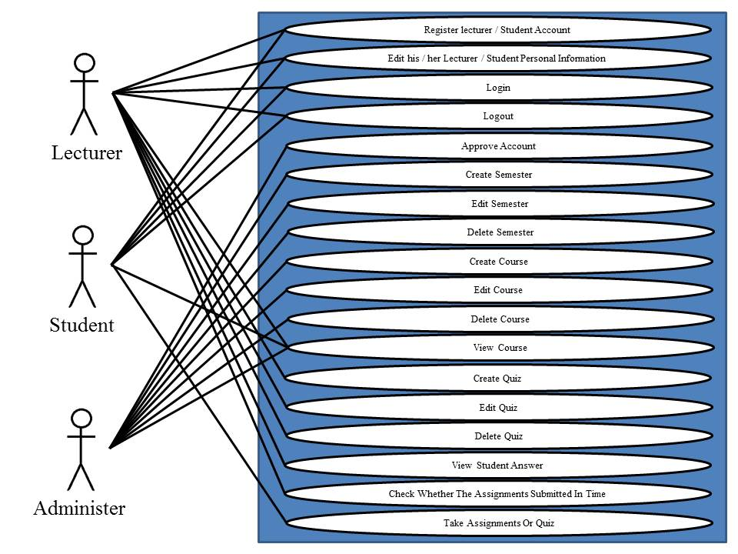

3.1.1 Login to the system Use Case Diagram
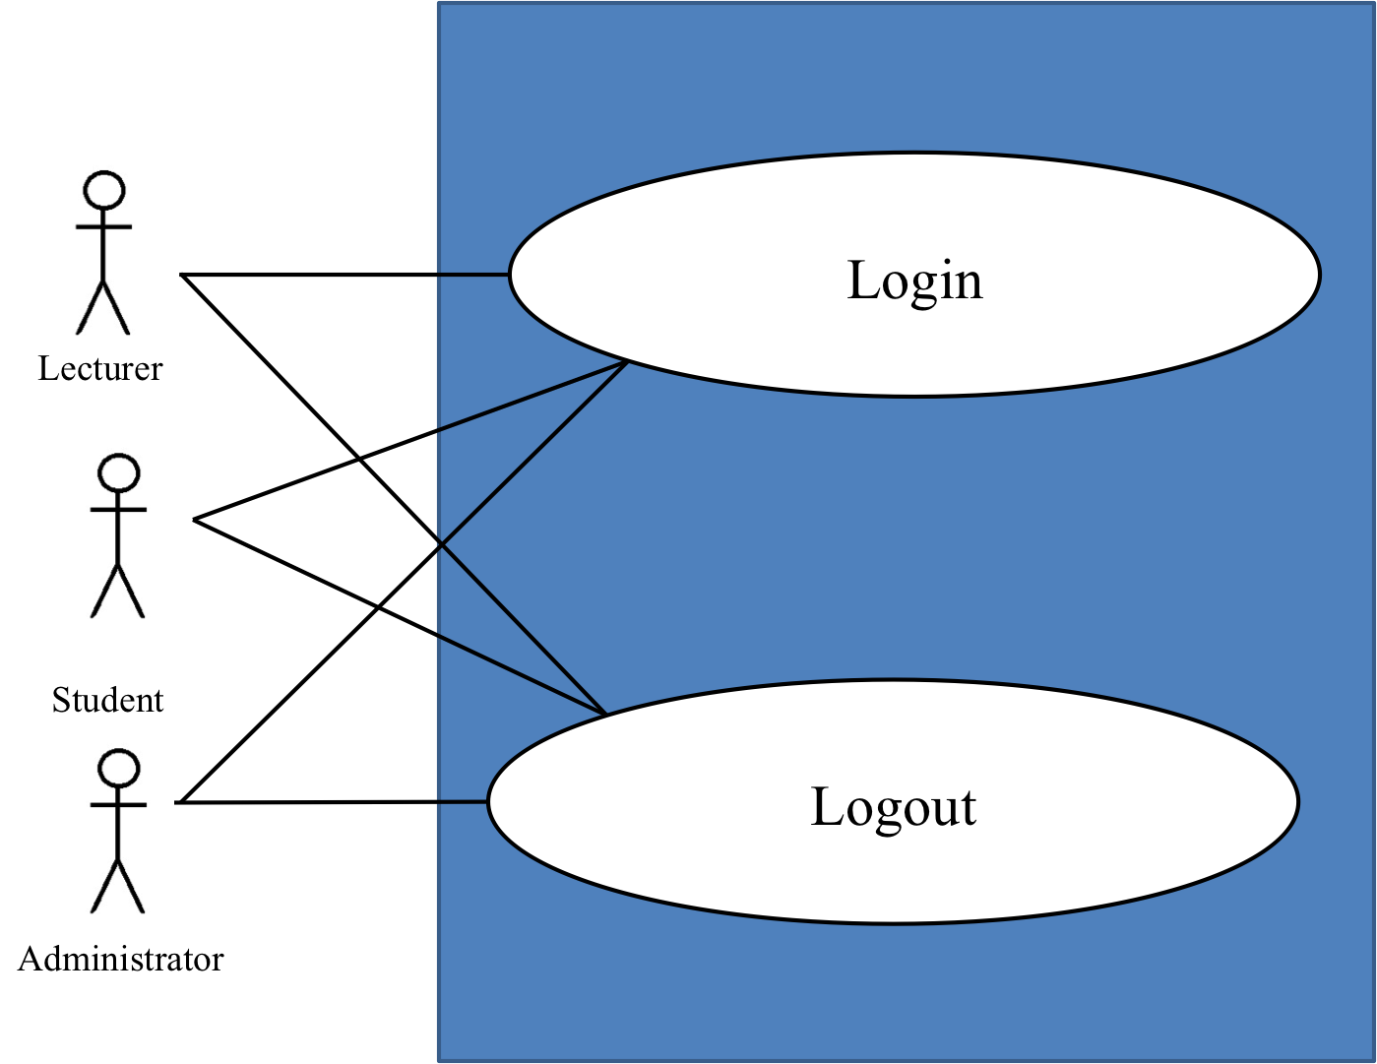

Description
The functions in this diagram are accession to the system of Lecturer/Student/Administrator on the web application.

3.1.2 Register and edit information Use Case Diagram

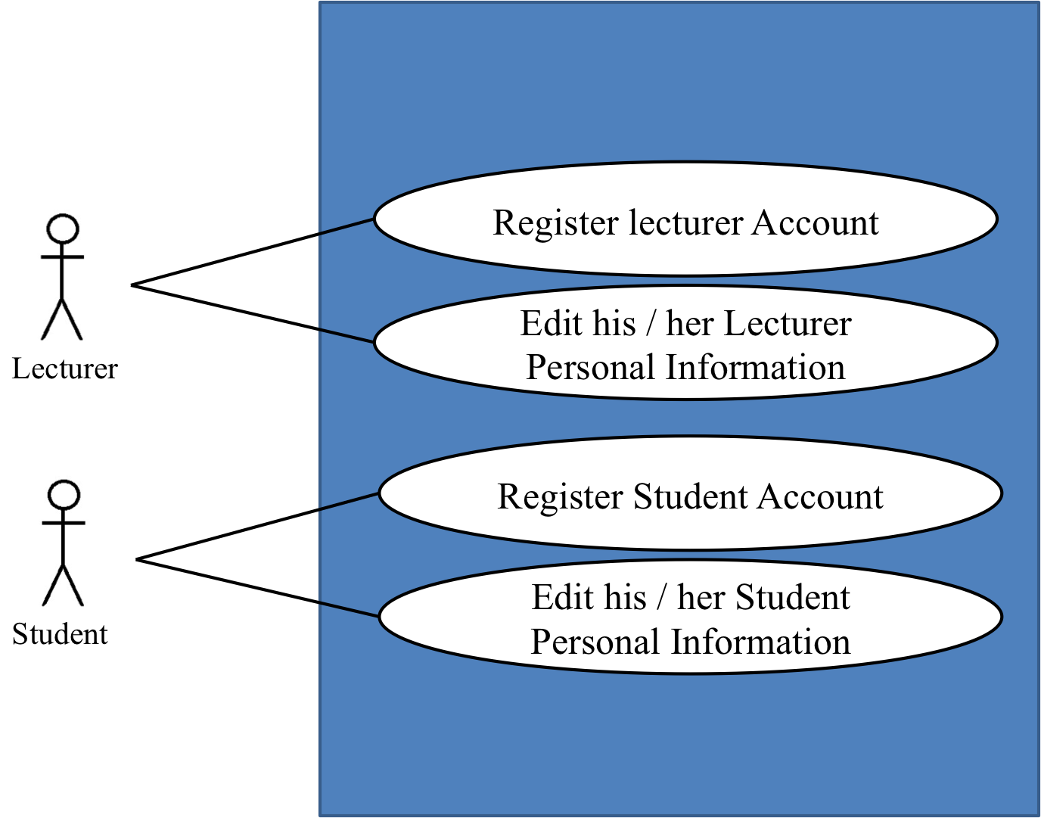

Description
The functions in this diagram for lecturer and student for register and edit personal information

3.1.3 Administrator function Use Case Diagram

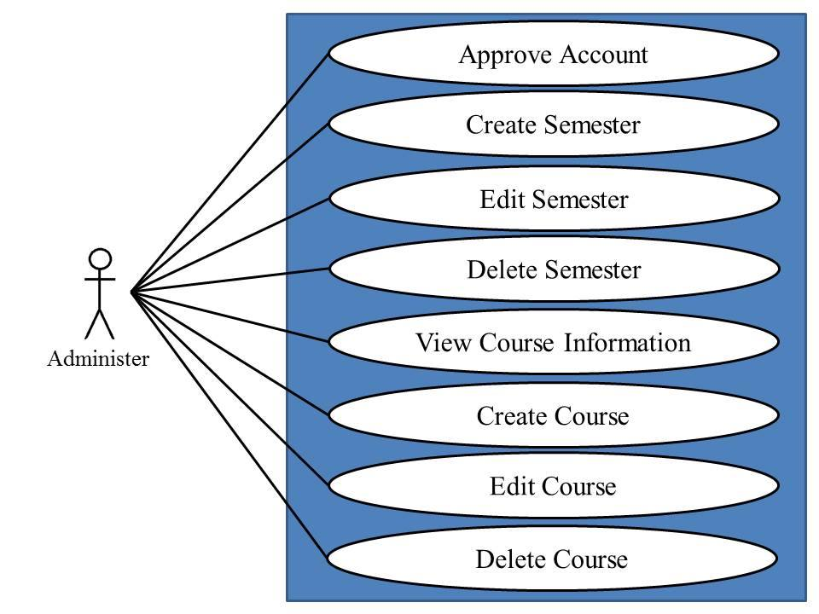

Description
The functions in this diagram for Administrator. this diagram provide the function of administrator in web application.

3.1.4 Administrator function Use Case Diagram
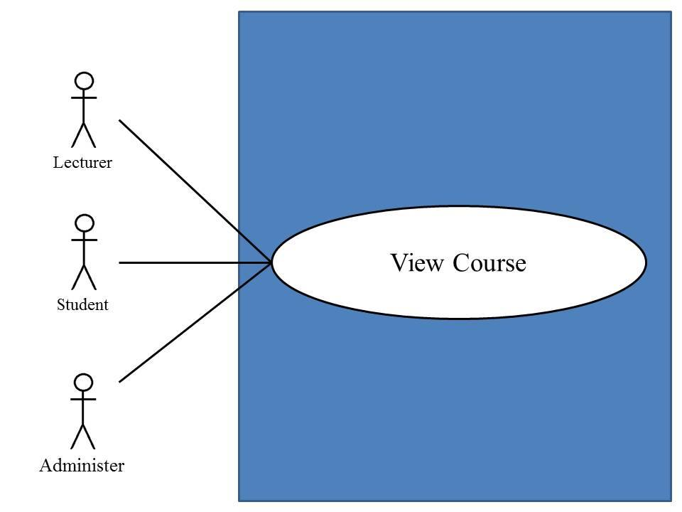

Description
The functions in this diagram for Administrator. Lecturer and student this diagram provide the function of view course in web application.

3.1.5 lecturer function Use Case Diagram
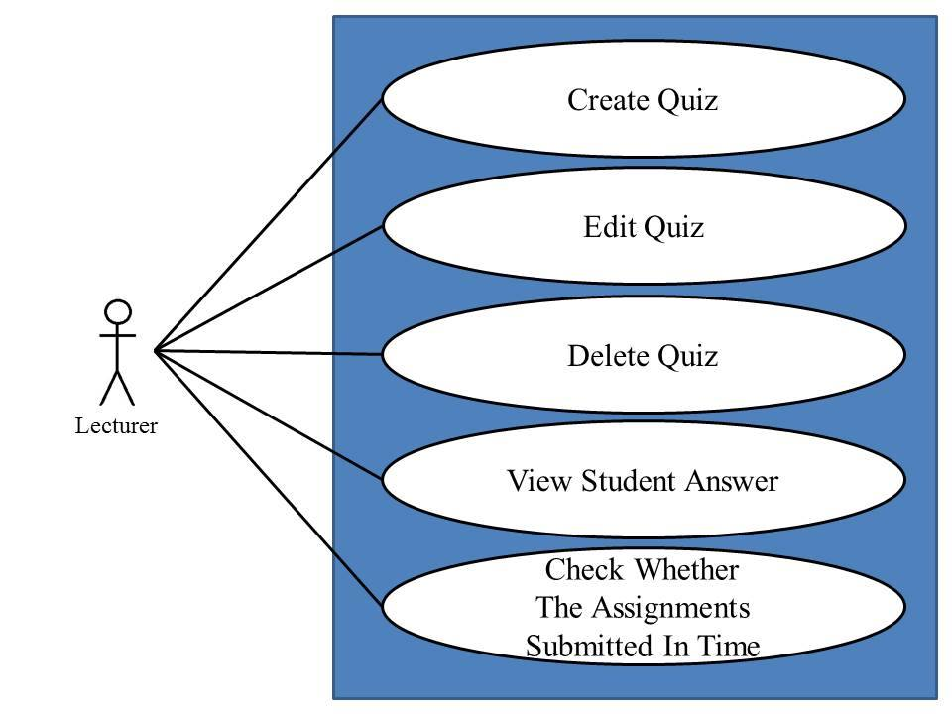

Description
The functions in this diagram for Lecturer this diagram provide the function for lecturer in web application.

3.1.6 Student take assignment Use Case Diagram
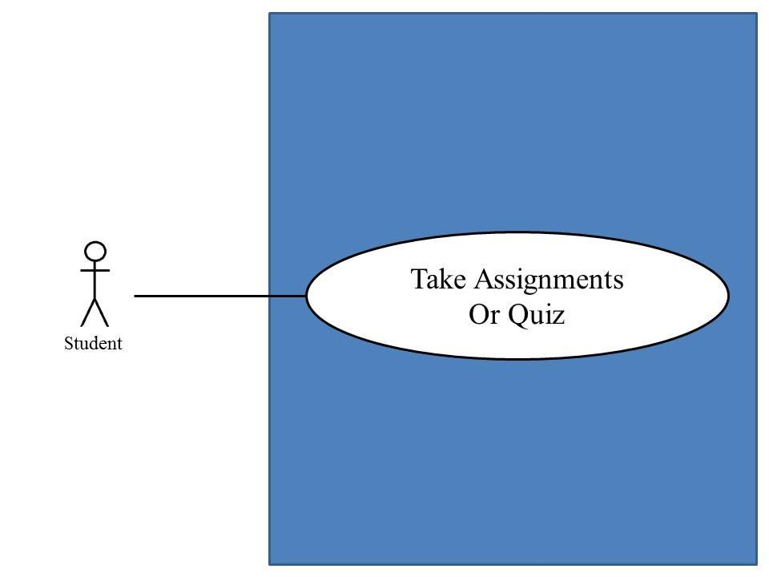

Description
The functions in this diagram for student. this diagram provide the function for Student take assignment r in web application.

3.1.2 Mobile application Use Case Diagram

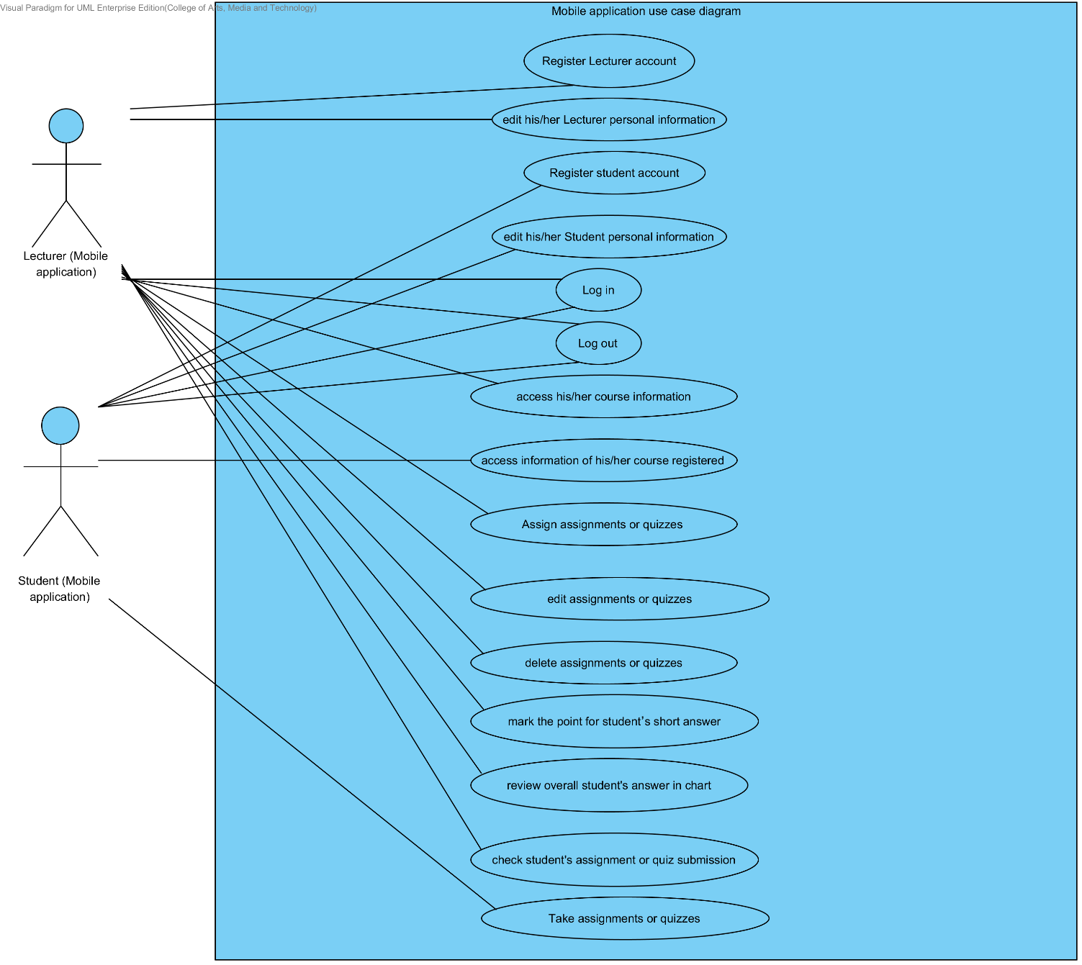

3.1.2 User Registration Use Case Diagram
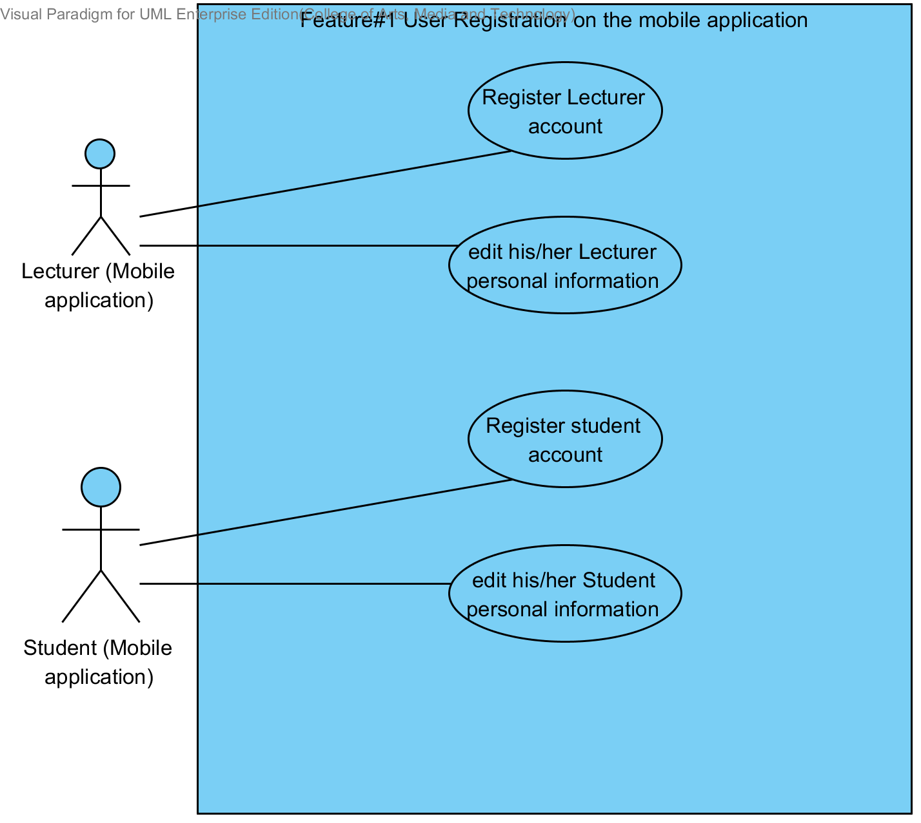

Description
The functions in this diagram are registration of Lecturer/Student on the mobile application for using the system.

3.1.3 Login to the system Use Case Diagram
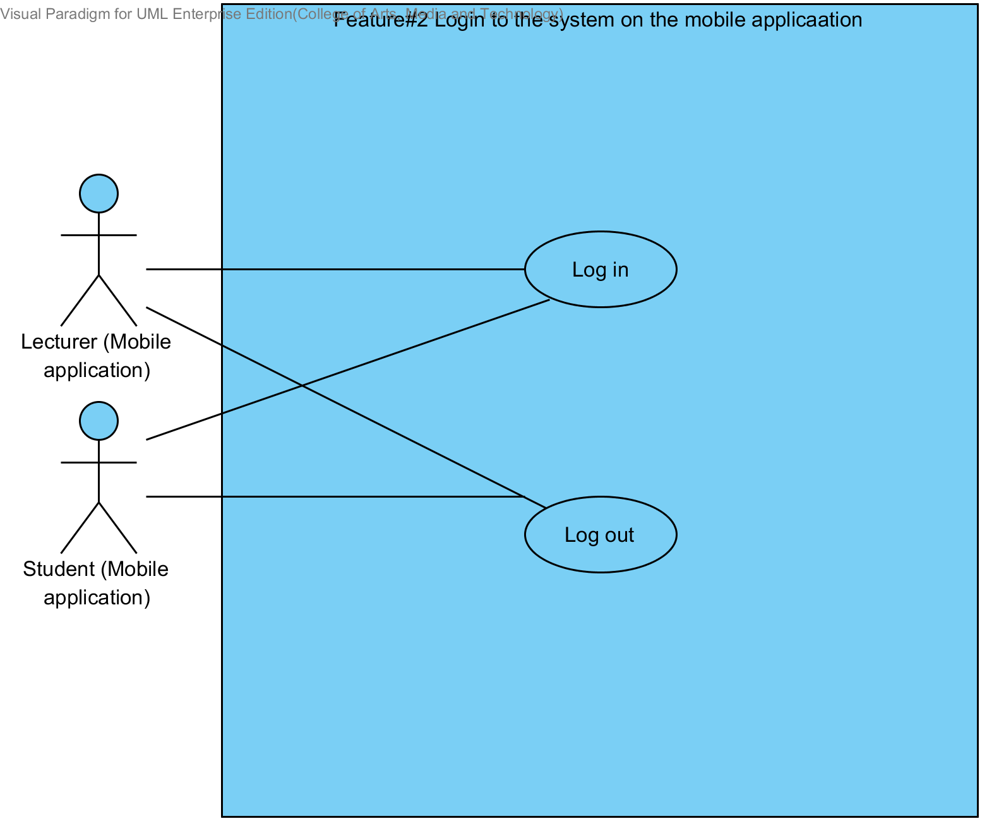

Description
The functions in this diagram are accession to the system of Lecturer/Student on the mobile application.

3.1.4 Course management Use Case Diagram
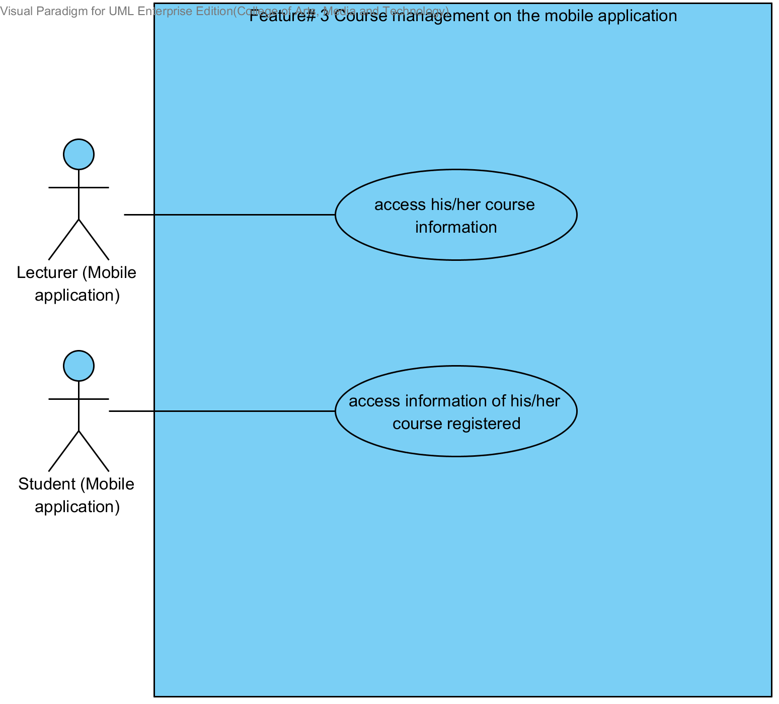

Description
The functions in this diagram are accession to courses information that were taught by Lecturer on the mobile application. Student access to courses information that were registered on the mobile application. Users need login before use the system.

3.1.5 Assignments and quizzes management Use Case Diagram

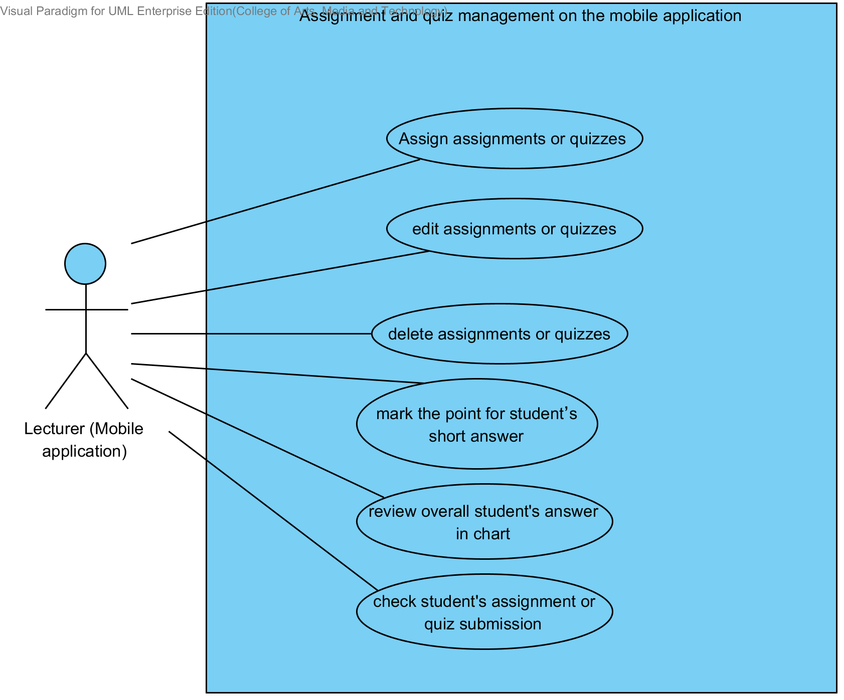

Description
The functions in this diagram are assignments and quizzes management by Lecturer on the mobile application. Which provide assignation assignments or quizzes, edition assignments or quizzes, deletion assignments or quizzes, review overall student’s answer in chart, and checking student submission. Lecturer need login before user the system.

3.1.6 Taking assignments and quizzes Use Case Diagram

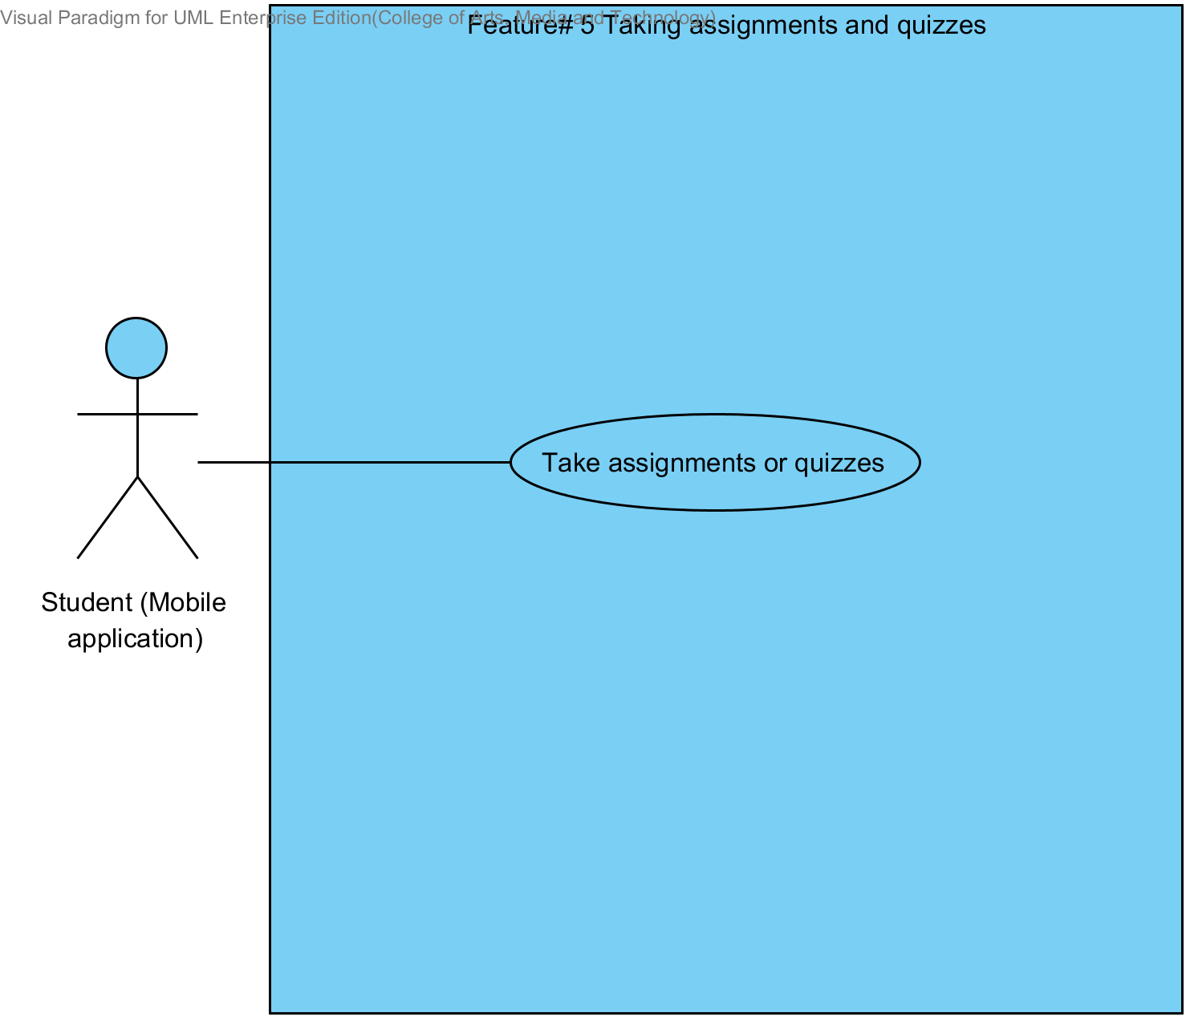

Description
The functions in this diagram are taking assignment and quizzes by Student. Student need login before user the system.

Chapter Four | Use case description

4.1 Lecturer registers to the system (UC-01)
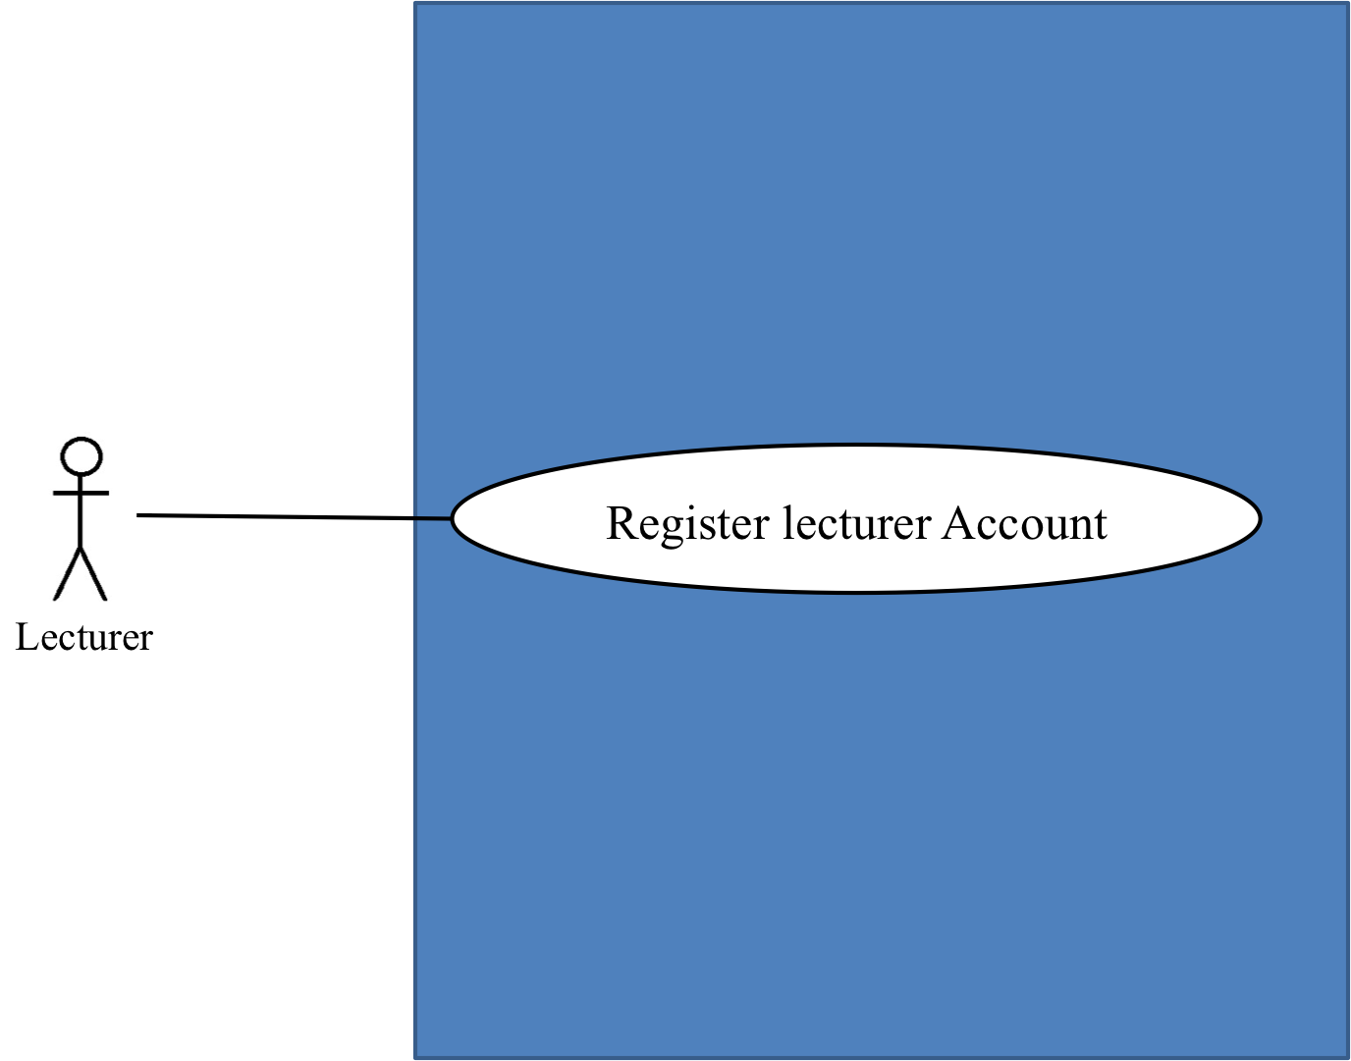

Use Case ID: | UC-01
Use Case Name: | Lecturer registers to the system
Created By: | Mr.Chaichan Suttee |  | Last Updated By: | Mr.Chaichan Suttee
Date Created: | 10/05/2014 |  | Last Revision Date: | 10/05/2014
Actors: |  | Lecturer
Description: |  | This use case is provided for Lecturer request to register account to the system on the web application.
Trigger: |  | Submit the Lecturer registration form
Preconditions: |  | N/A
Post conditions: |  | - The system display “Registration Successful” message.
Normal Flow: |  | - Lecturer enters the login page.  - Lecturer enters the Lecturer registration page.  - Lecturer provides the Lecturer information into the registration page.  - Lecturer submits the Lecturer registration form into the web application.  - The system validate the existing of the username and the information format.  - The system display “Registration Successful” message.  - The system redirect into the Lecturer main page with registration successful message.
Alternative Flows: |  | 5A. if Lecturer input data in the wrong format, the system should provide the error message as followed:  - The wrong lecturer ID format: The error message is “The Lecturer ID must be the number only”  - The wrong username format: The error message is “The Lecturer’s username must be only 4-16 alphabet characters”  - The wrong password format: The error message is “The Lecturer’s password must be only 4-16 characters”  - The wrong name format: The error message is “The Lecturer’s name must be the combination of alphabet and space only”  - The wrong Telephone number format: The error message is “The Lecturer’s telephone number must be number only”  - The wrong lecturer email format: The error message is “The Lecturer’s email must be the character and only one @ symbol”  5B. if Lecturer submitted the data, but there is the existing username in the system. The system won’t allow the user the register with that Username. The system will display the error message “Existing Lecturer’s username, please using different Lecturer’s username” to the user.
Exceptions: |  | N/A
Includes: |  | N/A
Frequency of Use: |  | Only at the first time when user begins to use this application.
Assumptions: |  | N/A
Notes and Issues: |  | N/A

URS1-1. Lecturer can register to the system
Lecturer must register into the web application, in order to using the other features as Lecturer. Lecture provides lecturer ID, lecturer username, lecturer password, lecturer name, lecturer faculty, lecturer department, lecturer email, and lecturer telephone number into the system. After, the registration has been completed. The web application will redirect to the Lecturer main page.
Actor: The users
Prerequisite: -

Input:
Name | Description | Example | Remarks
lecturer ID | Only number is allowed. | 21115011
lecturer username | Only Alphabet is allowed, within the range of 4-16 Characters | “tony”
lecturer password | Can be any character within the range of 4-16 characters. | “12345”
lecturer name | Only The combination of alphabet and space is allowed. | “Tony Stark”
lecturer faculty | Can be any character is allowed. | College of Arts media and technology, Chiang mai University
lecturer department | Can be any character is allowed. | Software engineer
lecturer email | The combination of character and only one @ symbol is allowed. | tony999@gmail.com
lecturer telephone number | Only number is allowed. | 0832109999

Flow of Execution:
- Lecturer enters the login page.
- Lecturer enters the Lecturer registration page.
- Lecturer provides the Lecturer information into the registration page.
- Lecturer submits the Lecturer registration form into the web application.
- The system validate the existing of the username and the information format.
- The system display “Registration Successful” message.
- The system redirect into the Lecturer main page with registration successful message.

Alternative Flow:
5A. if Lecturer input data in the wrong format, the system should provide the error message as followed:
  - The wrong lecturer ID format: The error message is “The Lecturer ID must be the number only”
  - The wrong username format: The error message is “The Lecturer’s username must be only 4-16 alphabet characters”
  - The wrong password format: The error message is “The Lecturer’s password must be only 4-16 characters”
  - The wrong name format: The error message is “The Lecturer’s name must be the combination of alphabet and space only”
  - The wrong Telephone number format: The error message is “The Lecturer’s telephone number must be number only”
  - The wrong lecturer email format: The error message is “The Lecturer’s email must be the character and only one @ symbol”

5B. if Lecturer submitted the data, but there is the existing username in the system. The system won’t allow the user the register with that Username. The system will display the error message “Existing Lecturer’s username, please using different Lecturer’s username” to the user.

System Requirement Specification of URS1.1
SRS1-1.1: The system shall redirect to Lecturer registration page
SRS1-2.1: The system shall redirect to Lecture main page
SRS1-3.1: The system shall provide Lecturer registration interface on the including lecturer ID, lecturer username, lecturer password, lecturer name, lecturer faculty, lecturer department, lecturer email, and lecturer telephone for Lecturer register to the system.
SRS1-4.1: The system shall store the Lecturer personal information into the system after Lecturer submitted his/her register information from Lecturer registration interface.
SRS.1-5.1: The system shall display “Registration Successful” message when Lecturer registered the Lecturer account in Lecturer registration interface .
SRS.1-6.1: The system shall validate the format of the Lecturer personal information after the Lecturer submitted his/her information from Lecturer registration interface .
SRS.1-7.1: The system shall display “The Lecturer ID must be the number only” when the lecturer ID format is wrong.
SRS.1-8.1: The system shall display “The Lecturer’s username must be only 4-16 alphabet characters” when the lecturer username format is wrong.
SRS.1-9.1: The system shall display “The Lecturer’s password must be only 4-16 characters” when the lecturer password format is wrong.
SRS.1-10.1: The system shall display “The Lecturer’s name must be the combination of alphabet and space only” when the lecturer name format is wrong.
SRS.1-11.1: The system shall display “The Lecturer’s telephone must be number only” when the lecturer telephone format is wrong.
SRS.1-12.1: The system shall validate the duplication of the lecturer username after Lecturer submitted his/her information from Lecturer registration interface.
SRS.1-13.1: The system shall display “Existing Lecturer’s username, please using different Lecturer’s username” when the lecturer username duplicates exist lecturer username.

4.2 Student registers to the system (UC-02)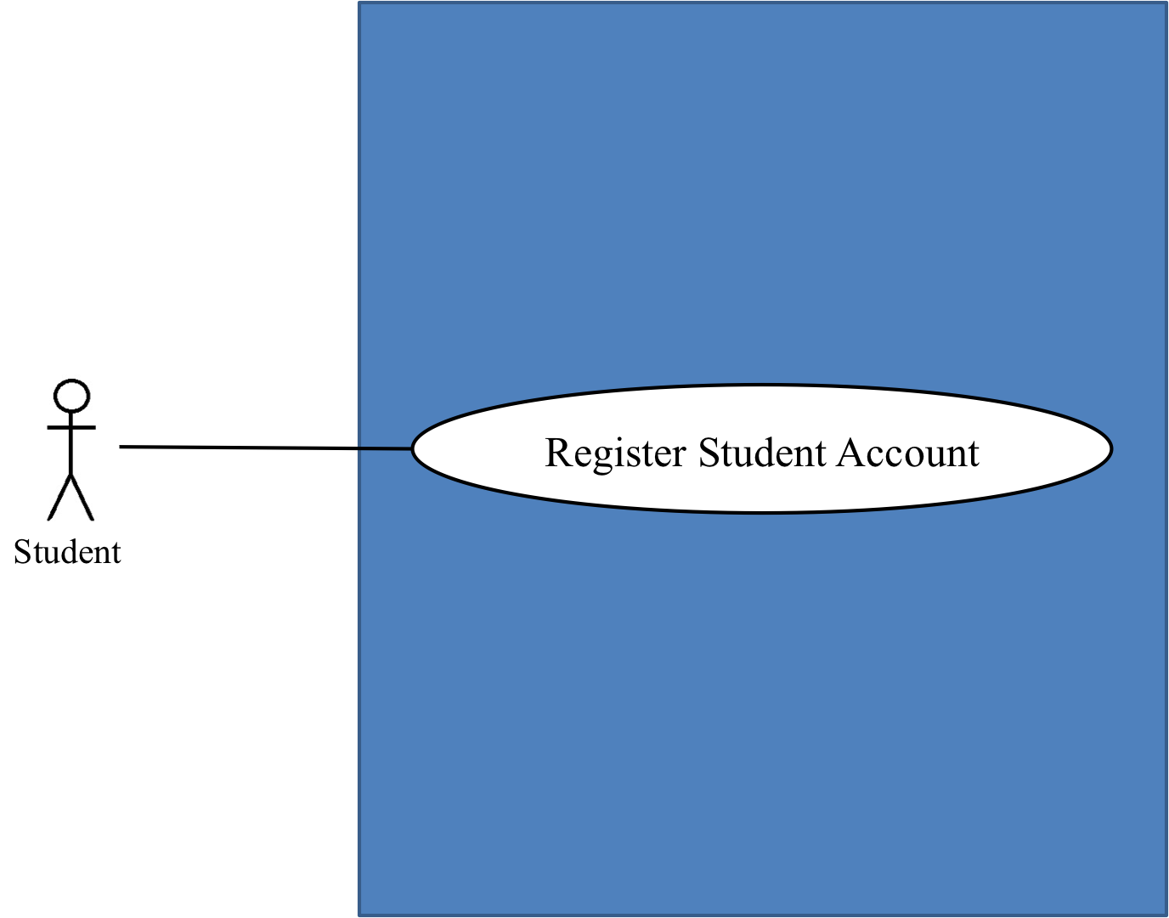

Use Case ID: | UC-02
Use Case Name: | Student registers to the system
Created By: | Mr.Chaichan suttee |  | Last Updated By: | Mr.Chaichan suttee
Date Created: | 10/05/2014 |  | Last Revision Date: | 10/05/2014
Actors: |  | Student
Description: |  | This use case is provided for Student request to register account to the system on the web application.
Trigger: |  | Submit the Student registration form
Preconditions: |  | N/A
Post conditions: |  | - The system display “Registration Successful” message.
Normal Flow: |  | - Student enters the login page.  - Student enters the Student registration page.  - Student provides the Student information into the registration page.  - Student submits the Student registration form into the web application.  - The system validate the existing of the username and the information format.  - The system display “Registration Successful” message.  - The system redirect into the Student main page with registration successful message.
Alternative Flows: |  | 5A. if Student input data in the wrong format, the system should provide the error message as followed:  - The wrong student ID format: The error message is “The Student ID must be number only”  - The wrong username format: The error message is “The Student’s username must be only 4-16 alphabet characters”  - The wrong password format: The error message is “The Student’s password must be only 4-16 characters”  - The wrong name format: The error message is “The Student’s name must be the combination of alphabet and space only”  - The wrong Telephone number format: The error message is “The Student’s telephone number must be number only”  - The wrong student email format: The error message is “The Student’s email must be the character and only one @ symbol”  5B. if Student submitted the data, but there is the existing username in the system. The system won’t allow the user the register with that Username. The system will display the error message “Existing Student’s username, please using different Student’s username” to the user.
Exceptions: |  | N/A
Includes: |  | N/A
Frequency of Use: |  | Only at the first time when user begins to use this application.
Assumptions: |  | N/A
Notes and Issues: |  | N/A

URS2.1 Student can register to the system
Student must register into the web application, in order to using the other features as Student. Student provides student ID, student username, student password, student name, student address, student faculty, student department, student email, and student telephone number into the system. After, the registration has been completed. The web application will redirect to the Student main page.
Actor: The users
Prerequisite: -

Input:
Name | Description | Example | Remarks
student ID | Only number is allowed. | 542115099
student username | Only Alphabet is allowed, within the range of 4-16 Characters | “jenny”
student password | Can be any character within the range of 4-16 characters. | “12345”
student name | Only The combination of alphabet and space is allowed. | “Jenny Stark”
student faculty | Can be any character is allowed. | College of Arts media and technology, Chiang mai University
student department | Can be any character is allowed. | Software engineer
student address | Can be any character. | Women dorm 4, Chiang mai university, Chiang mai, Thailand, 50000
student email | The combination of character and only one @ symbol is allowed. | jenny999@gmail.com
student telephone number | Only number is allowed. | 0823207777

Flow of Execution:
- Student enters the login page.
- Student enters the Student registration page.
- Student provides the Student information into the registration page.
- Student submits the Student registration form into the web application.
- The system validate the existing of the username and the information format.
- The system display “Registration Successful” message.
- The system redirect into the Student main page with registration successful message.

Alternative Flow
5A. if Student input data in the wrong format, the system should provide the error message as followed:
  - The wrong student ID format: The error message is “The Student ID must be number only”
  - The wrong username format: The error message is “The Student’s username must be only 4-16 alphabet characters”
  - The wrong password format: The error message is “The Student’s password must be only 4-16 characters”
  - The wrong name format: The error message is “The Student’s name must be the combination of alphabet and space only”
  - The wrong Telephone number format: The error message is “The Student’s telephone number must be number only”
  - The wrong student email format: The error message is “The Student’s email must be the character and only one @ symbol”

5B. if Student submitted the data, but there is the existing username in the system. The system won’t allow the user the register with that Username. The system will display the error message “Existing Student’s username, please using different Student’s username
System Requirement Specification of URS2.1

SRS2-1.1: The system shall redirect to Student registration page.
SRS2-2.1: The system shall redirect to Student main page.
SRS2-3.1: The system shall provide Student registration interface including student ID, student username, student password, student name, student address, student faculty, student department, student email, and student telephone for Student register to the system.
SRS2-4.1: The system shall store the Student personal information into the system after Student submitted his/her register information from Student registration interface.
SRS2-5.1: The system shall display “Registration Successful” message when Student registered the Student account in Student registration interface.
SRS2-6.1: The system shall validate the format of the Student information after the Student submitted his/her information from Student registration interface.
SRS2-7.1: The system shall display “The Student ID must be the number only” when the student ID format is wrong.
SRS2-8.1: The system shall display “The Student’s username must be only 4-16 alphabet characters” when the student username format is wrong.
SRS2-9.1: The system shall display “The Student’s password must be only 4-16 characters” when the student password format is wrong.
SRS2-10.1: The system shall display “The Student’s name must be the combination of alphabet and space only” when the student name format is wrong.
SRS2-11.1: The system shall display “The Student’s telephone must be number only” when the student telephone format is wrong.
SRS2-12.1: The system shall validate the duplication of the student username after Student submitted his/her information from Student registration interface.
SRS2-13.1: The system shall display “Existing Student’s username, please using different Student’s username” when the student username duplicates exist student username.

4.3 Administrator can approve Lecturer or Student account which has registered. (UC-03)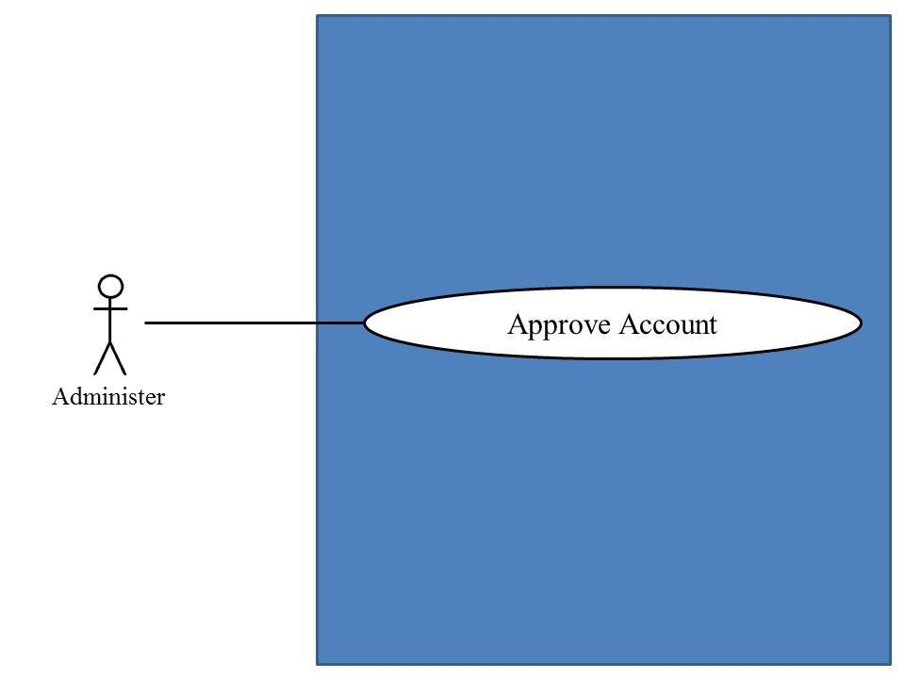

Use Case ID: | UC-03
Use Case Name: | Administrator approve account
Created By: | Mr.Chaichan suttee |  | Last Updated By: | Mr.Chaichan suttee
Date Created: | 10/05/2014 |  | Last Revision Date: | 10/05/2014
Actors: |  | Administrator
Description: |  | This use case is provided for Administrator approve account to the system on the web application.
Trigger: |  | Administrator click Approve user account.
Preconditions: |  | Administrator must logged in to system
Post conditions: |  | - The system display “Approbation Successful” message.  - The web application redirect to the account approbation page.
Normal Flow: |  | - Administrator enters the Administrator main page.  - Administrator enters the account approbation page.  - Administrator submits to approve Lecturer or Student account from account approbation page.  - The system display “Approbation Successful” message.  - The web application redirect to the account approbation page.
Alternative Flows: |  | N/A
Exceptions: |  | N/A
Includes: |  | N/A
Frequency of Use: |  | Depend on the user registration
Assumptions: |  | N/A
Notes and Issues: |  | N/A

URS1-3. Administrator can approve Lecturer or Student account which has registered.
The Administrator must approve Lecturer or Student account that fully qualification.
Actor: The Administrator

Input: None
Prerequisite: -

Flow of Execution:
- Administrator enters the Administrator main page.
- Administrator enters the account approbation page.
- Administrator submits to approve Lecturer or Student account from account approbation page.
- The system display “Approbation Successful” message.
- The web application redirect to the account approbation page.
System Requirement Specification of URS1-3
SRS3-1.1: The system shall redirect to Administrator Main page.
SRS3-2.1: The system shall provide Registration approve interface
SRS3-3.1: The system shall Display Registration information interface including student ID, student username, student password, student name, student faculty, student department.
SRS3-4.1: The system shall validate the user status form Administrator.

4.4 Lecturer edits personal information (UC-04)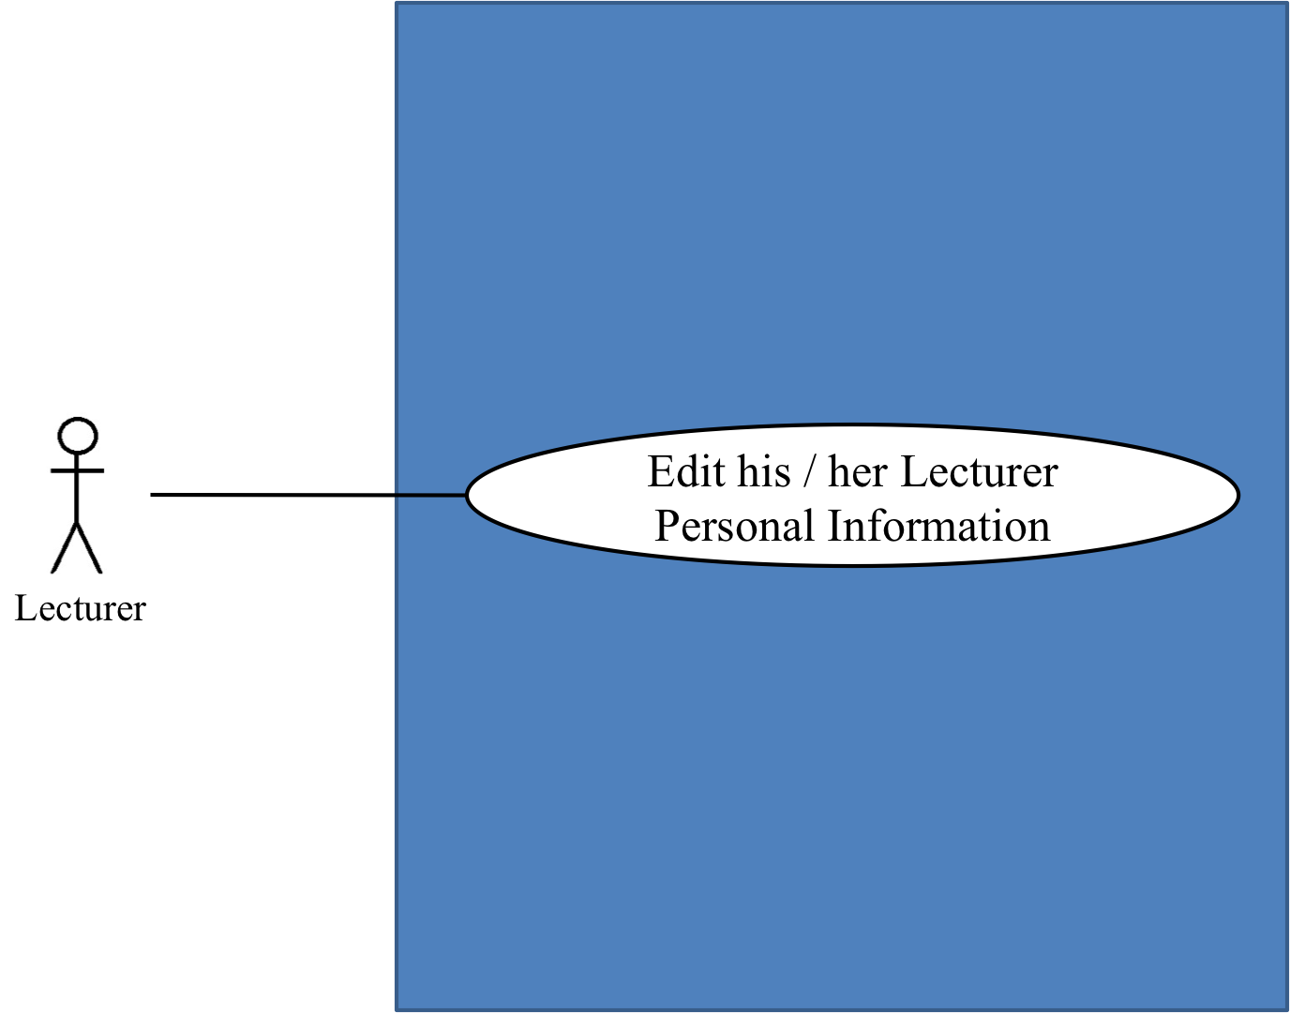

Use Case ID: | UC-04
Use Case Name: | Lecturer edits personal information.
Created By: | Mr.Chaichan suttee |  | Last Updated By: | Mr.Chaichan suttee
Date Created: | 10/05/2014 |  | Last Revision Date: | 10/05/2014
Actors: |  | Lecturer
Description: |  | This use case is provided for Lecturer edits his/her personal information on the web application.
Trigger: |  | Submit click edit personal information
Preconditions: |  | Lecturer log in to the system already.
Post conditions: |  | Lecturer edits his/her personal information are successful.
Normal Flow: |  | - Lecturer enters the Lecturer main page.  - Lecturer enters the Lecturer personal information page.  - The system provides lecturer password, lecturer name, lecturer faculty, lecturer department, and lecturer telephone number.  - Lecturer provides information that want to edit.  - Lecturer provides confirm password for editing.  - Lecturer submits the Lecturer editing form into the web application.  - The system validates the password and confirm password.  - The system display “Editing Information Successful” message.  - The system redirect to the Lecturer main page.
Alternative Flows: |  | 6A. if Lecturer input data in the wrong format, the system should provide the error message as followed:  - The wrong password format: The error message is “The Lecturer’s password must be only 4-16 characters”  - The wrong name format: The error message is “The Lecturer’s name must be the combination of alphabet and space only”  - The wrong Telephone number format: The error message is “The Lecturer’s telephone number must be number only”  - The wrong lecturer email format: The error message is “The Lecturer’s email must be the character and only one @ symbol”  6B. if Lecturer submitted the data, but password and confirm password is not matched. The system will display the error message “Password and confirm password is not matched” to Lecturer.
Exceptions: |  | N/A
Includes: |  | N/A
Frequency of Use: |  | Often
Assumptions: |  | N/A
Notes and Issues: |  | N/A

URS1-4. Lecturer can edit his/her personal information.
Lecturer can edit his/her personal information which consist lecturer password, lecturer name, lecturer faculty, lecturer department, lecturer email, and lecturer telephone number.
Actor: Lecturer
Prerequisite: Lecturer must have logged.

Input:
Name | Description | Example | Remarks
lecturer password | Can be any character within the range of 4-16 characters. | “123456”
lecturer name | Only The combination of alphabet and space is allowed. | “Tony Stark”
lecturer faculty | Can be any character is allowed. | College of Arts media and technology, Chiang mai University
lecturer department | Can be any character is allowed. | Software engineering
lecturer email | The combination of character and only one @ symbol is allowed. | tony999@gmail.com
lecturer telephone number | Only number is allowed. | 0832109999

Flow of Execution:
- Lecturer enters the Lecturer main page.
- Lecturer enters the Lecturer personal information page.
- The system provides lecturer password, lecturer name, lecturer faculty, lecturer department, and lecturer telephone number.
- Lecturer provides information that want to edit.
- Lecturer provides confirm password for editing.
- Lecturer submits the Lecturer editing form into the web application.
- The system validates the password and confirm password.
- The system display “Editing Information Successful” message.
- The system redirect to the Lecturer main page.

Alternative Flow:
6A. if Lecturer input data in the wrong format, the system should provide the error message as followed:
  - The wrong password format: The error message is “The Lecturer’s password must be only 4-16 characters”
  - The wrong name format: The error message is “The Lecturer’s name must be the combination of alphabet and space only”
  - The wrong Telephone number format: The error message is “The Lecturer’s telephone number must be number only”
  - The wrong lecturer email format: The error message is “The Lecturer’s email must be the character and only one @ symbol”

6B. if Lecturer submitted the data, but password and confirm password is not matched. The system will display the error message “Password and confirm password is not matched” to Lecturer.

System Requirement Specification of URS1-4
SRS1-2.1: The system shall redirect to Lecture main page.
SRS4-1.1: The system shall redirect to Lecturer personal information interface.
SRS4-2.1: The system shall provide Lecturer personal information interface, including lecturer password, lecturer name, lecturer faculty, lecturer department, lecturer email, and lecturer telephone number for Lecturer edits his/her personal information into the system.
SRS4-3.1: The system shall update Lecturer personal information into the system after Lecturer submits to edit his/her personal information from Lecturer personal information interface.
SRS4-4.1: The system shall display “Editing Information Successful” message when Lecturer edited the Lecturer personal information in Lecturer personal information interface.
SRS4-5.1: The system shall validate the format of the Lecture personal information after Lecturer submitted his/her personal information from Lecturer personal information interface.
SRS4-6.1: The system shall display “The Lecturer’s password must be only 4-16 characters” when the lecturer password format is wrong.
SRS4-7.1: The system shall display “The Lecturer’s name must be the combination of alphabet and space only” when the lecturer name format is wrong.
SRS4-8.1: The system shall display “The Lecturer’s telephone number must be number only” when the lecturer telephone number format is wrong.
SRS4-9.1: The system shall display “The Lecturer’s email must be the character and only one @ symbol” when the lecturer email format is wrong.
SRS4-10.1: The system shall validate the similarity of password and confirm password after Lecturer submitted his/her personal information from Lecturer personal information interface.
SRS4-11.1: The system shall display “Password and confirm password is not matched” when password and confirm password is not matched.
4.5 Student edits personal information (UC-05)
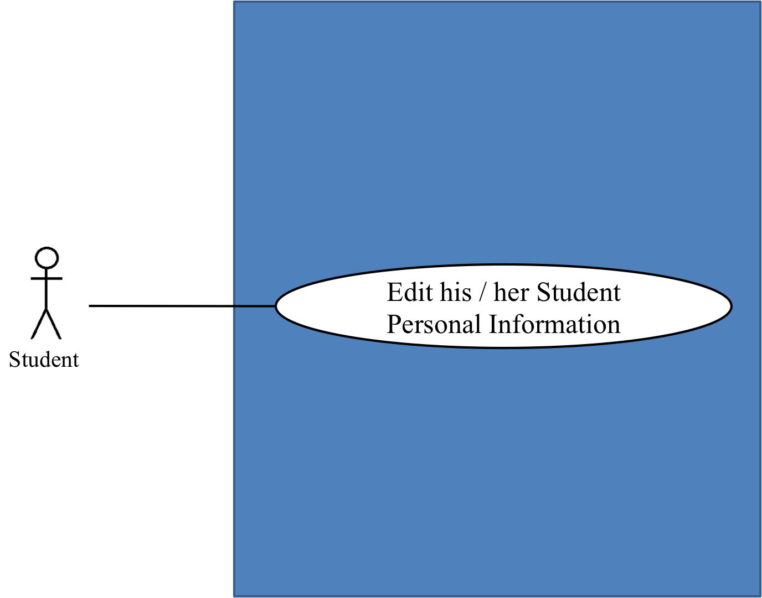
Use Case ID: | UC-05
Use Case Name: | Student edits personal information.
Created By: | Mr.Chaichan Suttee |  | Last Updated By: | Mr.Chaichan Suttee
Date Created: | 10/05/2014 |  | Last Revision Date: | 10/05/2014
Actors: |  | Student
Description: |  | This use case is provided for Student edits his/her personal information on the web application.
Trigger: |  | Student click edit personal information.
Preconditions: |  | Student log in to the system already.
Post conditions: |  | The system display “Editing Information Successful” message.
Normal Flow: |  | - Student enters the Student main page.  - Student enters the Student personal information page.  - The system provides consist student password, student name, student faculty, student department, student address, and student telephone number.  - Student provides information that want to edit.  - Student provides confirm password for editing.  - Student submits the Lecturer editing form into the web application.  - The system validates the password and confirm password.  - The system display “Editing Information Successful” message.
Alternative Flows: |  | 6A. if Student input data in the wrong format, the system should provide the error message as followed:  - The wrong password format: The error message is “The Student’s password must be only 4-16 characters”  - The wrong name format: The error message is “The Student’s name must be the combination of alphabet and space only”  - The wrong Telephone number format: The error message is “The Student’s telephone number must be number only”  - The wrong student email format: The error message is “The Student’s email must be the character and only one @ symbol”  6B. if Student submitted the data, but password and confirm password is not matched. The system will display the error message “Password and confirm password is not matched” to Student.
Exceptions: |  | N/A
Includes: |  | N/A
Frequency of Use: |  | Often
Assumptions: |  | N/A
Notes and Issues: |  | N/A

URS1-5. Student can edit his/her personal information.
Student can edit his/her personal information which consist student ID, student password, student name, student address, student faculty, student department, and student telephone number.
Actor: Student
Prerequisite: Student must have logged.

Input:
Name | Description | Example | Remarks
student password | Can be any character within the range of 4-16 characters. | “123456”
student name | Only The combination of alphabet and space is allowed. | “Jenny Stark”
student faculty | Can be any character is allowed. | College of Arts media and technology, Chiang mai University
student department | Can be any character is allowed. | Software engineering
student address | Can be any character. | Women dorm 4, Chiang mai university, Chiang mai, Thailand, 50000
student email | The combination of character and only one @ symbol is allowed. | jenny999@gmail.com
student telephone number | Only number is allowed. | 0823207777

Flow of Execution:
- Student enters the Student main page.
- Student enters the Student personal information page.
- The system provides consist student password, student name, student faculty, student department, student address, and student telephone number.
- Student provides information that want to edit.
- Student provides confirm password for editing.
- Student submits the Lecturer editing form into the web application.
- The system validates the password and confirm password.
- The system display “Editing Information Successful” message.
- The system redirect to the Student main page.

Alternative Flow:
6A. if Student input data in the wrong format, the system should provide the error message as followed:
  - The wrong password format: The error message is “The Student’s password must be only 4-16 characters”
  - The wrong name format: The error message is “The Student’s name must be the combination of alphabet and space only”
  - The wrong Telephone number format: The error message is “The Student’s telephone number must be number only”
  - The wrong student email format: The error message is “The Student’s email must be the character and only one @ symbol”

6B. if Student submitted the data, but password and confirm password is not matched. The system will display the error message “Password and confirm password is not matched” to Student.
System Requirement Specification of URS1-5

SRS2-2-2: The system shall redirect to Student main page.
SRS2-5-1: The system shall redirect to Student personal information interface
SRS2-5-2: The system shall provide Student personal information interface including student password, student name, student faculty, student department, student address, student email, and student telephone number for Student edits his/her personal information into the system.
SRS2-5-3: The system shall update Student personal information into the system after Student submits to edit his/her personal information from Student personal information interface.
SRS2-5-4: The system shall display “Editing Information Successful” message when Student edited the Student personal information in Student personal information interface.
SRS2-5-5: The system shall validate the format of the Student personal information after Student submitted his/her personal information from Student personal information interface.
SRS2-5-6: The system shall display “The Student’s password must be only 4-16 characters” when the student password format is wrong.
SRS2-5-7: The system shall display “The Student’s name must be the combination of alphabet and space only” when the student name format is wrong.
SRS2-5-8: The system shall display “The Student’s telephone number must be number only” when the student telephone format is wrong.
SRS2-5-9: The system shall validate the similarity of password and confirm password after Student submitted his/her personal information from Student personal information interface.
SRS2-5-10: The system shall display “Password and confirm password is not matched” when password and confirm password is not matched.

4.6 Lecturer Login to system (UC-06)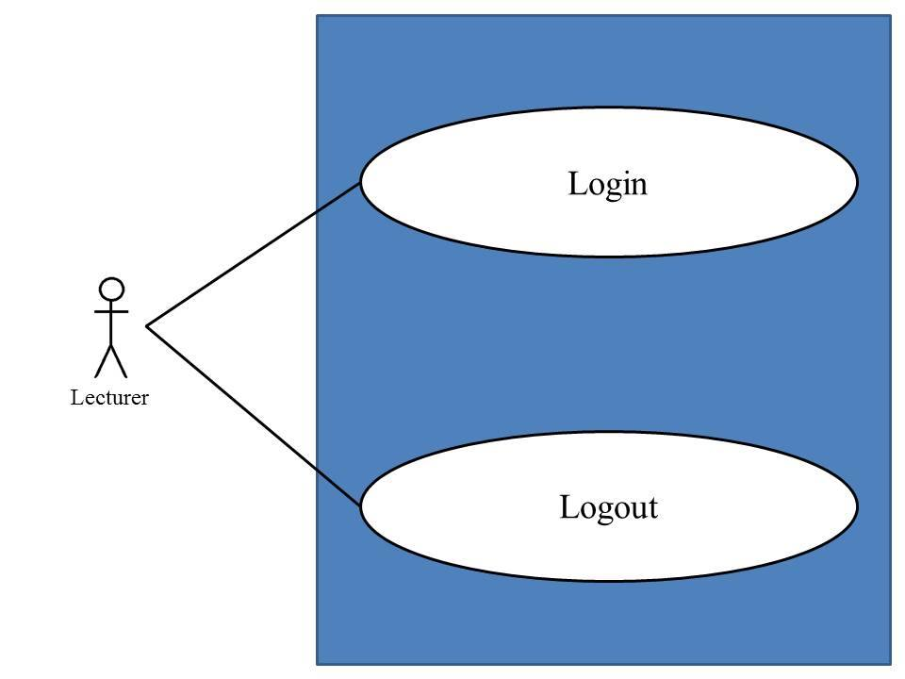
Use Case ID: | UC-06
Use Case Name: | Lecturer Login to the system.
Created By: | Mr.Chaichan Suttee |  | Last Updated By: | Mr.Chaichan Suttee
Date Created: | 10/05/2014 |  | Last Revision Date: | 10/05/2014
Actors: |  | Lecturer,
Description: |  | This use case is provided for Lecturer log in to the system on the mobile application.
Trigger: |  | Lecturer click login
Preconditions: |  | Lecturer registered account already.
Post conditions: |  | Lecturer can log in to the system.
Normal Flow: |  | - Lecturer enters the Login page.  - Lecturer provides login information into the web application.  - Lecturer submit login form into the web application.  - The system validate login information from Lecturer.  - The system redirect into the Lecturer main page with Lecturer ID on the top right of the interface.
Alternative Flows: |  | 4A. if the username and password are not matched, the system will display the error message “Invalid Username and/or Password” to the user.
Exceptions: |  | N/A
Includes: |  | N/A
Frequency of Use: |  | Often
Assumptions: |  | N/A
Notes and Issues: |  | N/A

URS1-6. Lecturer can login to the system.
After the Lecturer account was approved. Lecturer can login to the system by providing username and password.
Actor: Lecturer
Prerequisite: Lecturer must have logged.

Input:
Name | Description | Example | Remarks
lecturer username | Only Alphabet is allowed, within the range of 4-16 Characters | “tony”
lecturer password | Can be any character within the range of 4-16 characters. | “12345”

Flow of Execution:
- Lecturer enters the Login page.
- Lecturer provides login information into the web application.
- Lecturer submit login form into the web application.
- The system validate login information from Lecturer.
- The system redirect into the Lecturer main page with Lecturer ID on the top right of the interface.

Alternative Flow
4A. if the username and password are not matched, the system will display the error message “Invalid Username and/or Password” to the user.

System Requirement Specification of URS1-6
SRS2-1-2: The system shall redirect to Lecture main page.
SRS2-6-1: The system shall redirect to Login page.
SRS2-6-2: The system shall fetch login information of Lecturer from the system to validate the correctness of login information in Login interface
SRS2-6-3: The system shall display “Invalid Username and/or Password” when username and password are wrong to Lecturer.

4.7 Student Login to system (UC-07)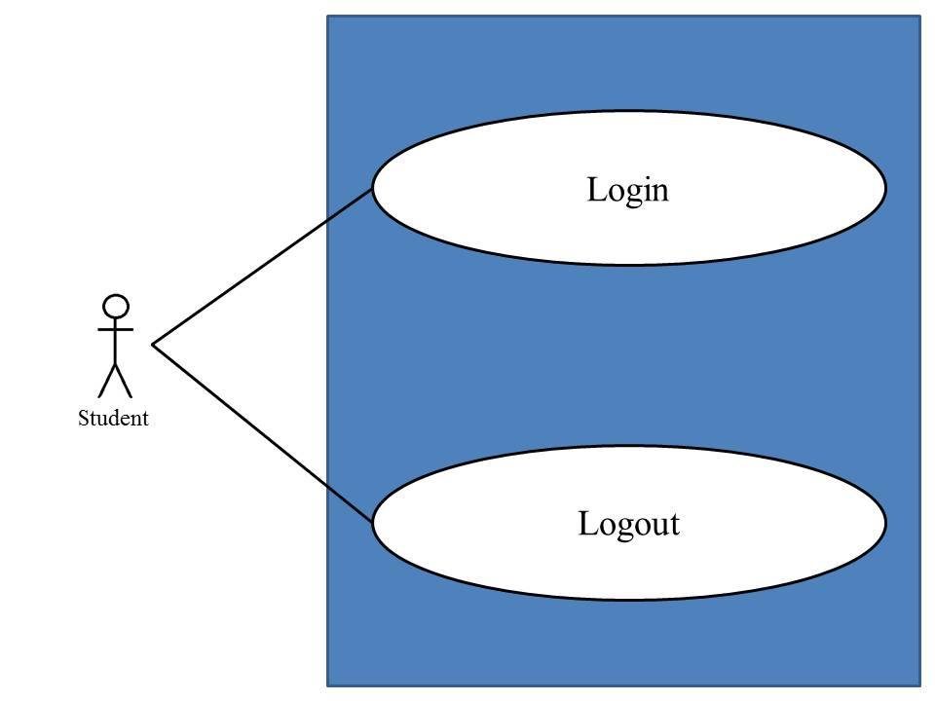
Use Case ID: | UC-07
Use Case Name: | Student Login to the system.
Created By: | Mr.Chaichan Suttee |  | Last Updated By: | Mr.Chaichan Suttee
Date Created: | 10/05/2014 |  | Last Revision Date: | 10/05/2014
Actors: |  | Student
Description: |  | This use case is provided for Lecturer log in to the system on the mobile application.
Trigger: |  | Student click login
Preconditions: |  | Student registered account already.
Post conditions: |  | Student can log in to the system.
Normal Flow: |  | - Student enters the Login page.  - Student provides login information into the web application.  - Student submit login form into the web application.  - The system validate login information from Student.  - The system redirect into the Student main page with Student ID on the top right of the interface.  - to Lecture main page on the mobile application.
Alternative Flows: |  | 4A. if the username and password are not matched, the system will display the error message “Invalid Username and/or Password” to the user.
Exceptions: |  | N/A
Includes: |  | N/A
Frequency of Use: |  | Often
Assumptions: |  | N/A
Notes and Issues: |  | N/A

URS1-7. Student can login to the system.
After the Student account was approved. Student can login to the system by providing username and password.
Actor: Student
Prerequisite: Student must have logged.

Input:
Name | Description | Example | Remarks
student username | Only Alphabet is allowed, within the range of 4-16 Characters | “jenny”
student password | Can be any character within the range of 4-16 characters. | “12345”

Flow of Execution:
- Student enters the Login page.
- Student provides login information into the web application.
- Student submit login form into the web application.
- The system validate login information from Student.
- The system redirect into the Student main page with Student ID on the top right of the interface.

Alternative Flow
4A. if the username and password are not matched, the system will display the error message “Invalid Username and/or Password” to the user.

System Requirement Specification of URS1-7
SRS2-2-2: The system shall redirect to Student main page.
SRS2-7-1: The system shall provide Login interface on the, including username and password for Student login his/her account into the system.
SRS2-7-2: The system shall fetch login information of Student from the system to validate the correctness of login information in Login interface
SRS2-7-3: The system shall display “Invalid Username and/or Password” when username and password are wrong to Student.

URS1-9. Administrator can create a semester.
SRS1-3-1: The system shall redirect to Administrator Main page.
SRS1-9-1: The system shall redirect to semester Main page.
SRS1-9-3: The system shall provide semester interface including “Create semester ,Edit semester ,Delete semester” for Administrator create a semester.
SRS1-9-4: The system shall redirect to crate semester page.
SRS1-9-5: The system shall provide create semester interface including Name of semester and Description .
SRS1-9-6: The system shall store the data in the database table.
SRS1-9-7: The system shall display “Addition Semester Successful” message.

4.7 Administrator Login to system (UC-08) 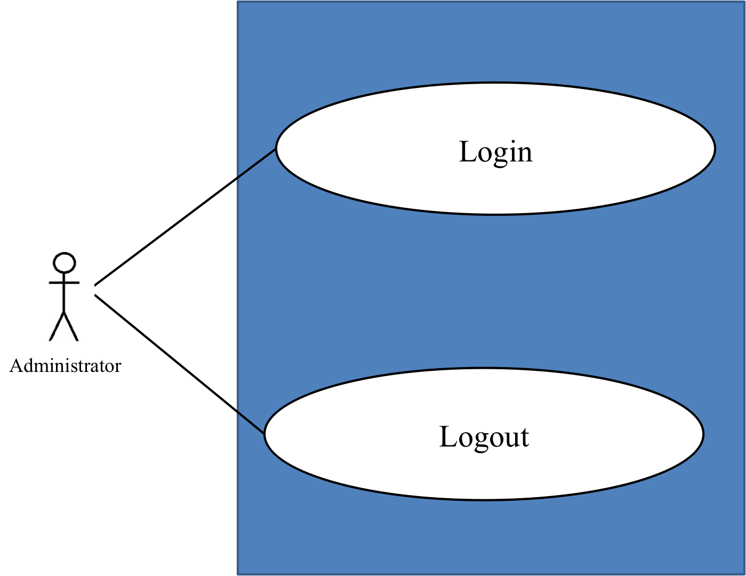
Use Case ID: | UC-07
Use Case Name: | Student Login to the system.
Created By: | Mr.Chaichan Suttee |  | Last Updated By: | Mr.Chaichan Suttee
Date Created: | 10/05/2014 |  | Last Revision Date: | 10/05/2014
Actors: |  | Student
Description: |  | This use case is provided for Administrator log in to the system on the web application.
Trigger: |  | Submit login form
Preconditions: |  | N/A
Post conditions: |  | Administrator can log in to the system.
Normal Flow: |  | - Administrator enters the Login page.  - Administrator provides login information into the web application.  - Administrator submit login form into the web application.  - The system validate login information from Administrator.  - The system redirect into the Administrator main page.
Alternative Flows: |  | 4A. if the username and password are not matched, the system will display the error message “Invalid Username and/or Password” to the user.
Exceptions: |  | N/A
Includes: |  | N/A
Frequency of Use: |  | Often
Assumptions: |  | N/A
Notes and Issues: |  | N/A

URS1-8. Administrator can login to the system.
Administrator can login to the system by providing username and password.
Actor: Administrator
Prerequisite: Administrator must have logged.

Input:
Name | Description | Example | Remarks
administrator username | Only Alphabet is allowed, within the range of 4-16 Characters | “admin”
administrator password | Can be any character within the range of 4-16 characters. | “12345”

Flow of Execution:
- Administrator enters the Login page.
- Administrator provides login information into the web application.
- Administrator submit login form into the web application.
- The system validate login information from Administrator.
- The system redirect into the Administrator main page.

Alternative Flow
4A. if the username and password are not matched, the system will display the error message “Invalid Username and/or Password” to the user.

System Requirement Specification of URS1-8
SRS1-3-1: The system shall redirect to Administrator Main page.
SRS1-8-1: The system shall provide Login interface on the, including username and password for Administrator login his/her account into the system.
SRS1-8-2: The system shall fetch login information of Administrator from the system to validate the correctness of login information in Login interface
SRS1-8-3: The system shall display “Invalid Username and/or Password” when username and password are wrong to Administrator.

4.9 Administrator can create a semester (UC-09)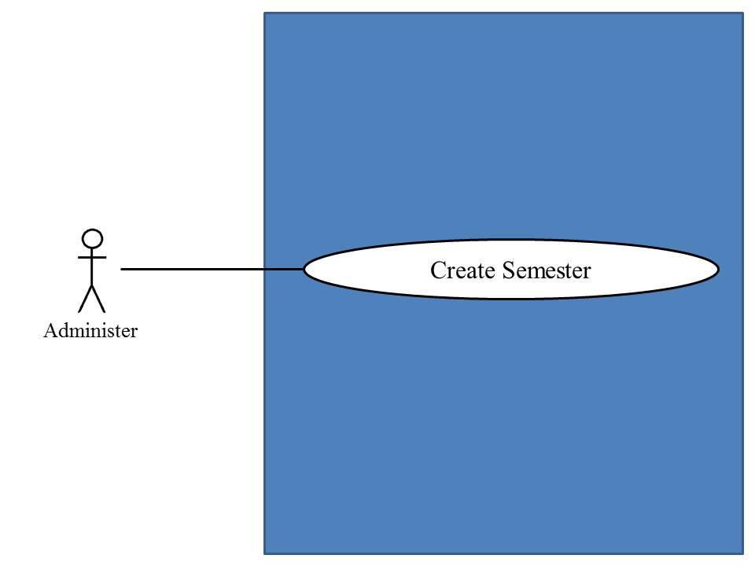
Use Case ID: | UC-09
Use Case Name: | Administrator can create a semester.
Created By: | Mr.Chaichan Suttee |  | Last Updated By: | Mr.Chaichan Suttee
Date Created: | 10/05/2014 |  | Last Revision Date: | 10/05/2014
Actors: |  | Administrator
Description: |  | This use case is provided for Administrator create a semester on the web application.
Trigger: |  | Create a semester
Preconditions: |  | Administrator must logged in
Post conditions: |  | The system display “Addition Semester Successful” message.
Normal Flow: |  | - Administrator enters the Administrator main page.  - Administrator enters the Semester page.  - Administrator submits addition semester academic year form into the web application.  - The system redirects to the Addition semester page.  - Administrator provides semester academic year information into the web application.  - Administrator submits semester academic year information.  - The system validate semester academic year information from Administrator.  - The system display “Addition Semester Successful” message.
Alternative Flows: |  | 5A. if Administrator input semester academic year in the wrong format, the system should provide the error message as followed:  - The wrong semester academic year format: The error message is “Semester academic year must be S/YYYY form. Which S is a semester and YYYY is an academic year”
Exceptions: |  | N/A
Includes: |  | N/A
Frequency of Use: |  | Often
Assumptions: |  | N/A
Notes and Issues: |  | N/A

URS1-9. Administrator can create a semester.
Administrator can create a semester by providing semester academic year information.
Actor: Administrator
Prerequisite: Administrator must have logged.

Input:
Name | Description | Example | Remarks
Semester academic year | Form of semester academic year “S/YYYY”  - S is a semester  - Y is an academic year | “1/2557”

Flow of Execution:
- Administrator enters the Administrator main page.
- Administrator enters the Semester page.
- Administrator submits addition semester academic year form into the web application.
- The system redirects to the Addition semester page.
- Administrator provides semester academic year information into the web application.
- Administrator submits semester academic year information.
- The system validate semester academic year information from Administrator.
- The system display “Addition Semester Successful” message.

Alternative Flow
5A. if Administrator input semester academic year in the wrong format, the system should provide the error message as followed:
  - The wrong semester academic year format: The error message is “Semester academic year must be S/YYYY form. Which S is a semester and YYYY is an academic year”
System Requirement Specification of URS1-9
SRS1-3-1: The system shall redirect to Administrator Main page.
SRS1-9-1: The system shall redirect to semester Main page.
SRS1-9-3: The system shall provide semester interface including “Create semester ,Edit semester ,Delete semester” for Administrator create a semester.
SRS1-9-4: The system shall redirect to crate semester page.
SRS1-9-5: The system shall provide create semester interface including Name of semester and Description .
SRS1-9-6: The system shall store the data in the database table.
SRS1-9-7: The system shall display “Addition Semester Successful” message.

4.10 Administrator can edit a semester (UC-10)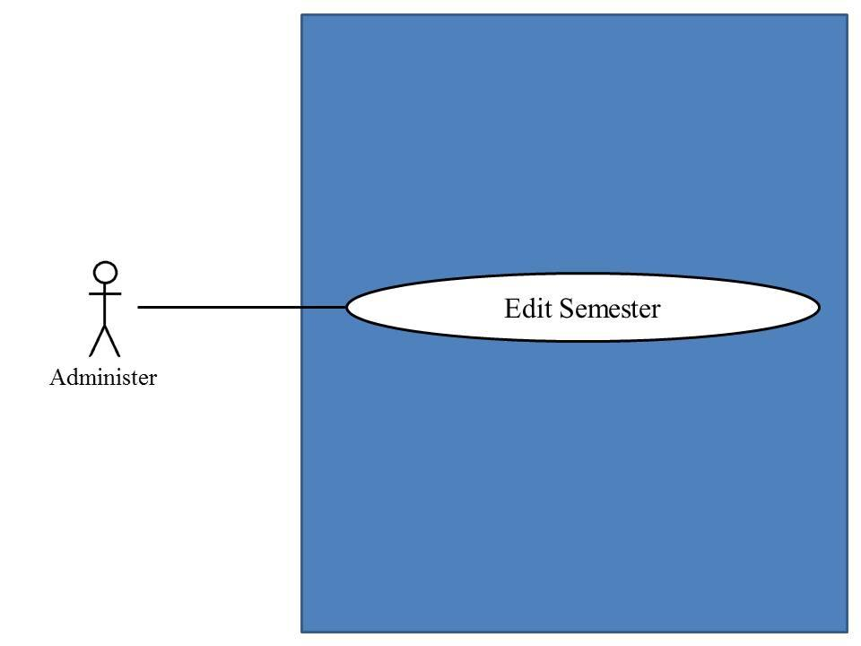

Use Case ID: | UC-10
Use Case Name: | Administrator can edit a semester
Created By: | Mr.Chaichan Suttee |  | Last Updated By: | Mr.Chaichan Suttee
Date Created: | 10/05/2014 |  | Last Revision Date: | 10/05/2014
Actors: |  | Administrator
Description: |  | This use case is provided for Administrator edit a semester on the web application.
Trigger: |  | edit a semester
Preconditions: |  | Administrator must logged in
Post conditions: |  | The system display “Editing Semester Successful” message.
Normal Flow: |  | - Administrator enters the Administrator main page.  - Administrator enters the Semester page.  - Administrator submits edition semester academic year form.  - The system redirects to the Edition semester page.  - Administrator provides semester academic year information into the web application.  - Administrator submits semester academic year into the web application.  - The system validate semester academic year information from Administrator.  - The system display “Editing Semester Successful” message.  - The system redirects to the Semester page.
Alternative Flows: |  | 7A. if Administrator input semester academic year in the wrong format, the system should provide the error message as followed:  - The wrong semester academic year format: The error message is “Semester academic year must be S/YYYY form. Which S is a semester and YYYY is an academic year”
Exceptions: |  | N/A
Includes: |  | N/A
Frequency of Use: |  | Often
Assumptions: |  | N/A
Notes and Issues: |  | N/A

URS1-10. Administrator can edit a semester.
Administrator can edit a semester by providing semester academic year information.
Actor: Administrator
Prerequisite: Administrator must have logged.

Input:
Name | Description | Example | Remarks
Semester academic year | Form of semester academic year “S/YYYY”  - S is a semester  - Y is an academic year | “2/2557”

Flow of Execution:
- Administrator enters the Administrator main page.
- Administrator enters the Semester page.
- Administrator submits edition semester academic year form.
- The system redirects to the Edition semester page.
- Administrator provides semester academic year information into the web application.
- Administrator submits semester academic year into the web application.
- The system validate semester academic year information from Administrator.
- The system display “Editing Semester Successful” message.
- The system redirects to the Semester page.

Alternative Flow
7A. if Administrator input semester academic year in the wrong format, the system should provide the error message as followed:
  - The wrong semester academic year format: The error message is “Semester academic year must be S/YYYY form. Which S is a semester and YYYY is an academic year”
System Requirement Specification of URS1-10
- SRS1-3-1: The system shall redirect to Administrator Main page.
- SRS1-9-1: The system shall redirect to semester Main page.
- SRS1-9-3: The system shall provide semester interface including “Create semester ,Edit semester ,Delete semester” for Administrator create a semester.
- SRS1-10-1: The system shall redirect to edit semester page.
- SRS1-10-2: The system shall provide edit semester interface including Name of semester and Description .
- SRS1-10-3: The system shall update the data in the database table.
- SRS1-10-4: The system display “Editing Semester Successful” message.

4.11 Administrator can delete a semester (UC-11)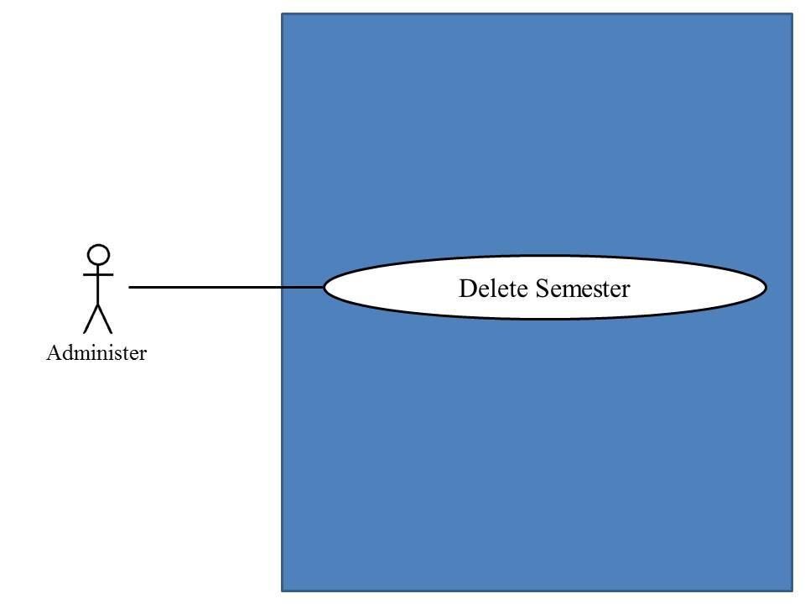

Use Case ID: | UC-11
Use Case Name: | Administrator can delete a semester
Created By: | Mr.Chaichan Suttee |  | Last Updated By: | Mr.Chaichan Suttee
Date Created: | 10/05/2014 |  | Last Revision Date: | 10/05/2014
Actors: |  | Administrator
Description: |  | This use case is provided for Administrator delete a semester on the web application.
Trigger: |  | Administrator click delete a semester
Preconditions: |  | Administrator must logged in
Post conditions: |  | The system display “Deletion Semester Successful” message.
Normal Flow: |  | - Administrator enters the Administrator main page.  - Administrator enters the Semester page.  - Administrator select a semester academic year that want to delete.  - Administrator submits deletion semester academic year form.  - The system redirects to the semester page.  - Administrator delete semester academic year into the web application.  - The system display “Deletion Semester Successful” message.  - The system redirects to the Semester page.
Alternative Flows: |  | N/A
Exceptions: |  | N/A
Includes: |  | N/A
Frequency of Use: |  | Often
Assumptions: |  | N/A
Notes and Issues: |  | N/A

URS1-11. Administrator can delete a semester.
Administrator can delete a semester.
Actor: Administrator
Prerequisite: Administrator must have logged.

Input: None

Flow of Execution:
- Administrator enters the Administrator main page.
- Administrator enters the Semester page.
- Administrator select a semester academic year that want to delete.
- Administrator submits deletion semester academic year form.
- The system redirects to the semester page.
- Administrator delete semester academic year into the web application.
- The system display “Deletion Semester Successful” message.
- The system redirects to the Semester page.

System Requirement Specification of URS1-11

SRS1-3-1: The system shall redirect to Administrator Main page.
SRS1-9-1: The system shall redirect to semester Main page.
SRS1-9-3: The system shall provide semester interface including “Create semester ,Edit semester ,Delete semester” for Administrator create a semester.
SRS1-11-1: The system shall redirect to delete semester page.
SRS1-11-2: The system shall provide delete semester interface including Name of semester ,Description and Delete button .
SRS1-11-3: The system shall update the data in the database table.
SRS1-11-4: The system display “Deletion Semester Successful” message.

4.12 Administrator can create a course (UC-12)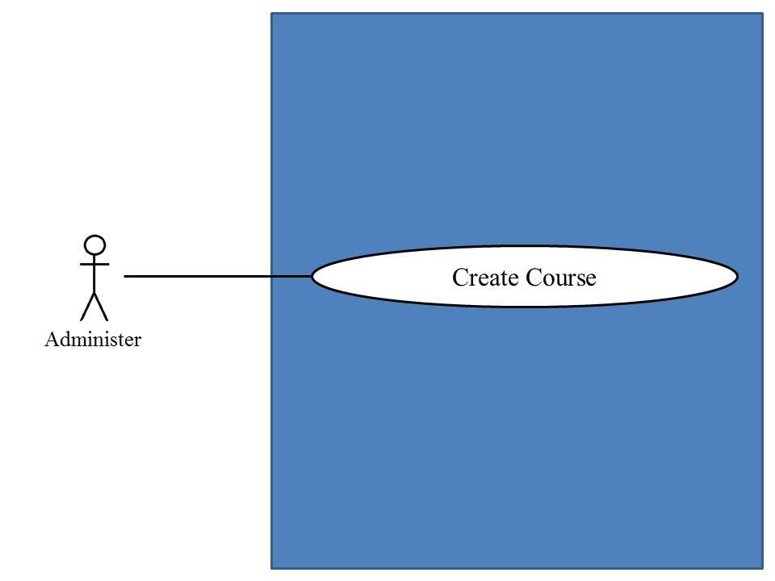
Use Case ID: | UC-12
Use Case Name: | Administrator can create a semester
Created By: | Mr.Chaichan Suttee |  | Last Updated By: | Mr.Chaichan Suttee
Date Created: | 10/05/2014 |  | Last Revision Date: | 10/05/2014
Actors: |  | Administrator
Description: |  | This use case is provided for Administrator create a course on the web application.
Trigger: |  | Administrator click create a semester
Preconditions: |  | Administrator must logged in
Post conditions: |  | The system display “Adding Course Successful” message.
Normal Flow: |  | - Administrator enters the Administrator main page.  - Administrator enters the Course management page.  - Administrator enters the Course Adding page.  - Administrator provides course information into the web application.  - Administrator submit the course information form into the web application.  - The system validate course information from Administrator.  - The system redirects to the Student Adding page.  - Administrator add a list of students to Course.  - Administrator submit a list of student to Course into the web application.  - The system display “Adding Course Successful” message.  - The system redirects to the Course management page.
Alternative Flows: |  | 6A. if Administrator input data in the wrong format, the system should provide the error message as followed:  - The wrong credit format: The error message is “The course credit must be number only”
Exceptions: |  | N/A
Includes: |  | N/A
Frequency of Use: |  | Often
Assumptions: |  | N/A
Notes and Issues: |  | N/A

URS1-12. Administrator can create a course.
Administrator can create a course by providing course name, course credit, course description, lecturer name. Administrator can register a list of students to a course.
Actor: Administrator
Prerequisite: Administrator must have logged.

Input:
Name | Description | Example | Remarks
course name | Can be any character is allowed. | “Computer programming”
course credit | Only number is allowed. | 3
course description | Can be any character is allowed. | Computer programing is a learn process that leads from an original formulation of a computing problem to executable programs.
lecturer name | Administrator select a lecturer name by selecting from the database. | “Dr. Tony Stark’’

Flow of Execution:
- Administrator enters the Administrator main page.
- Administrator enters the Course management page.
- Administrator enters the Course Adding page.
- Administrator provides course information into the web application.
- Administrator submit the course information form into the web application.
- The system validate course information from Administrator.
- The system redirects to the Student Adding page.
- Administrator add a list of students to Course.
- Administrator submit a list of student to Course into the web application.
- The system display “Adding Course Successful” message.
- The system redirects to the Course management page.

Alternative Flow
6A. if Administrator input data in the wrong format, the system should provide the error message as followed:
  - The wrong credit format: The error message is “The course credit must be number only”
System Requirement Specification of URS1-12
SRS1-3-1: The system shall redirect to Administrator Main page.
SRS1-12-1: The system shall redirect to Course Main page.
SRS1-12-2: The system shall provide course interface including “Create course ,Edit course ,Delete course ,Course information” for Administrator.
SRS1-12-4: The system shall redirect to crate course page.
SRS1-12-5: The system shall provide create semester interface including course name, course credit, course description, lecturer name.
SRS1-12-6: The system shall store the data in the database table.
SRS1-12-7: The system shall display “Adding Course Successful” message.

4.13 Administrator can edit a course (UC-13)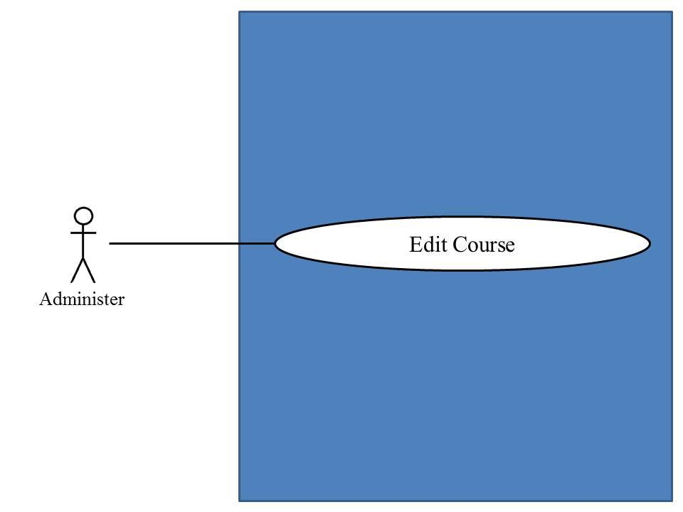

Use Case ID: | UC-12
Use Case Name: | Administrator can edit a semester
Created By: | Mr.Chaichan Suttee |  | Last Updated By: | Mr.Chaichan Suttee
Date Created: | 10/05/2014 |  | Last Revision Date: | 10/05/2014
Actors: |  | Administrator
Description: |  | This use case is provided for Administrator create a semester on the web application.
Trigger: |  | edit a semester
Preconditions: |  | Administrator must logged in
Post conditions: |  | The system display “editing Course Successful” message.
Normal Flow: |  | - Administrator enters the Administrator main page.  - Administrator enters the Course management page.  - Administrator select a course that want to edit.  - Administrator submits editing course form.  - The system redirects to the Course editing page.  - Administrator provides course information into the web application.  - Administrator submits the course information form into the web application.  - The system validate course information from Administrator.  - Administrator submit all information of editing.  - The system display “editing Course Successful” message.  - The system redirects to the Course management page.
Alternative Flows: |  | 8A. if Administrator input data in the wrong format, the system should provide the error message as followed:  - The wrong credit format: The error message is “The course credit must be number only”  6A. Administrator remove students from the course.  - Administrator selects students.  - Administrator submit the remove student form into the web application.  - Flow of execution resumes to step 9.  6B. Administrator adds students to the course.  - Administrator enter adding student page.  - Administrator selects a list of students for adding in the course.  - Administrator submit the add student form into the web application.  - Flow of execution resumes to step 9.
Exceptions: |  | N/A
Includes: |  | N/A
Frequency of Use: |  | Often
Assumptions: |  | N/A
Notes and Issues: |  | N/A

URS1-13. Administrator can edit a course.
Administrator can edit a course by providing course name, course credit, course description, lecturer name. Administrator can add or remove students from a course.
Actor: Administrator
Prerequisite: Administrator must have logged.

Input:
Name | Description | Example | Remarks
course name | Can be any character is allowed. | “Vocabulary in Thai”
course credit | Only number is allowed. | 3
course description | Can be any character is allowed. | Vocabulary in Thai is a learn vocabularies that Thai uses in life every day.
lecturer name | Administrator select a lecturer name by selecting from the database. | “Aj. Linlee”

Flow of Execution:
- Administrator enters the Administrator main page.
- Administrator enters the Course management page.
- Administrator select a course that want to edit.
- Administrator submits editing course form.
- The system redirects to the Course editing page.
- Administrator provides course information into the web application.
- Administrator submits the course information form into the web application.
- The system validate course information from Administrator.
- Administrator submit all information of editing.
- The system display “editing Course Successful” message.
- The system redirects to the Course management page.

Alternative Flow
8A. if Administrator input data in the wrong format, the system should provide the error message as followed:
  - The wrong credit format: The error message is “The course credit must be number only”

6A. Administrator remove students from the course.
- Administrator selects students.
- Administrator submit the remove student form into the web application.
- Flow of execution resumes to step 9.
6B. Administrator adds students to the course.
- Administrator enter adding student page.
- Administrator selects a list of students for adding in the course.
- Administrator submit the add student form into the web application.
- Flow of execution resumes to step 9.

System Requirement Specification of URS1-13

SRS1-3-1: The system shall redirect to Administrator Main page.
SRS1-12-1: The system shall redirect to Course Main page.
SRS1-12-2: The system shall provide course interface including “Create course ,Edit course ,Delete course ,Course information” for Administrator.
SRS1-13-3: The system shall redirect to Edit Course page.
SRS1-13-4: The system shall provide edit semester interface including course name, course credit, course description, lecturer name.
SRS1-13-5: The system shall update the data in the database table.
SRS1-13-6: The system shall display “Editing Course Successful” message.

4.14 Administrator can delete a course (UC-14)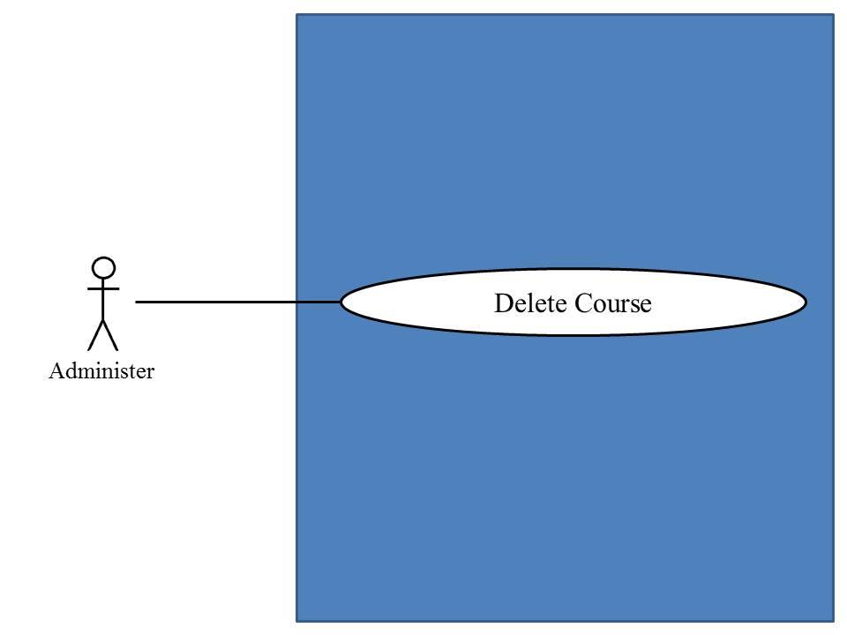
Use Case ID: | UC-14
Use Case Name: | Administrator can delete a course
Created By: | Mr.Chaichan Suttee |  | Last Updated By: | Mr.Chaichan Suttee
Date Created: | 10/05/2014 |  | Last Revision Date: | 10/05/2014
Actors: |  | Administrator
Description: |  | This use case is provided for Administrator create a semester on the web application.
Trigger: |  | Delete a semester
Preconditions: |  | N/A
Post conditions: |  | The semester was deleted
Normal Flow: |  | - Administrator enters the Administrator main page.  - Administrator enters the Course management page.  - Administrator select a course that want to delete.  - Administrator submit deleting course form.  - The system display “Deleting Course Successful” message.
Alternative Flows: |  | N/A
Exceptions: |  | N/A
Includes: |  | N/A
Frequency of Use: |  | Often
Assumptions: |  | N/A
Notes and Issues: |  | N/A

URS1-14. Administrator can delete a course.
Administrator can delete a course.
Actor: Administrator
Prerequisite: Administrator must have logged.

Input: None

Flow of Execution:
- Administrator enters the Administrator main page.
- Administrator enters the Course management page.
- Administrator select a course that want to delete.
- Administrator submit deleting course form.
- The system display “Deleting Course Successful” message.

System Requirement Specification of URS1-14

URS1-14. Administrator can delete a course.
SRS1-3-1: The system shall redirect to Administrator Main page.
SRS1-12-1: The system shall redirect to Course Main page.
SRS1-12-2: The system shall provide course interface including “Create course ,Edit course ,Delete course, course information” for Administrator.
SRS1-14-3: The system shall redirect to Delete Course page.
SRS1-14-4: The system shall provide delete semester interface including course name, course credit, course description, lecturer name and delete button.
SRS1-14-5: The system shall update the data in the database table.
SRS1-14-6: The system shall display “Deleting Course Successful” message.

4.15 Administrator can view a course (UC-15)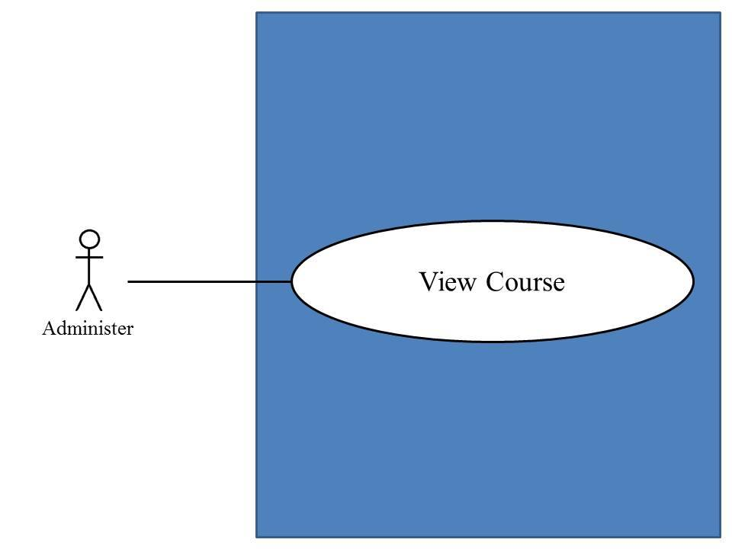
Use Case ID: | UC-15
Use Case Name: | Administrator view course
Created By: | Mr.Chaichan Suttee |  | Last Updated By: | Mr.Chaichan Suttee
Date Created: | 10/05/2014 |  | Last Revision Date: | 10/05/2014
Actors: |  | Administrator
Description: |  | This use case is provided for Administrator view course on the web application.
Trigger: |  | View course
Preconditions: |  | Administrator must logged in to system
Post conditions: |  | System display course information
Normal Flow: |  | - Administrator enters the Administrator main page.  - Administrator enters the Course management page.  - The system provides all course name.  - Administrator selects a course that want to view.  - Administrator submits viewing course form.  - The system redirects to the Course information page.  - The system provides a course information into the web application which are course name, credit, description, lecturer name, a list of students in the course.
Alternative Flows: |  | N/A
Exceptions: |  | N/A
Includes: |  | N/A
Frequency of Use: |  | Often
Assumptions: |  | N/A
Notes and Issues: |  | N/A

URS1-15. Administrator can view courses information.
Administrator can view a course information.
Actor: Administrator
Prerequisite: Administrator must have logged.

Input: None

Flow of Execution:
- Administrator enters the Administrator main page.
- Administrator enters the Course management page.
- The system provides all course name.
- Administrator selects a course that want to view.
- Administrator submits viewing course form.
- The system redirects to the Course information page.
- The system provides a course information into the web application which are course name, credit, description, lecturer name, a list of students in the course.

System Requirement Specification of URS1-15
SRS1-3-1: The system shall redirect to Administrator Main page.
SRS1-12-1: The system shall redirect to Course Main page.
SRS1-12-2: The system shall provide course interface including “Create course ,Edit course ,Delete course, course information” for Administrator.
SRS1-15-1: The system shall redirect to Course Information page.
SRS2-15-4: The system shall redirect to Course information page interface, including course name, course credit, course description, lecturer name, a list of students in the course.
SRS2-15-5: The system shall fetch the course information from the system to display into Course information page.

4.16 Lecturer can view a course (UC-16)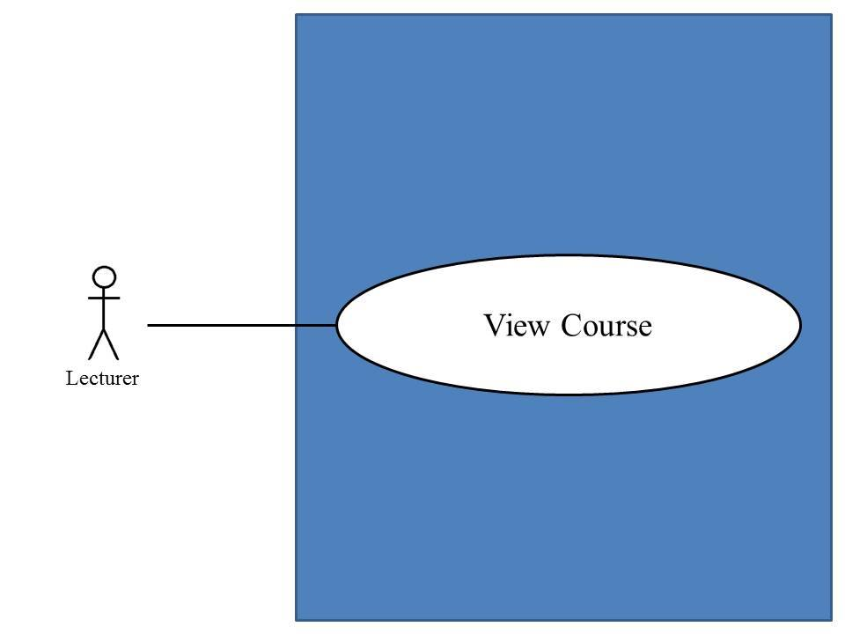
Use Case ID: | UC-16
Use Case Name: | Lecturer can view course
Created By: | Mr.Chaichan Suttee |  | Last Updated By: | Mr.Chaichan Suttee
Date Created: | 10/05/2014 |  | Last Revision Date: | 10/05/2014
Actors: |  | Lecturer
Description: |  | This use case is provided for Lecturer view course on the web application.
Trigger: |  | Lecturer click view course
Preconditions: |  | Lecturer must logged in to system
Post conditions: |  | System display course information
Normal Flow: |  | - Lecturer enters the Lecturer main page.  - Lecturer enters the Course management page.  - The system provides all courses name which were taught by Lecturer.  - Lecturer selects a course that want to view.  - Lecturer submits viewing course form.  - The system redirects to the Course main page.  - Lecturer submits viewing course information form.  - The system provides a course information into the web application which are course name, credit, description, lecturer name, a list of students in the course.
Alternative Flows: |  | N/A
Exceptions: |  | N/A
Includes: |  | N/A
Frequency of Use: |  | Often
Assumptions: |  | N/A
Notes and Issues: |  | N/A

URS1-16. Lecturer can view courses information.
Lecturer can view a course information into the web application.
Actor: Lecturer
Prerequisite: Lecturer must have logged.

Input: None

Flow of Execution:
- Lecturer enters the Lecturer main page.
- Lecturer enters the Course management page.
- The system provides all courses name which were taught by Lecturer.
- Lecturer selects a course that want to view.
- Lecturer submits viewing course form.
- The system redirects to the Course main page.
- Lecturer submits viewing course information form.
- The system provides a course information into the web application which are course name, credit, description, lecturer name, a list of students in the course.
System Requirement Specification of URS1-16

SRS16-1.1: The system shall redirect to Course management page.
SRS16-2.1: The system shall provide all courses name in Course management page which were taught by finding from lecturer ID.
SRS16-3.1: The system shall redirect to Course main page.
SRS16-4.1: The system shall redirect to Course information page interface, including course name, course credit, course description, lecturer name, a list of students in the course.
SRS15-5.1: The system shall fetch the course information from the system to display into Course information page.

4.17 Student can view a course (UC-17)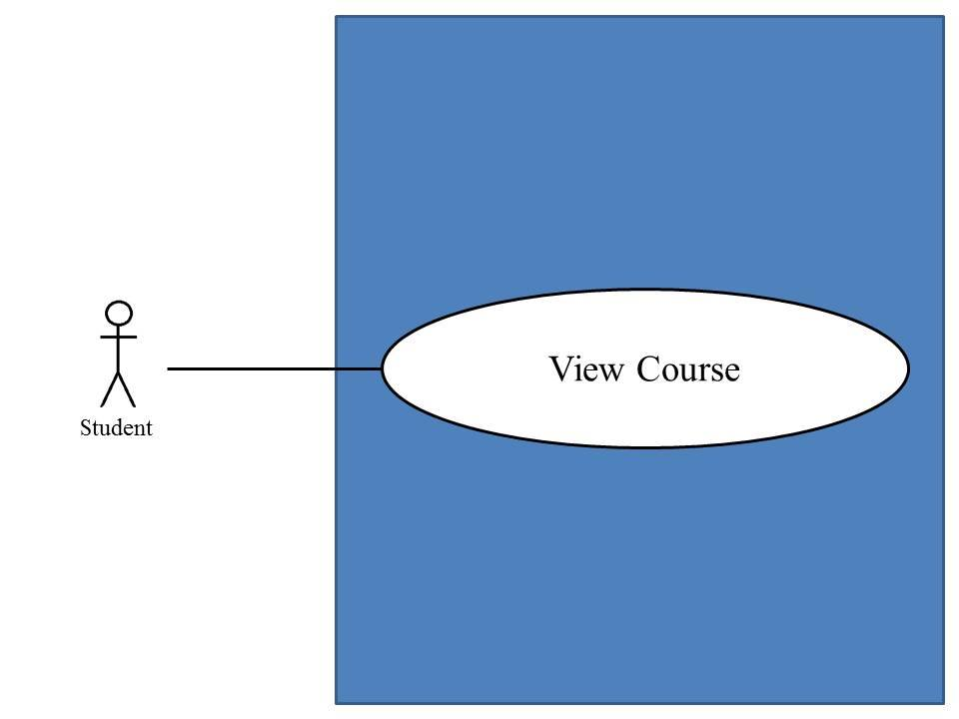
Use Case ID: | UC-15
Use Case Name: | Student can view course
Created By: | Mr.Chaichan Suttee |  | Last Updated By: | Mr.Chaichan Suttee
Date Created: | 10/05/2014 |  | Last Revision Date: | 10/05/2014
Actors: |  | Student
Description: |  | This use case is provided for Lecturer view course on the web application.
Trigger: |  | Student click view course
Preconditions: |  | Student must logged in to system
Post conditions: |  | System display course information
Normal Flow: |  | - Student enters the Student main page.  - Student enters the Course main page.  - The system provides all courses name which were studied by Student.  - Student selects a course that want to view.  - Student submits viewing course form.  - The system redirects to the Course information page.  - The system provides a course information into the web application which are course name, credit, description, lecturer name, a list of students in the course.
Alternative Flows: |  | N/A
Exceptions: |  | N/A
Includes: |  | N/A
Frequency of Use: |  | Often
Assumptions: |  | N/A
Notes and Issues: |  | N/A

URS1-17. Student can view courses information.
Student can view a course information into the web application.
Actor: Student
Prerequisite: Student must have logged.

Input: None

Flow of Execution:
- Student enters the Student main page.
- Student enters the Course main page.
- The system provides all courses name which were studied by Student.
- Student selects a course that want to view.
- Student submits viewing course form.
- The system redirects to the Course information page.
- The system provides a course information into the web application which are course name, credit, description, lecturer name, a list of students in the course.
System Requirement Specification of URS1-17

SRS2-2.1: The system shall redirect to Student main page.
SRS16-4.1: The system shall redirects to Course information page interface, including course name, course credit, course description, lecturer name, a list of students in the course.
SRS16-5.1: The system shall fetch the course information from the system to display into Course information page
SRS17-1.1: The system shall redirect to Overall course page.
SRS17-2.1: The system shall provide all courses name in Overall course page on the which were studied by finding from student ID.
SRS17-3.1: The system shall redirects to Course main page for Student.

4.18)Lecturer assigns assignments or quizzes. (UC-18)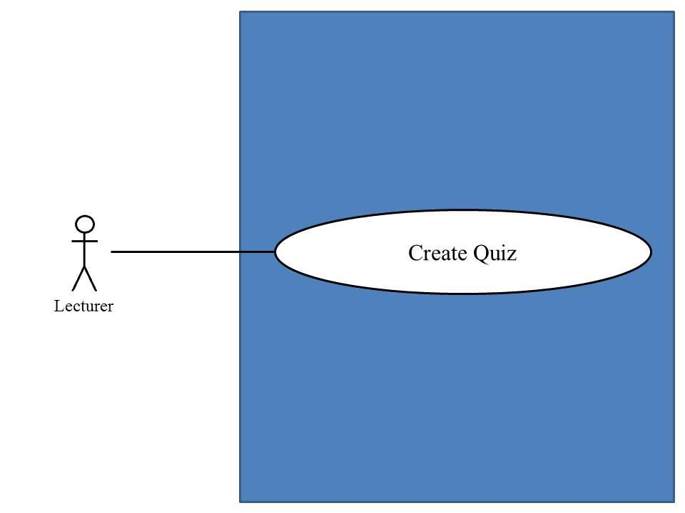
Use Case ID: | UC-18
Use Case Name: | Lecturer assigns assignments or quizzes.
Created By: | Mr.Chaichan suttee |  | Last Updated By: | Mr.Chaichan suttee
Date Created: | 10/05/2014 |  | Last Revision Date: | 10/05/2014
Actors: |  | Lecturer
Description: |  | This use case is provided for Lecturer assigns assignments or quizzes on the mobile application.
Trigger: |  | Lecturer click create quiz.
Preconditions: |  | Lecturer log in to the system already.
Post conditions: |  | The system display “Creating Assignment Successful” message.
Normal Flow: |  | - Lecturer enters the Lecturer main page.  - Lecturer enters the Course management page.  - The system provides all courses name which were taught by Lecturer.  - Lecturer selects a course that want to view.  - Lecturer submits viewing course form.  - The system redirects to the Course main page.  - Lecturer submits overall testing form.  - The system redirects to the overall testing page.  - Lecturer submits adding testing form.  - The system redirects to the testing management page.  - Lecturer provides type of testing, an amount of questions, student name, randomize order of the question status, and posting status into the testing page.  - Lecturer submits testing information into web application.  - The system validates testing information from Lecturer.  - The system redirects to the assigning assignment and quiz page.  - Lecturer provides type of question (Multiple choices), question description, choice description, and an answer.  - Lecturer submits assignment or quiz information into web application.  - The system validates testing information from Lecturer.  - The system redirects to the assigning assignment and quiz in a next page until last page. Flow of execution resumes to step 13  - The system redirects to the overview testing page.  - Lecturer submit creating testing form.  - The system display “Creating Assignment Successful” message.  - The system redirects to the Course main page.
Alternative Flows: |  | 13A. if Lecturer input data in the wrong format, the system should provide the error message as followed:  - The wrong amount of questions format: The error message is “Amount of questions must be number only”  15A. Lecturer provides type of question is true/false question.  - Lecturer provides question description, choice description, and an answer.  - Lecturer submits assignment or quiz information into web application.  - The system validates testing information from Lecturer.  - Flow of execution resumes to step 16.  15B. Lecturer provides type of question is short answer.  - Lecturer provides question description.  - Lecturer submits assignment or quiz information into web application.  - The system validates testing information from Lecturer.  - Flow of execution resumes to step 16.  13A 3A. if Lecturer input data in the wrong format, the system should provide the error message as followed:  - The wrong answer format: The error message is “Answer must be a, b, c, and d only”  17A if Lecturer input data in the wrong format in multiple choices question the system should provide the error message as followed:  - The wrong answer format: The error message is “Answer must be a, b, c, and d only”  21A if Lecturer creates a quiz is completed, the system should provide the Successful massage as followed:  - The system display “Creating Quiz Successful” message.  24B when the true/false answer format is wrong. The system provides the error message as followed:  1. The system displays “Answer must be a and b only” on the mobile application.  2. Use Case resumes on step 22 of normal flow.  24C when the question point format is wrong. The system provides the error message as followed:  1. The system displays “Question point must be number only” on the mobile application.  2. Use Case resumes on step 16 of normal flow  29A if Lecturer assigns quizzes, the system provides the error message as followed:  1. The system displays “Creating Quiz Successful” message on the mobile application
Exceptions: |  | N/A
Includes: |  | N/A
Frequency of Use: |  | Often
Assumptions: |  | N/A
Notes and Issues: |  | N/A

URS1-18. Lecturer can assign assignments or quizzes which are multiple choices question, true/false question, and short answers.
Lecturer can assign assignments or quizzes into the web application. Lecturer can limit access to the assignment or quiz of authority. Lecturer must provide type of testing, an amount of questions, type of question, question information, student name, randomize order of the question status, and posting status.
Lecturer must provide question information by separating from type of questions.
- Lecturer can assign multiple choices questions which provide type of question, question description, choice description, and an answer.
- Lecturer can assign true/false questions which provide type of question, questions description, choice description, and an answer.
- Lecturer can assign short answers which provide type of question, questions description.
Actor: Lecturer
Prerequisite: Lecturer must have logged.

Input:
Name | Description | Example | Remarks
type of testing | The system provides two types of testing which are assignment and quiz. Lecturer must select one type only. | Assignment
amount of question | Only number is allowed. | 3
student name | Lecturer adds a list of students for limiting access to the assignment or quiz. | 542115099,  542115091
randomize order of the question status | This status is showing status of random order of the question to student. | random
Posting status | Status is an available and not available. | available

Multiple choices question

Name | Description | Example | Remarks
type of question | The system provides three types of question which are multiple choices, true/false question, and short answer. Lecturer must select one type only. | Multiple choices
question description | Can be any character is allowed. | What is an answer of 1+1?
choice description | Choices must have four choices. Can be any character is allowed. | a. 2  b. 1  c. 3  d. 5
answer | Only “a, b, c, d” is allowed. | a

True/false question

Name | Description | Example | Remarks
type of question | The system provides three types of question which are multiple choices, true/false question, and short answer. Lecturer must select one type only. | True/false question
question description | Can be any character is allowed. | Answer of 1+1 is 2.
choice description | Choices must have two choices. Can be true and false is allowed. | a. false  b. true
answer | Only “a, b, c, d” is allowed. | b

Short answer

Name | Description | Example | Remarks
type of question | The system provides three types of question which are multiple choices, true/false question, and short answer. Lecturer must select one type only. | Short answer
question description | Can be any character is allowed. | What is an answer of 1+1? You must explain how to find the answer.

Flow of Execution:
- Lecturer enters the Lecturer main page.
- Lecturer enters the Course management page.
- The system provides all courses name which were taught by Lecturer.
- Lecturer selects a course that want to view.
- Lecturer submits viewing course form.
- The system redirects to the Course main page.
- Lecturer submits overall testing form.
- The system redirects to the overall testing page.
- Lecturer submits adding testing form.
- The system redirects to the testing management page.
- Lecturer provides type of testing, an amount of questions, student name, randomize order of the question status, and posting status into the testing page.
- Lecturer submits testing information into web application.
- The system validates testing information from Lecturer.
- The system redirects to the assigning assignment and quiz page.
- Lecturer provides type of question (Multiple choices), question description, choice description, and an answer.
- Lecturer submits assignment or quiz information into web application.
- The system validates testing information from Lecturer.
- The system redirects to the assigning assignment and quiz in a next page until last page. Flow of execution resumes to step 13
- The system redirects to the overview testing page.
- Lecturer submit creating testing form.
- The system display “Creating Assignment Successful” message.
- The system redirects to the Course main page.

Alternative Flow:
13A. if Lecturer input data in the wrong format, the system should provide the error message as followed:
  - The wrong amount of questions format: The error message is “Amount of questions must be number only”

15A. Lecturer provides type of question is true/false question.
- Lecturer provides question description, choice description, and an answer.
- Lecturer submits assignment or quiz information into web application.
- The system validates testing information from Lecturer.
- Flow of execution resumes to step 16.

15B. Lecturer provides type of question is short answer.
- Lecturer provides question description.
- Lecturer submits assignment or quiz information into web application.
- The system validates testing information from Lecturer.
- Flow of execution resumes to step 16.

13A 3A. if Lecturer input data in the wrong format, the system should provide the error message as followed:
    - The wrong answer format: The error message is “Answer must be a, b, c, and d only”

17A if Lecturer input data in the wrong format in multiple choices question the system should provide the error message as followed:
  - The wrong answer format: The error message is “Answer must be a, b, c, and d only”

21A if Lecturer creates a quiz is completed, the system should provide the Successful massage as followed:
  - The system display “Creating Quiz Successful” message.

System Requirement Specification of URS1-18

SRS1-2.1: The system shall redirect to Lecture main page.
SRS16-1.1: The system shall redirect to Course management page.
SRS16-2.1: The system shall provide all courses name in Course management page which were taught by finding from lecturer ID.
SRS16-3.1: The system shall redirect to Course main page.
SRS18-1.1: The system shall redirect to Overall testing page.
SRS18-2.1: The system shall redirect to Addition testing page.
SRS18-3.1: The system shall provide Addition testing page interface, including testing name, a type of testing, an amount of questions, a testing score student name, randomize order of the question status, and posting status for Lecturer adds an assignment or quiz into the system.
SRS18-4.1: The system shall validate testing information from Lecturer.
SRS18-5.1: The system shall redirect to Assigning assignment and quiz page.
SRS18-6.1: The system shall provide Assign assignment and quiz page interface, including a type of question, question description, choice description, an answer, and a question point for Lecturer assigns assignments or quizzes into the system.
SRS18-7.1: The system shall validate assignment or quiz information from Lecturer.
SRS18-8.1: The system shall store the testing information from Lecturer into the system.
SRS18-9.1: The system shall store assignment or quiz information from Lecturer into the system.
SRS18-10.1: The system shall display “Amount of questions must be number only” message when the amount of questions format is wrong.
SRS18-11.1: The system shall display “Answer must be a, b, c, and d only” message when the multiple choices answer format is wrong.
SRS18-12.1: The system shall display “Answer must be a and b only” message when the true/false answer format is wrong.
SRS18-13.1: The system shall display “Testing score must be number only” message when the testing score format is wrong.
SRS18-14.1: The system shall display “Question point must be number only” message when the question point format is wrong.
SRS18-15.1: The system shall display “Creating Assignment Successful” message when Lecturer assign an assignment is successful.
SRS18-16.1: The system shall display “Creating Quiz Successful” message when Lecturer assign a quiz is successful.
SRS18-17.1: The system shall redirect to confirm creating testing page.

4.19)Lecturer can edit assignments or quizzes. (UC-19)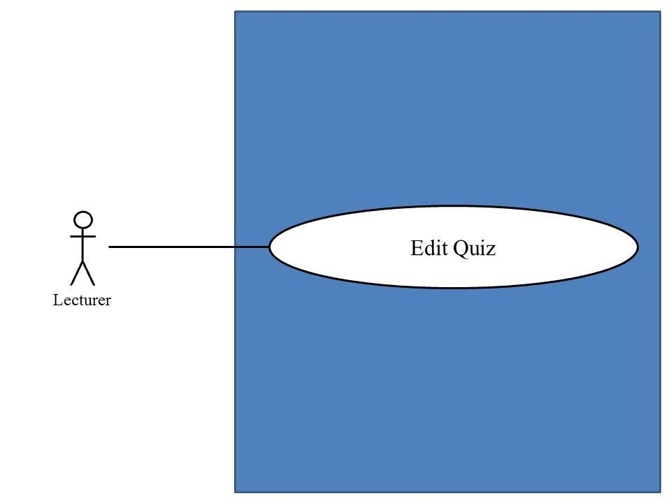
Use Case ID: | UC-19
Use Case Name: | Lecturer edits assignments or quizzes.
Created By: | Mr.Chaichan Suttee |  | Last Updated By: | Mr.Chaichan Suttee
Date Created: | 10/05/2014 |  | Last Revision Date: | 10/05/2014
Actors: |  | Lecturer
Description: |  | This use case is provided for Lecturer edits assignments or quizzes on the mobile application.
Trigger: |  | Lecturer click edit quiz.
Preconditions: |  | Lecturer log in to the system already.
Post conditions: |  | The system display “Editing Assignment Successful” message.
Normal Flow: |  | - Lecturer enters the Lecturer main page.  - Lecturer enters the Course management page.  - The system provides all courses name which were taught by Lecturer.  - Lecturer selects a course that want to view.  - Lecturer submits viewing course form.  - The system redirects to the Course main page.  - Lecturer submits overall testing form.  - The system redirects to the overall testing page.  - Lecturer select a testing that want to edit.  - Lecturer submits editing testing form.  - Lecturer provides type of testing, an amount of questions, student name, randomize order of the question status, and posting status into the testing page.  - Lecturer submits testing information into web application.  - The system validates testing information from Lecturer.  - The system redirects to the assigning assignment and quiz page.  - Lecturer provides type of question (Multiple choices), question description, choice description, and an answer.  - Lecturer submits assignment or quiz information into web application.  - The system validates testing information from Lecturer.  - The system redirects to the assigning assignment and quiz in a next page until last page. Flow of execution resumes to step 15  - The system redirects to the overview testing page.  - Lecturer submit editing testing form.  - The system display “Editing Assignment Successful” message.  - The system redirects to the Course main page.
Alternative Flows: |  | 13A. if Lecturer input data in the wrong format, the system should provide the error message as followed:  - The wrong amount of questions format: The error message is “Amount of questions must be number only”  15A. Lecturer provides type of question is true/false question.  - Lecturer provides question description, choice description, and an answer.  - Lecturer submits assignment or quiz information into web application.  - The system validates testing information from Lecturer.  - Flow of execution resumes to step 16.  15B. Lecturer provides type of question is short answer.  - Lecturer provides question description.  - Lecturer submits assignment or quiz information into web application.  - The system validates testing information from Lecturer.  - Flow of execution resumes to step 16.  15A 3A. if Lecturer input data in the wrong format, the system should provide the error message as followed:  - The wrong answer format: The error message is “Answer must be a, b, c, and d only”  17A if Lecturer input data in the wrong format in multiple choices question the system should provide the error message as followed:  - The wrong answer format: The error message is “Answer must be a, b, c, and d only”  21A if Lecturer edits a quiz is completed, the system should provide the Successful massage as followed:  - The system display “Editing Quiz Successful” message.
Exceptions: |  | N/A
Includes: |  | N/A
Frequency of Use: |  | Often
Assumptions: |  | N/A
Notes and Issues: |  | N/A

URS1-19. Lecturer can edit assignments or quizzes information which are multiple choices question, true/false question, and short answers.
Lecturer can edit assignments or quizzes information into the web application. Lecturer can limit access to the assignment or quiz of authority. Lecturer must provide type of testing, an amount of questions, type of question, question information, student name, randomize order of the question status, and posting status.
Lecturer must provide question information by separating from type of questions.
- Lecturer can edit multiple choices questions which provide type of question, question description, choice description, and an answer.
- Lecturer can edit true/false questions which provide type of question, questions description, choice description, and an answer.
- Lecturer can edit short answers which provide type of question, questions description.
Actor: Lecturer
Prerequisite: Lecturer must have logged.

Input:
Name | Description | Example | Remarks
type of testing | The system provides two types of testing which are assignment and quiz. Lecturer must select one type only. | Assignment
amount of question | Only number is allowed. | 3
student name | Lecturer adds a list of students for limiting access to the assignment or quiz. | 542115099,  542115091,  542115092
randomize order of the question status | This status is showing status of random order of the question to student. | random
Posting status | Status is an available and not available. | Available

Multiple choices question

Name | Description | Example | Remarks
type of question | The system provides three types of question which are multiple choices, true/false question, and short answer. Lecturer must select one type only. | Multiple choices
question description | Can be any character is allowed. | What is an answer of 1+1?
choice description | Choices must have four choices. Can be any character is allowed. | a. 2  b. 1  c. 3  d. 5
answer | Only “a, b, c, d” is allowed. | a

True/false question

Name | Description | Example | Remarks
type of question | The system provides three types of question which are multiple choices, true/false question, and short answer. Lecturer must select one type only. | True/false question
question description | Can be any character is allowed. | Answer of 1+1 is 2.
choice description | Choices must have two choices. Can be true and false is allowed. | a. false  b. true
answer | Only “a, b, c, d” is allowed. | b

Short answer

Name | Description | Example | Remarks
type of question | The system provides three types of question which are multiple choices, true/false question, and short answer. Lecturer must select one type only. | Short answer
question description | Can be any character is allowed. | What is an answer of 1+1? You must explain how to find the answer.

Flow of Execution:
- Lecturer enters the Lecturer main page.
- Lecturer enters the Course management page.
- The system provides all courses name which were taught by Lecturer.
- Lecturer selects a course that want to view.
- Lecturer submits viewing course form.
- The system redirects to the Course main page.
- Lecturer submits overall testing form.
- The system redirects to the overall testing page.
- Lecturer select a testing that want to edit.
- Lecturer submits editing testing form.
- Lecturer provides type of testing, an amount of questions, student name, randomize order of the question status, and posting status into the testing page.
- Lecturer submits testing information into web application.
- The system validates testing information from Lecturer.
- The system redirects to the assigning assignment and quiz page.
- Lecturer provides type of question (Multiple choices), question description, choice description, and an answer.
- Lecturer submits assignment or quiz information into web application.
- The system validates testing information from Lecturer.
- The system redirects to the assigning assignment and quiz in a next page until last page. Flow of execution resumes to step 15
- The system redirects to the overview testing page.
- Lecturer submit editing testing form.
- The system display “Editing Assignment Successful” message.
- The system redirects to the Course main page.

Alternative Flow:
13A. if Lecturer input data in the wrong format, the system should provide the error message as followed:
  - The wrong amount of questions format: The error message is “Amount of questions must be number only”

15A. Lecturer provides type of question is true/false question.
- Lecturer provides question description, choice description, and an answer.
- Lecturer submits assignment or quiz information into web application.
- The system validates testing information from Lecturer.
- Flow of execution resumes to step 16.

15B. Lecturer provides type of question is short answer.
- Lecturer provides question description.
- Lecturer submits assignment or quiz information into web application.
- The system validates testing information from Lecturer.
- Flow of execution resumes to step 16.

15A 3A. If lecturer input data in the wrong format, the system should provide the error message as followed:
    - The wrong answer format: The error message is “Answer must be a, b, c, and d only”

17A if Lecturer input data in the wrong format in multiple choices question the system should provide the error message as followed:
  - The wrong answer format: The error message is “Answer must be a, b, c, and d only”
21A if Lecturer edits a quiz is completed, the system should provide the Successful massage as followed:
  - The system display “Editing Quiz Successful” message.

System Requirement Specification of URS1-19
SRS1-2.1: The system shall redirect to Lecture main page.
SRS16-1.1: The system shall redirect to Course management page.
SRS16-2.1: The system shall provide all courses name in Course management which were taught by finding from lecturer ID.
SRS16-3.1: The system shall redirect to Course main page.
SRS18-1.1: The system shall redirect to Overall testing page.
SRS18-4.1: The system shall validate testing information from Lecturer.
SRS18-7.1: The system shall validate assignment or quiz information from Lecturer.
SRS18-10.1: The system shall display “Amount of questions must be number only” message when the amount of questions format is wrong.
SRS18-11.1: The system shall display “Answer must be a, b, c, and d only” message when the multiple choices answer format is wrong.
SRS18-12.1: The system shall display “Answer must be a and b only” message when the true/false answer format is wrong.
SRS18-13.1: The system shall display “Testing score must be number only” message when the testing score format is wrong.
SRS18-14.1: The system shall display “Question point must be number only” message when the question point format is wrong.
SRS19-1.1: The system shall redirect to Edition testing page.
SRS19-2.1: The system shall redirects to Edition assignment and quiz page.
SRS19-3.1: The system shall fetch the testing information from the system to display on Edition testing page.
SRS19-4.1: The system shall fetch the assignment or quiz information from the system to display on Edition assignment and quiz page.
SRS19-5.1: The system shall provide Edition testing page interface including testing name, a type of testing, an amount of questions, a score testing, student name, randomize order of the question status, and posting status for Lecturer adds an assignment or quiz into the system.
SRS19-6.1: The system shall provide Edition assignment and quiz page interface on the, including a type of question, question description, choice description, an answer, and a question point for Lecturer assigns assignments or quizzes into the system.
SRS19-7.1: The system shall update the testing information from Lecturer into the system.
SRS19-8.1: The system shall update assignment or quiz information from Lecturer into the system.
SRS19-9.1: The system shall display “Editing Assignment Successful” message when Lecturer edits an assignment is successful.
SRS19-10.1: The system shall display “Editing Quiz Successful” message when Lecturer edits a quiz is successful.
SRS19-11.1: The system shall redirect to confirm edition testing page.

4.20 Lecturer can delete assignments or quizzes.(UC-20)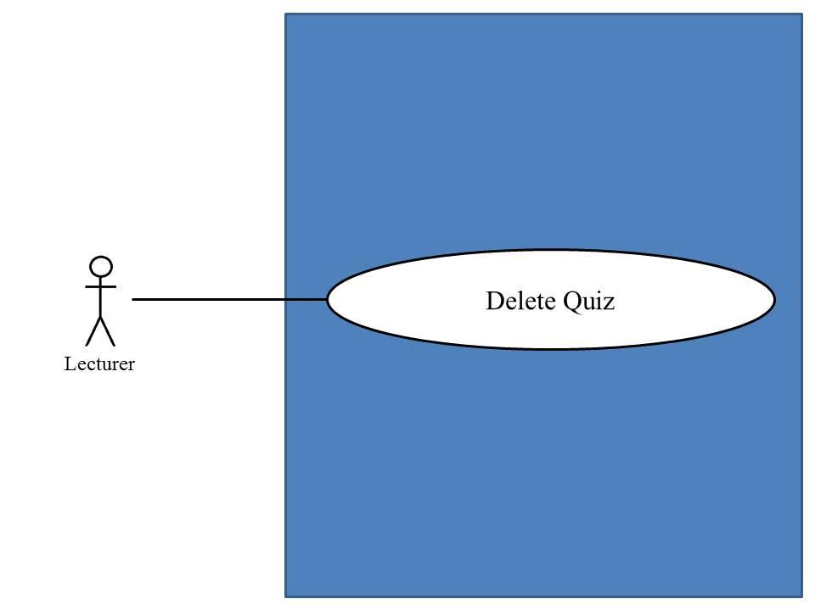

Use Case ID: | UC-20
Use Case Name: | Lecturer delete assignments or quizzes.
Created By: | Mr.Chaichan Suttee |  | Last Updated By: | Mr.Chaichan Suttee
Date Created: | 10/05/2014 |  | Last Revision Date: | 10/05/2014
Actors: |  | Lecturer
Description: |  | This use case is provided for Lecturer deletes assignments or quizzes on the mobile application.
Trigger: |  | Lecturer deleting quiz.
Preconditions: |  | Lecturer log in to the system already.
Post conditions: |  | The system display “Deleting Assignment Successful” message.
Normal Flow: |  | - Lecturer enters the Lecturer main page.  - Lecturer enters the Course management page.  - The system provides all courses name which were taught by Lecturer.  - Lecturer selects a course that want to view.  - Lecturer submits viewing course form.  - The system redirects to the Course main page.  - Lecturer submits overall testing form.  - The system redirects to the overall testing page.  - Lecturer select a testing that want to delete.  - Lecturer submits deleting testing form.  - The system display “Deleting Assignment Successful” message.  - The system redirects to the overall testing page.
Alternative Flows: |  | N/A
Exceptions: |  | N/A
Includes: |  | N/A
Frequency of Use: |  | Often
Assumptions: |  | N/A
Notes and Issues: |  | N/A

URS1-20. Lecturer can delete assignments or quizzes which are multiple choices question, true/false question, and short answers.
Lecturer can delete assignments or quizzes into the web application.

Actor: Lecturer
Prerequisite: Lecturer must have logged.

Input: None

Flow of Execution:
- Lecturer enters the Lecturer main page.
- Lecturer enters the Course management page.
- The system provides all courses name which were taught by Lecturer.
- Lecturer selects a course that want to view.
- Lecturer submits viewing course form.
- The system redirects to the Course main page.
- Lecturer submits overall testing form.
- The system redirects to the overall testing page.
- Lecturer select a testing that want to delete.
- Lecturer submits deleting testing form.
- The system display “Deleting Assignment Successful” message.
- The system redirects to the overall testing page.

System Requirement Specification of URS1-20
SRS1-2.1: The system shall redirect to Lecture main page.
SRS16-1.1: The system shall redirect to Course management page.
SRS16-2.1: The system shall provide all courses name in Course management which were taught by finding from lecturer ID.
SRS16-3.1: The system shall redirects to Course main page.
SRS18-1.1: The system shall redirects to Overall testing page.
SRS20-1.1: The system shall delete the testing information from the system.
SRS20-2.1: The system shall delete assignment or quiz information from the system.
SRS20-3.1: The system shall display “Deleting Assignment Successful” message when Lecturer deletes an assignment is successful.
SRS20-4.1: The system shall display “Deleting Quiz Successful” message when Lecturer deletes a quiz is successful.

4.21 Lecturer can reviews student’s answers in chart. (UC-21)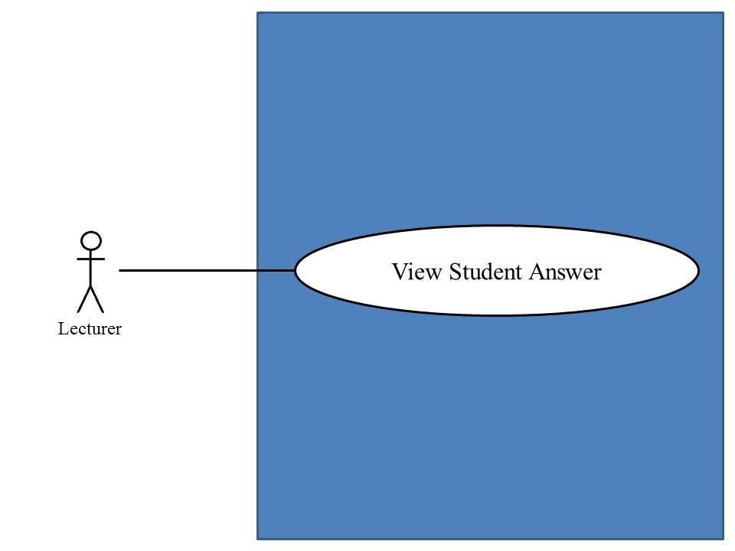

Use Case ID: | UC-21
Use Case Name: | Lecturer reviews student’s answers in chart
Created By: | Mr.Chaichan Suttee |  | Last Updated By: | Mr.Chaichan Suttee
Date Created: | 10/05/2014 |  | Last Revision Date: | 10/05/2014
Actors: |  | Lecturer
Description: |  | This use case is provided for Lecturer reviews student’s answers in chart on the web application.
Trigger: |  | Lecturer click show answers in chart
Preconditions: |  | Lecturer log in to the system already.
Post conditions: |  | System display answer chart
Normal Flow: |  | - Lecturer enters the Lecturer main page.  - Lecturer enters the Course management page.  - The system provides all courses name which were taught by Lecturer.  - Lecturer selects a course that want to view.  - Lecturer submits viewing course form.  - The system redirects to the Course main page.  - Lecturer submits overall testing form.  - The system redirects to the overall testing page.  - Lecturer select a testing that want to review overall student’s answer in each choice of assignment or quiz in chart format.  - Lecturer submits chart format of student’s answer form.  - The system redirects to the chart format of student’s answer page.
Alternative Flows: |  | N/A
Exceptions: |  | N/A
Includes: |  | N/A
Frequency of Use: |  | Often
Assumptions: |  | N/A
Notes and Issues: |  | N/A

URS1-21. Lecturer can review overall student’s answer in each choice of assignment or quiz in chart format.
Lecturer can review overall student’s answer in each choice of assignment or quiz in chart format into the web application. Which Lecturer can analyze thinking of students in decision choose answers.

Actor: Lecturer
Prerequisite: Lecturer must have logged.

Input: None

Flow of Execution:
- Lecturer enters the Lecturer main page.
- Lecturer enters the Course management page.
- The system provides all courses name which were taught by Lecturer.
- Lecturer selects a course that want to view.
- Lecturer submits viewing course form.
- The system redirects to the Course main page.
- Lecturer submits overall testing form.
- The system redirects to the overall testing page.
- Lecturer select a testing that want to review overall student’s answer in each choice of assignment or quiz in chart format.
- Lecturer submits chart format of student’s answer form.
- The system redirects to the chart format of student’s answer page.

System Requirement Specification of URS1-21
SRS1-2.1: The system shall redirect to Lecture main page.
SRS16-1.1: The system shall redirect to Course management page.
SRS16-2.1: The system shall provide all courses name in Course management page which were taught by finding from lecturer ID.
SRS16-3.1: The system shall redirects to Course main page.
SRS18-1.1: The system shall redirects to Overall testing page.
SRS21-1.1: The system shall redirect to Chart format of student’s answer page
SRS21-2.1: The system shall fetch the assignment or quiz information from the system.
SRS21-3.1: The system shall display overall student’s answer in each choice of assignment or quiz in chart format into Chart format of student’s answer page.

4.22 Lecturer can check whether the assignments are submitted in time. (UC-22)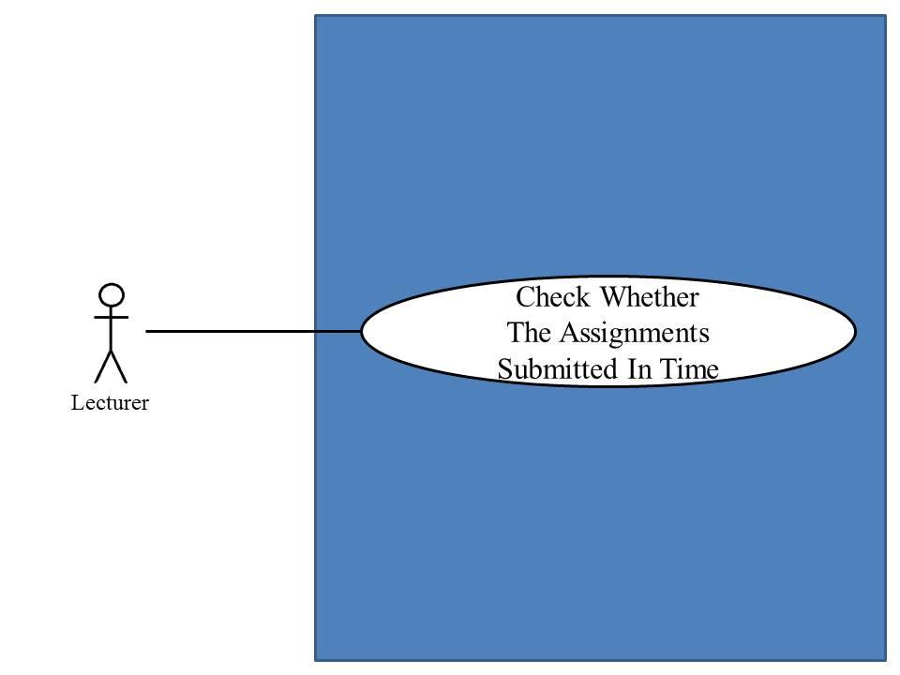

Use Case ID: | UC-22
Use Case Name: | Lecturer can check whether the assignments are submitted in time.
Created By: | Mr.Chaichan Suttee |  | Last Updated By: | Mr.Chaichan Suttee
Date Created: | 10/05/2014 |  | Last Revision Date: | 10/05/2014
Actors: |  | Lecturer
Description: |  | This use case is provided for Lecturer check whether the assignments are submitted in time.
Trigger: |  | Lecturer click check time.
Preconditions: |  | Lecturer log in to the system already.
Post conditions: |  | System display time of submitted
Normal Flow: |  | - Lecturer enters the Lecturer main page.  - Lecturer enters the Course management page.  - The system provides all courses name which were taught by Lecturer.  - Lecturer selects a course that want to view.  - Lecturer submits viewing course form.  - The system redirects to the Course main page.  - Lecturer submits overall testing form.  - The system redirects to the overall testing page.  - Lecturer select a testing that want to check students that submit assignments in time.  - Lecturer submit assignment status form.  - The system redirects to the chart format of student’s answer page.
Alternative Flows: |  | N/A
Exceptions: |  | N/A
Includes: |  | N/A
Frequency of Use: |  | Often
Assumptions: |  | N/A
Notes and Issues: |  | N/A

URS1-22. Lecturer can check whether the assignments are submitted in time.
Lecturer can check whether who submitted an assignment or quiz in time into the web application. Also, who didn’t submit an assignment or quiz in time.

Actor: Lecturer
Prerequisite: Lecturer must have logged.

Input: None

Flow of Execution:
- Lecturer enters the Lecturer main page.
- Lecturer enters the Course management page.
- The system provides all courses name which were taught by Lecturer.
- Lecturer selects a course that want to view.
- Lecturer submits viewing course form.
- The system redirects to the Course main page.
- Lecturer submits overall testing form.
- The system redirects to the overall testing page.
- Lecturer select a testing that want to check students that submit assignments in time.
- Lecturer submit assignment status form.
- The system redirects to the chart format of student’s answer page.

System Requirement Specification of URS1-22
SRS1-1-2: The system shall redirect to Lecture main page.
SRS1-16-1: The system shall redirect to Course management page.
SRS1-16-2: The system shall provide all courses name in Course management page which were taught by finding from lecturer ID.
SRS1-16-3: The system shall redirects to Course main page.
SRS1-18-1: The system shall redirects to Overall testing page.
SRS1-22-1: The system shall redirect to testing submission page.
SRS1-22-2: The system shall fetch the testing submission information from the system.
SRS1-22-3: The system shall display testing submission information into testing submission page which consist student name, student ID.

4.23 Student can take assignments or quizzes. (UC-23)
Use Case ID: | UC-23
Use Case Name: | Student can Take Assignment
Created By: | Mr.Chaichan Suttee |  | Last Updated By: | Mr.Chaichan Suttee
Date Created: | 10/05/2014 |  | Last Revision Date: | 10/05/2014
Actors: |  | Student
Description: |  | This use case is provided for Student to take Assignment or quiz
Trigger: |  | Student click do quiz
Preconditions: |  | Student log in to the system already.
Post conditions: |  | Student can take assignment
Normal Flow: |  | - Student enters the Student main page.  - Student enters the Overall course page.  - The system provides all courses name which were studied by Student.  - Student selects a course that want to view.  - Student submits viewing course form.  - The system redirects to the Course main page.  - Student submits overall testing form.  - The system redirects to the overall testing page.  - Student select a testing that want to take an assignment or quiz.  - Student submit taking assignment or quiz form.  - The system redirects assignment or quiz page.  - Student provides answers in every question.  - Student submit answers.  - The system redirects to overall testing page.
Alternative Flows: |  | N/A
Exceptions: |  | N/A
Includes: |  | N/A
Frequency of Use: |  | Often
Assumptions: |  | N/A
Notes and Issues: |  | N/A

URS1-23. Student can take assignments or quizzes which are multiple choices, true/false questions, short answers.
Student can take assignments or quizzes which are multiple choices, true/false questions, short answers via the web application.
Student must provide answer information by separating from type of questions.
- Student can take multiple choices questions which provide one answer only in each order of questions.
- Student can take true/false questions which provide one answer only in each order of questions.
- Student can take short answers which provide characters or texts.
Actor: Student
Prerequisite: Student must have logged.

Input:
Multiple choices question

Name | Description | Example | Remarks
multiple choices answer | Only “a, b, c, d” is allowed. | a

True/false question

Name | Description | Example | Remarks
true/false answer | Only “a, b, c, d” is allowed. | b

Short answer

Name | Description | Example | Remarks
short answer | Can be any character is allowed. | From the picture is a dog.

Flow of Execution:
- Student enters the Student main page.
- Student enters the Overall course page.
- The system provides all courses name which were studied by Student.
- Student selects a course that want to view.
- Student submits viewing course form.
- The system redirects to the Course main page.
- Student submits overall testing form.
- The system redirects to the overall testing page.
- Student select a testing that want to take an assignment or quiz.
- Student submit taking assignment or quiz form.
- The system redirects assignment or quiz page.
- Student provides answers in every question.
- Student submit answers.
- The system redirects to overall testing page.

System Requirement Specification of URS1-23

SRS1-2.1: The system shall redirect to Lecture main page.
SRS16-1.1: The system shall redirect to Course management page.
SRS16-2.1: The system shall provide all courses name in Course management page which were taught by finding from lecturer ID.
SRS16-3.1: The system shall redirects to Course main page.
SRS18-1.1: The system shall redirects to Overall testing page.
SRS22-1.1: The system shall redirect to testing submission page.
SRS22-2.1: The system shall fetch the testing submission information from the system.
SRS22-3.1: The system shall display testing submission information into testing submission page which consist student name, student ID.

4.1 Lecturer registers to the system (UC 1.2)
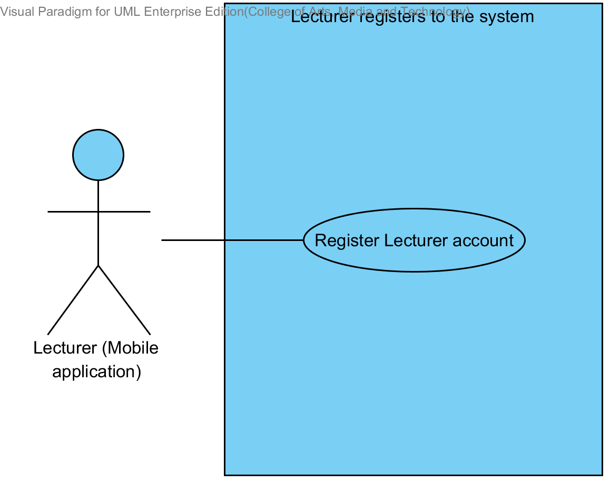

Use Case ID: | UC 1.2
Use Case Name: | Lecturer registers to the system
Created By: | Mr.Tanadol Parn-ong |  | Last Updated By: | Mr.Tanadol Parn-ong
Date Created: | 10/05/2014 |  | Last Revision Date: | 10/05/2014
Actors: |  | Lecturer
Description: |  | This use case is provided for Lecturer request to register account to the system on the mobile application.
Trigger: |  | Lecturer enters to Lecturer registration page.
Preconditions: |  | N/A
Post conditions: |  | Lecturer sees “Registration Successful” message on the mobile application.
Normal Flow: |  | - Lecturer enters to Lecturer registration page.  - The system redirects to Lecturer registration page on the mobile application.  - The system provides Lecturer registration interface on the mobile application, including lecturer ID, lecturer username, lecturer password, lecturer name, lecturer faculty, lecturer department, lecturer email, and lecturer tel.  - Lecturer provides the Lecturer information into the registration page.  - Lecturer submits the Lecturer registration form into the mobile application.  - The system validates the format of the Lecturer personal information.  - The system validates the duplication of the lecturer username.  - The system stores the Lecturer personal information into the system.  - The system displays “Registration Successful” message on the mobile application.  - The system redirects to Lecturer main page on the mobile application.
Alternative Flows: |  | 6A. when the lecturer ID format is wrong. The system provides the error message as followed:  1. The system displays “The Lecturer ID must be the number only” on the mobile application.  2. Use Case resumes on step 4 of normal flow.  6B. when the lecturer username format is wrong. The system provides the error message as followed:  1. The system displays “The Lecturer’s username must be only 4-16 alphabet characters” on the mobile application.  2. Use Case resumes on step 4 of normal flow.  6C. when the lecturer password format is wrong. The system provides the error message as followed:  1. The system displays “The Lecturer’s password must be only 4-16 characters” on the mobile application.  2. Use Case resumes on step 4 of normal flow.  6D. when the lecturer name format is wrong. The system provides the error message as followed:  1. The system displays “The Lecturer’s name must be the combination of alphabet and space only” on the mobile application.  2. Use Case resumes on step 4 of normal flow.  6E. when the lecturer tel format is wrong. The system provides the error message as followed:  1. The system displays “The Lecturer’s tel must be number only” on the mobile application.  2. Use Case resumes on step 4 of normal flow.  6F. when the lecturer email format is wrong. The system provides the error message as followed:  1. The system displays “The Lecturer’s email must be the character and only one @ symbol” on the mobile application.  2. Use Case resumes on step 4 of normal flow.  7A. when the lecturer username is duplicate with exist lecturer username in the system. The system provides the error message as followed: “Existing Lecturer’s username, please using different Lecturer’s username” on the mobile application.
Exceptions: |  | N/A
Includes: |  | N/A
Frequency of Use: |  | Only at the first time when user begins to use this application.
Assumptions: |  | N/A
Notes and Issues: |  | N/A

URS 1.2 Lecturer can register to the system
Lecturer must register into the mobile application, in order to using the other features as Lecturer. Lecturer have to provide lecturer ID, lecturer username, lecturer password, lecturer name, lecturer faculty, lecturer department, lecturer email, and lecturer tel into the system. After, the registration has been completed. The mobile application will redirect to the Lecturer main page.
Actor: The users
Prerequisite: -
Input:
Name | Description | Example | Remarks
lecturer ID | Only number is allowed. | 21115011
lecturer username | Only Alphabet is allowed, within the range of 4-16 Characters | “tony”
lecturer password | Can be any character within the range of 4-16 characters. | “12345”
lecturer name | Only The combination of alphabet and space is allowed. | “Tony Stark”
lecturer faculty | Can be any character is allowed. | College of Arts media and technology, Chiang mai University
lecturer department | Can be any character is allowed. | Software engineer
lecturer email | The combination of character and only one @ symbol is allowed. | tony999@gmail.com
lecturer tel | Only number is allowed. | 0832109999

Flow of Execution:
- Lecturer enters to Lecturer registration page.
- Lecturer provides the Lecturer information into the registration page.
- Lecturer submit the Lecturer registration form into the mobile application.

Alternative Flow:
3A. if Lecturer input data in the wrong format, the system should provide the error message as followed:
  - The wrong lecturer ID format: The error message is “The Lecturer ID must be the number only”
  - The wrong lecturer username format: The error message is “The Lecturer’s username must be only 4-16 alphabet characters”
  - The wrong lecturer password format: The error message is “The Lecturer’s password must be only 4-16 characters”
  - The wrong lecturer name format: The error message is “The Lecturer’s name must be the combination of alphabet and space only”
  - The wrong lecturer tel format: The error message is “The Lecturer’s tel must be number only”
  - The wrong lecturer email format: The error message is “The Lecturer’s email must be the character and only one @ symbol”

3B. if Lecturer submitted the data, but there is the existing username in the system. The system will not allow the user the register with that Username. The system will display the error message “Existing Lecturer’s username, please using different Lecturer’s username” to the user.

System Requirement Specification of URS1.2

SRS 1-1.2: The system shall redirect to Lecturer registration page on the mobile application.
SRS 1-2.2: The system shall redirect to Lecture main page on the mobile application.
SRS 1-3.2: The system shall provide Lecturer registration interface on the mobile application, including lecturer ID, lecturer username, lecturer password, lecturer name, lecturer faculty, lecturer department, lecturer email, and lecturer tel for Lecturer register to the system.
SRS 1-4.2: The system shall store the Lecturer personal information into the system after Lecturer submitted his/her register information from Lecturer registration interface on the mobile application.
SRS 1-5.2: The system shall display “Registration Successful” message when Lecturer registered the Lecturer account in Lecturer registration interface on the mobile application.
SRS 1-6.2: The system shall validate the format of the Lecturer personal information after the Lecturer submitted his/her information from Lecturer registration interface on the mobile application.
SRS 1-7.2: The system shall display “The Lecturer ID must be the number only” when the lecturer ID format is wrong.
SRS 1-8.2: The system shall display “The Lecturer’s username must be only 4-16 alphabet characters” when the lecturer username format is wrong.
SRS 1-9.2: The system shall display “The Lecturer’s password must be only 4-16 characters” when the lecturer password format is wrong.
SRS 1-10.2: The system shall display “The Lecturer’s name must be the combination of alphabet and space only” when the lecturer name format is wrong.
SRS 1-11.2: The system shall display “The Lecturer’s tel must be number only” when the lecturer tel format is wrong.
SRS 1-12.2: The system shall display “The Lecturer’s email must be the character and only one @ symbol” when the lecturer email format is wrong.
SRS 1-13.2: The system shall validate the duplication of the lecturer username after Lecturer submitted his/her information from Lecturer registration interface on the mobile application.
SRS 1-14.2: The system shall display “Existing Lecturer’s username, please using different Lecturer’s username” when the lecturer username duplicates exist lecturer username.

4.2 Student registers to the system (UC 2.2)

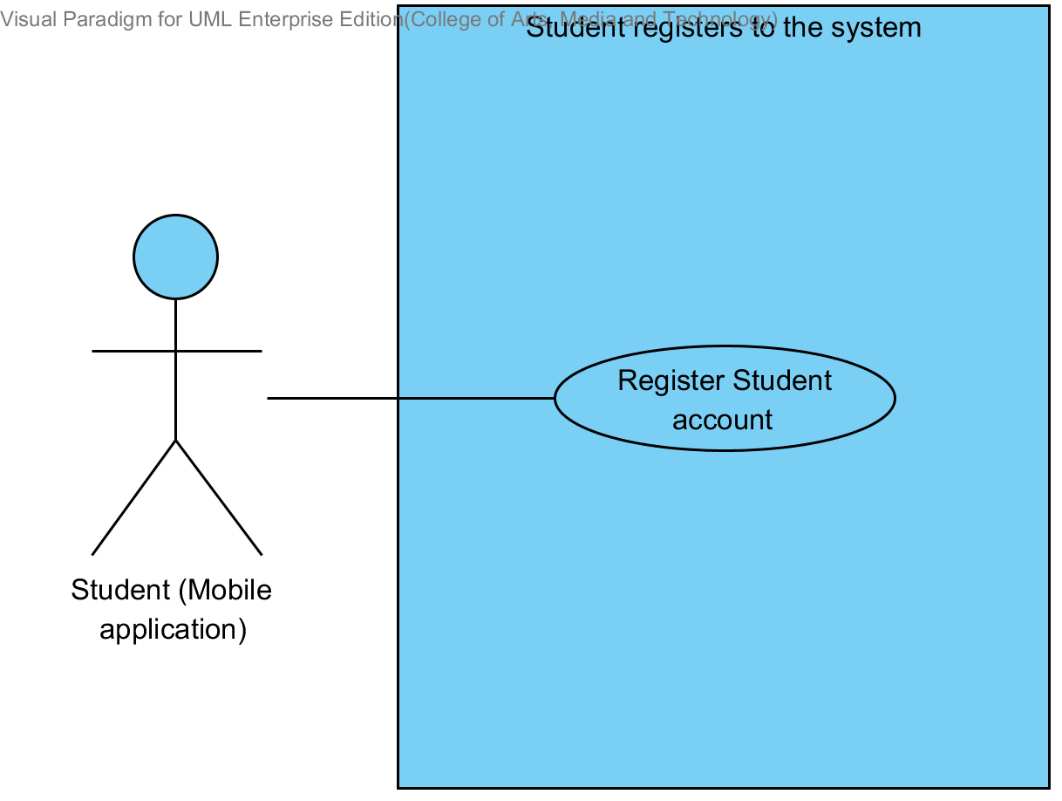

Use Case ID: | UC 2.2
Use Case Name: | Student registers to the system
Created By: | Mr.Tanadol Parn-ong |  | Last Updated By: | Mr.Tanadol Parn-ong
Date Created: | 10/05/2014 |  | Last Revision Date: | 10/05/2014
Actors: |  | Student
Description: |  | This use case is provided for Student request to register account to the system on the mobile application.
Trigger: |  | Student enters to Student registration page.
Preconditions: |  | N/A
Post conditions: |  | Student sees “Registration Successful” message on the mobile application.
Normal Flow: |  | - Student enters to Student registration page.  - The system redirects to Student registration page on the mobile application.  - The system provides Student registration interface on the mobile application, including student ID, student username, student password, student name, student address, student faculty, student department, student email, and student tel for Student register to the system.  - Student provides the Student information into the registration page.  - Student submits the Student registration form into the mobile application.  - The system validates the format of the Student personal information.  - The system validates the duplication of the lecturer username.  - The system stores the Student personal information into the system.  - The system displays “Registration Successful” message on the mobile application.  - The system redirects to Student main page on the mobile application.
Alternative Flows: |  | 6A. when the student ID format is wrong. The system provides the error message as followed:  1. The system displays “The Student ID must be the number only” on the mobile application.  2. Use Case resumes on step 5 of normal flow.  6B. when the student username format is wrong. The system provide the error message as followed:  1. The system displays “The Student’s username must be only 4-16 alphabet characters” on the mobile application.  2. Use Case resumes on step 4 of normal flow.  6C. when the student password format is wrong. The system provides the error message as followed:  1. The system displays “The Student’s password must be only 4-16 characters” on the mobile application.  2. Use Case resumes on step 4 of normal flow.  6D. when the student name format is wrong. The system provides the error message as followed:  1. The system displays “The Student’s name must be the combination of alphabet and space only” on the mobile application.  2. Use Case resumes on step 4 of normal flow.  6E. when the student tel format is wrong. The system provides the error message as followed:  1. The system displays “The Student’s tel must be number only” on the mobile application.  2. Use Case resumes on step 4 of normal flow.  6F. when the student email format is wrong. The system provides the error message as followed:  1. The system displays “The Student’s email must be the character and only one @ symbol” on the mobile application.  2. Use Case resumes on step 4 of normal flow.  7A. when the student username is duplicate with exist student username in the system. The system provides the error message as followed: “Existing Student’s username, please using different Student’s username” on the mobile application.
Exceptions: |  | N/A
Includes: |  | N/A
Frequency of Use: |  | Only at the first time when user begins to use this application.
Assumptions: |  | N/A
Notes and Issues: |  | N/A
URS 2.2 Student can register to the system
Student must register into the mobile application, in order to using the other features as Student. Student have to provide student ID, student username, student password, student name, student address, student faculty, student department, student email, and student tel into the system. After, the registration has been completed. The mobile application will redirect to the Student main page.
Actor: The users
Prerequisite: -

Input:
Name | Description | Example | Remarks
student ID | Only number is allowed. | 542115099
student username | Only Alphabet is allowed, within the range of 4-16 Characters | “jenny”
student password | Can be any character within the range of 4-16 characters. | “12345”
student name | Only The combination of alphabet and space is allowed. | “Jenny Stark”
student faculty | Can be any character is allowed. | College of Arts media and technology, Chiang mai University
student department | Can be any character is allowed. | Software engineer
student address | Can be any character. | Women dorm 4, Chiang mai university, Chiang mai, Thailand, 50000
student email | The combination of character and only one @ symbol is allowed. | jenny999@gmail.com
student tel | Only number is allowed. | 0823207777

Flow of Execution:
- Student enters to Student registration page.
- Student provides the Student information into the registration page.
- Student submits the Student registration form into the mobile application.

Alternative Flow
3A. if Student input data in the wrong format, the system should provide the error message as followed:
  - The wrong student ID format: The error message is “The Student ID must be number only”
  - The wrong username format: The error message is “The Student’s username must be only 4-16 alphabet characters”
  - The wrong password format: The error message is “The Student’s password must be only 4-16 characters”
  - The wrong name format: The error message is “The Student’s name must be the combination of alphabet and space only”
  - The wrong Tel format: The error message is “The Student’s tel must be number only”
  - The wrong student email format: The error message is “The Student’s email must be the character and only one @ symbol”

3B. if Student submitted the data, but there is the existing username in the system. The system won’t allow the user the register with that Username. The system will display the error message “Existing Student’s username, please using different Student’s username” to the user.

System Requirement Specification of URS 2.2

SRS 2-1.2: The system shall redirect to Student registration page on the mobile application.
SRS 2-2.2: The system shall redirect to Student main page on the mobile application.
SRS 2-3.2: The system shall provide Student registration interface on the mobile application, including student ID, student username, student password, student name, student address, student faculty, student department, student email, and student tel for Student register to the system.
SRS 2-4.2: The system shall store the Student personal information into the system after Student submitted his/her register information from Student registration interface on the mobile application.
SRS 2-5.2: The system shall display “Registration Successful” message when Student registered the Student account in Student registration interface on the mobile application.
SRS 2-6.2: The system shall validate the format of the Student information after the Student submitted his/her information from Student registration interface on the mobile application.
SRS 2-7.2: The system shall display “The Student ID must be the number only” when the student ID format is wrong.
SRS 2-8.2: The system shall display “The Student’s username must be only 4-16 alphabet characters” when the student username format is wrong.
SRS 2-9.2: The system shall display “The Student’s password must be only 4-16 characters” when the student password format is wrong.
SRS 2-10.2: The system shall display “The Student’s name must be the combination of alphabet and space only” when the student name format is wrong.
SRS 2-11.2: The system shall display “The Student’s tel must be number only” when the student tel format is wrong.
SRS 2-12.2: The system shall display “The Student’s email must be the character and only one @ symbol” when the student email format is wrong.
SRS 2-13.2: The system shall validate the duplication of the student username after Student submitted his/her information from Student registration interface on the mobile application.
SRS 2-14.2: The system shall display “Existing Student’s username, please using different Student’s username” when the student username duplicates exist student username.

4.3 Lecturer edits personal information (UC 3.2)

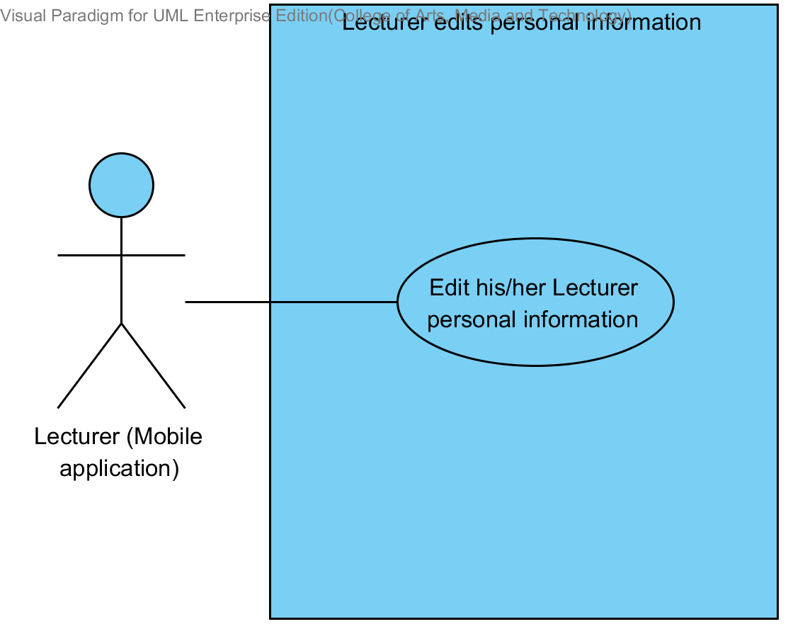

Use Case ID: | UC 3.2
Use Case Name: | Lecturer edits personal information.
Created By: | Mr.Tanadol Parn-ong |  | Last Updated By: | Mr.Tanadol Parn-ong
Date Created: | 10/05/2014 |  | Last Revision Date: | 10/05/2014
Actors: |  | Lecturer
Description: |  | This use case is provided for Lecturer edits his/her personal information on the mobile application.
Trigger: |  | Lecturer enters to Lecturer personal information page.
Preconditions: |  | Lecturer must logged in to the system.
Post conditions: |  | Lecturer sees “Editing Information Successful” message on the mobile application.
Normal Flow: |  | - Lecturer enters to Lecturer personal information page.  - The system redirects to Lecturer personal information interface on the mobile application.  - The system provides Lecturer personal information interface on the mobile application, including lecturer password, lecturer name, lecturer faculty, lecturer department, lecturer email, and lecturer tel.  - Lecturer provides information that want to edit.  - Lecturer provides confirm password for editing.  - Lecturer submits edition personal information on the mobile application.  - The system validates the format of the Lecture personal information.  - The system validates the similarity of password and confirm password  - The system updates Lecturer personal information into the system.  - The system displays “Editing Information Successful” message on the mobile application.
Alternative Flows: |  | 7A. when the lecturer password format is wrong. The system provides the error message as followed:  1. The system displays “The Lecturer’s password must be only 4-16 characters” on the mobile application.  2. Use Case resumes on step 5 of normal flow.  7B. when the lecturer name format is wrong. The system provides the error message as followed:  1. The system displays “The Lecturer’s name must be the combination of alphabet and space only” on the mobile application.  2. Use Case resumes on step 6 of normal flow.  7C. when the lecturer tel format is wrong. The system provides the error message as followed:  1. The system displays “The Lecturer’s tel must be number only” on the mobile application.  2. Use Case resumes on step 6 of normal flow.  7D. when the lecturer email format is wrong. The system provides the error message as followed:  1. The system displays “The Lecturer’s email must be the character and only one @ symbol” on the mobile application.  2. Use Case resumes on step 6 of normal flow.  8A. when the lecturer password and confirm password is not matched. The system provides the error message as followed:  1. The system displays “Password and confirm password is not matched” on the mobile application.  2. Use Case resumes on step 6 of normal flow.
Exceptions: |  | N/A
Includes: |  | N/A
Frequency of Use: |  | Often
Assumptions: |  | N/A
Notes and Issues: |  | N/A

URS 3.2 Lecturer can edit his/her personal information.
Lecturer can edit his/her personal information into the mobile application which consist lecturer ID, lecturer password, lecturer name, lecturer faculty, lecturer department, lecturer email, and lecturer tel.
Actor: Lecturer
Prerequisite: Lecturer must have logged.
Input:
Name | Description | Example | Remarks
lecturer password | Can be any character within the range of 4-16 characters. | “123456”
lecturer name | Only The combination of alphabet and space is allowed. | “Tony Stark”
lecturer faculty | Can be any character is allowed. | College of Arts media and technology, Chiang mai University
lecturer department | Can be any character is allowed. | Software engineering
lecturer email | The combination of character and only one @ symbol is allowed. | tony999@gmail.com
lecturer tel | Only number is allowed. | 0832109999

Flow of Execution:
- Lecturer enters to Lecturer personal information page.
- Lecturer provides information that want to edit.
- Lecturer provides confirm password for editing.
- Lecturer submits edition personal information on the mobile application.

Alternative Flow:
4A. if Lecturer input data in the wrong format, the system should provide the error message as followed:
  - The wrong password format: The error message is “The Lecturer’s password must be only 4-16 characters”
  - The wrong name format: The error message is “The Lecturer’s name must be the combination of alphabet and space only”
  - The wrong Tel format: The error message is “The Lecturer’s tel must be number only”
  - The wrong lecturer email format: The error message is “The Lecturer’s email must be the character and only one @ symbol”

4B. if Lecturer submitted the data, but password and confirm password is not matched. The system will display the error message “Password and confirm password is not matched” to Lecturer.

System Requirement Specification of URS 3.2

SRS 3-1.2: The system shall redirect to Lecturer personal information interface on the mobile application.
SRS 3-2.2: The system shall provide Lecturer personal information interface on the mobile application, including lecturer password, lecturer name, lecturer faculty, lecturer department, lecturer email, and lecturer tel for Lecturer edits his/her personal information into the system.
SRS 3-3.2: The system shall update Lecturer personal information into the system after Lecturer submits to edit his/her personal information from Lecturer personal information interface on the mobile application.
SRS 3-4.2: The system shall display “Editing Information Successful” message when Lecturer edited the Lecturer personal information in Lecturer personal information interface on the mobile application.
SRS 3-5.2: The system shall validate the format of the Lecture personal information after Lecturer submitted his/her personal information from Lecturer personal information interface on the mobile application.
SRS 3-6.2: The system shall display “The Lecturer’s password must be only 4-16 characters” when the lecturer password format is wrong.
SRS 3-7.2: The system shall display “The Lecturer’s name must be the combination of alphabet and space only” when the lecturer name format is wrong.
SRS 3-8.2: The system shall display “The Lecturer’s tel must be number only” when the lecturer tel format is wrong.
SRS 3-9.2: The system shall display “The Lecturer’s email must be the character and only one @ symbol” when the lecturer email format is wrong.
SRS 3-10.2: The system shall validate the similarity of password and confirm password after Lecturer submitted his/her personal information from Lecturer personal information interface in the mobile application.
SRS 3-11.2: The system shall display “Password and confirm password is not matched” when password and confirm password is not matched.

4.4 Student edits personal information (UC 4.2)

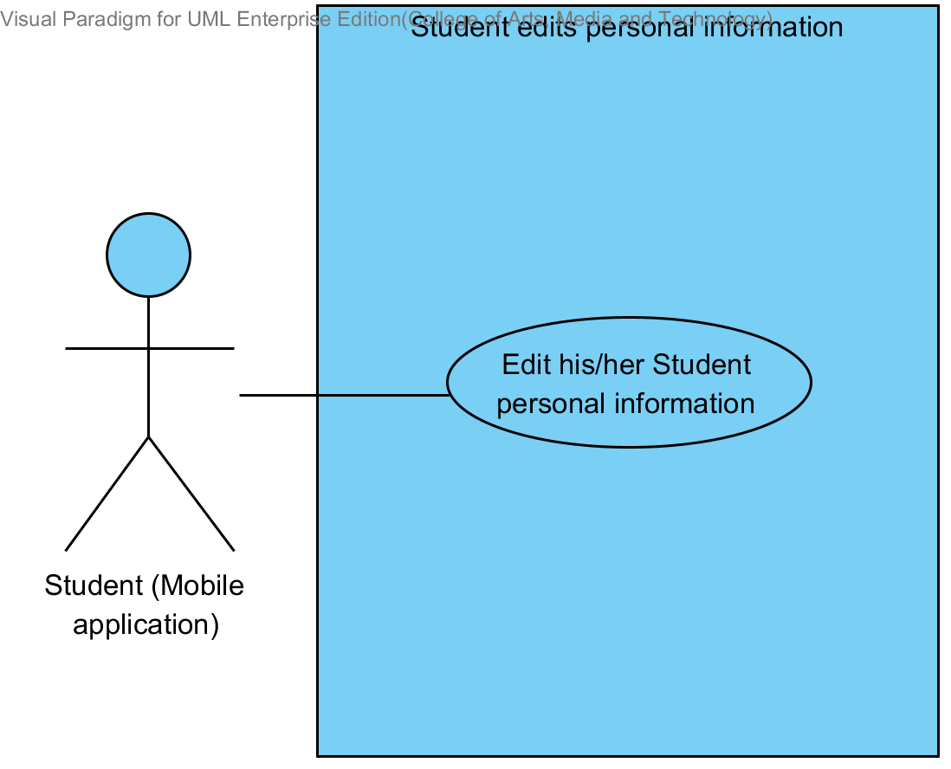

Use Case ID: | UC-04
Use Case Name: | Student edits personal information.
Created By: | Mr.Tanadol Parn-ong |  | Last Updated By: | Mr.Tanadol Parn-ong
Date Created: | 10/05/2014 |  | Last Revision Date: | 10/05/2014
Actors: |  | Student
Description: |  | This use case is provided for Student edits his/her personal information on the mobile application.
Trigger: |  | Student enters to Student personal information page.
Preconditions: |  | Student must logged in to the system.
Post conditions: |  | Student sees “Editing Information Successful” message on the mobile application.
Normal Flow: |  | - Student enters to Student personal information page.  - The system redirects to Student personal information interface on the mobile application.  - The system provides Student personal information interface on the mobile application, including student password, student name, student faculty, student department, student address, student email, and student tel.  - Student provides information that want to edit.  - Student provides confirm password for editing.  - Student submits edition personal information on the mobile application.  - The system validates the format of the Student personal information.  - The system validates the similarity of password and confirm password  - The system updates Student personal information into the system.  - The system displays “Editing Information Successful” message on the mobile application.
Alternative Flows: |  | 7A. when the student password format is wrong. The system provides the error message as followed:  1. The system displays “The Student’s password must be only 4-16 characters” on the mobile application.  2. Use Case resumes on step 5 of normal flow.  7B. when the student name format is wrong. The system provides the error message as followed:  1. The system displays “The Student’s name must be the combination of alphabet and space only” on the mobile application.  2. Use Case resumes on step 6 of normal flow.  7C. when the student tel format is wrong. The system provides the error message as followed:  1. The system displays “The Student’s tel must be number only” on the mobile application.  2. Use Case resumes on step 6 of normal flow.  7D. when the student email format is wrong. The system provides the error message as followed:  1. The system displays “The Student’s email must be the character and only one @ symbol” on the mobile application.  2. Use Case resumes on step 6 of normal flow.  8A. when the student password and confirm password is not matched. The system provides the error message as followed:  1. The system displays “Password and confirm password is not matched” on the mobile application.  2. Use Case resumes on step 6 of normal flow.
Exceptions: |  | N/A
Includes: |  | N/A
Frequency of Use: |  | Often
Assumptions: |  | N/A
Notes and Issues: |  | N/A

URS 4.2 Student can edit his/her personal information.
Student can edit his/her personal information into the mobile application which consist student ID, student password, student name, student address, student faculty, student department, student email, and student tel.
Actor: Student
Prerequisite: Student must have logged.
Input:
Name | Description | Example | Remarks
student ID | Only number is allowed. | 542115099
student password | Can be any character within the range of 4-16 characters. | “123456”
student name | Only The combination of alphabet and space is allowed. | “Jenny Stark”
student faculty | Can be any character is allowed. | College of Arts media and technology, Chiang mai University
student department | Can be any character is allowed. | Software engineering
student address | Can be any character. | Women dorm 4, Chiang mai university, Chiang mai, Thailand, 50000
student email | The combination of character and only one @ symbol is allowed. | jenny999@gmail.com
student tel | Only number is allowed. | 0823207777

Flow of Execution:
- Student enters to Student personal information page.
- Student provides information that want to edit.
- Student provides confirm password for editing.
- Student submits edition personal information form.

Alternative Flow:
4A. if Student input data in the wrong format, the system should provide the error message as followed:
  - The wrong password format: The error message is “The Student’s password must be only 4-16 characters”
  - The wrong name format: The error message is “The Student’s name must be the combination of alphabet and space only”
  - The wrong Tel format: The error message is “The Student’s tel must be number only”
  - The wrong student email format: The error message is “The Student’s email must be the character and only one @ symbol”

4B. if Student submitted the data, but password and confirm password is not matched. The system will display the error message “Password and confirm password is not matched” to Student.

System Requirement Specification of URS 4.2

SRS 4-1.2: The system shall redirect to Student personal information interface on the mobile application.
SRS 4-2.2: The system shall provide Student personal information interface on the mobile application, including student password, student name, student faculty, student department, student address, student email, and student tel for Student edits his/her personal information into the system.
SRS 4-3.2: The system shall update Student personal information into the system after Student submits to edit his/her personal information from Student personal information interface on the mobile application.
SRS 4-4.2: The system shall display “Editing Information Successful” message when Student edited the Student personal information in Student personal information interface on the mobile application.
SRS 4-5.2: The system shall validate the format of the Student personal information after Student submitted his/her personal information from Student personal information interface on the mobile application.
SRS 4-6.2: The system shall display “The Student’s password must be only 4-16 characters” when the student password format is wrong.
SRS 4-7.2: The system shall display “The Student’s name must be the combination of alphabet and space only” when the student name format is wrong.
SRS 4-8.2: The system shall display “The Student’s tel must be number only” when the student tel format is wrong.
SRS 4-9.2: The system shall display “The Student’s email must be the character and only one @ symbol” when the student email format is wrong.
SRS 4-10.2: The system shall validate the similarity of password and confirm password after Student submitted his/her personal information from Student personal information interface in the mobile application.
SRS 4-11.2: The system shall display “Password and confirm password is not matched” when password and confirm password is not matched.

4.5 Login to the system (UC 5.2)

Use Case ID: | UC 5.2
Use Case Name: | Login to the system.
Created By: | Mr.Tanadol Parn-ong |  | Last Updated By: | Mr.Tanadol Parn-ong
Date Created: | 10/05/2014 |  | Last Revision Date: | 10/05/2014
Actors: |  | Lecturer, Student
Description: |  | This use case is provided for Lecturer/Student log in to the system on the mobile application.
Trigger: |  | Lecturer/Student enters to Login page.
Preconditions: |  | Lecturer/Student is registered into the system and has his/her account.
Post conditions: |  | The system redirects to Lecture or Student main page on the mobile application.
Normal Flow: |  | - Lecturer/Student enters to Login page.  - The system redirects to Login page on the mobile application.  - The system provides Login interface on the mobile application, including username and password  - Lecturer/Student provides login information into the mobile application.  - Lecturer/Student submit login form into the mobile application.  - The system fetches login information of Lecturer/Student from the system to validate the correctness of login information in Login interface on the mobile application.  - The system redirects to Lecture main page on the mobile application.
Alternative Flows: |  | 7A. if Student log in to the system.  1. The system redirects to Student main page on the mobile application.  6C. when the username and password is wrong. The system provides the error message as followed:  1. The system displays “Invalid Username and/or Password” on the mobile application.  2. Use Case resumes on step 4 of normal flow.
Exceptions: |  | N/A
Includes: |  | N/A
Frequency of Use: |  | Often
Assumptions: |  | N/A
Notes and Issues: |  | N/A

URS 5.2 Lecturer/Student can login to the system.
After Lecturer/Student account was approved. Lecturer/Student can login to the system by providing username and password into the mobile application.
Actor: Lecturer, Student
Prerequisite: -
Input:
Name | Description | Example | Remarks
lecturer username | Only Alphabet is allowed, within the range of 4-16 Characters | “tony”
lecturer password | Can be any character within the range of 4-16 characters. | “12345”

Flow of Execution:
- Lecturer/Student enters to Login page.
- Lecturer/Student provides login information into the mobile application.
- Lecturer/Student submit login form into the mobile application.

Alternative Flow
3A. if the username and password are not matched, the system will display the error message “Invalid Username and/or Password” to the user.

System Requirement Specification of URS 5.2

SRS 1-2.2: The system shall redirect to Lecture main page on the mobile application.
SRS 2-2.2: The system shall redirect to Student main page on the mobile application.
SRS 5-1.2: The system shall redirect to Login page on the mobile application.
SRS 5-2.2: The system shall provide Login interface on the mobile application, including username and password for Lecturer/Student login his/her account into the system.
SRS 5-3.2: The system shall fetch login information of Lecturer/Student from the system to validate the correctness of login information in Login interface on the mobile application.
SRS 5-4.2: The system shall display “Invalid Username and/or Password” when username and password are wrong to Lecturer/Student.

4.6 Logout system (UC 6.2)

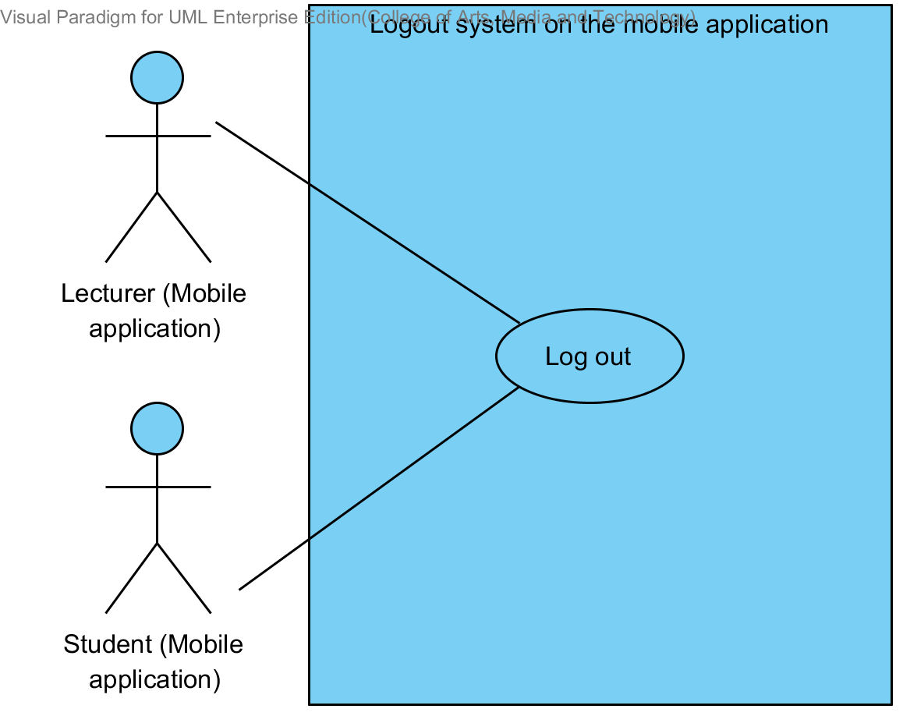

Use Case ID: | UC 6.2
Use Case Name: | Logout system.
Created By: | Mr.Tanadol Parn-ong |  | Last Updated By: | Mr.Tanadol Parn-ong
Date Created: | 10/05/2014 |  | Last Revision Date: | 10/05/2014
Actors: |  | Lecturer, Student
Description: |  | This use case is provided for Lecturer/Student log out the system on the mobile application.
Trigger: |  | Lecturer/Student submits log out form.
Preconditions: |  | Lecturer/Student must logged in to the system.
Post conditions: |  | The system redirects to Login page on the mobile application.
Normal Flow: |  | - The system provides Log out form in all page on the mobile application.  - Lecturer/Student submits log out form on the mobile application.  - The system redirects to Login page on the mobile application.
Alternative Flows: |  | N/A
Exceptions: |  | N/A
Includes: |  | N/A
Frequency of Use: |  | Often
Assumptions: |  | N/A
Notes and Issues: |  | N/A

URS 6.2 Lecturer/Student can log out from the system.
Lecturer/Student can log out from the system on the mobile application.
Actor: Lecturer, Student
Prerequisite: Lecturer/Student must have logged.
Input: None
Flow of Execution:
- Lecturer/Student submits log out form on the mobile application.

Alternative Flow
If user is a Student
1A. Student enters to Student main page.
2A. Student submits log out form on the mobile application.

System Requirement Specification of URS 6.2

SRS 5-1.2: The system shall redirect to Login page on the mobile application.
SRS 6-1.2: The system provides Log out form in all page on the mobile application.

4.7 Lecturer views course information (UC 7.2)

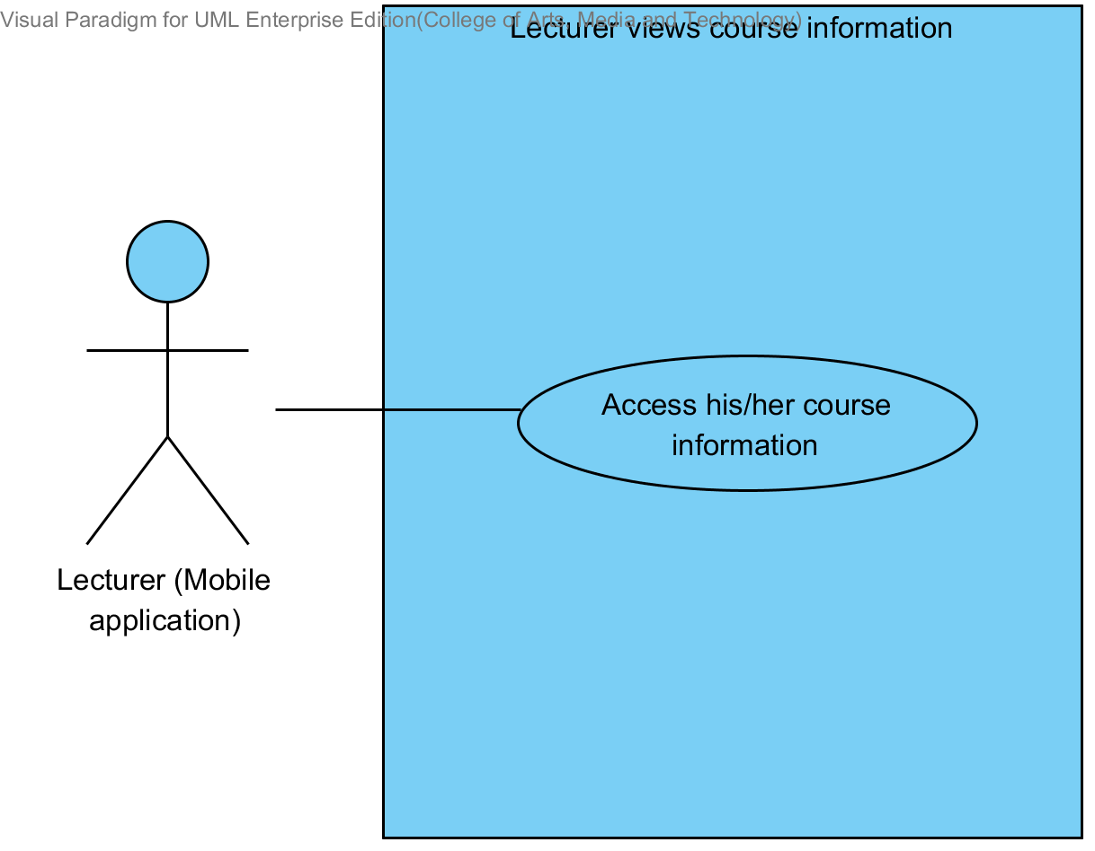

Use Case ID: | UC7.2
Use Case Name: | Lecturer views course information.
Created By: | Mr.Tanadol Parn-ong |  | Last Updated By: | Mr.Tanadol Parn-ong
Date Created: | 10/05/2014 |  | Last Revision Date: | 10/05/2014
Actors: |  | Lecturer
Description: |  | This use case is provided for Lecturer views his/her course information on the mobile application.
Trigger: |  | Lecturer enters to Course management page.
Preconditions: |  | Lecturer must logged in to the system.
Post conditions: |  | Lecturer sees the course information on the mobile application.
Normal Flow: |  | - Lecturer enters to Course management page.  - The system redirects to Course management page on the mobile application.  - The system provides all courses name in Course management page on the mobile application which were taught by finding from lecturer ID.  - Lecturer selects a course that want to view.  - Lecturer submits selecting course form.  - Lecturer enters to Course main page.  - The system redirects to Course main page on the mobile application  - Lecturer submits viewing course information form.  - The system redirects to Course information page interface on the mobile application, including course name, course credit, course description, lecturer name, a list of students in the course.  - The system fetches the course information from the system to display into Course information page on the mobile application.
Alternative Flows: |  | N/A
Exceptions: |  | N/A
Includes: |  | N/A
Frequency of Use: |  | Often
Assumptions: |  | N/A
Notes and Issues: |  | N/A

URS 7.2 Lecturer can view courses information.
Lecturer can view a course information into the mobile application.
Actor: Lecturer
Prerequisite: Lecturer must have logged.
Input: None
Flow of Execution:
- Lecturer enters to Course management page.
- Lecturer selects a course that want to view.
- Lecturer submits selecting course form.
- Lecturer enters to Course main page.
- Lecturer submits viewing course information form.

System Requirement Specification of URS 7.2

SRS 7-1.2: The system shall redirect to Course management page on the mobile application.
SRS 7-2.2: The system shall provide all courses name in Course management page on the mobile application which were taught by finding from lecturer ID.
SRS 7-3.2: The system shall redirect to Course main page on the mobile application.
SRS 7-4.2: The system shall redirect to Course information page interface on the mobile application, including course name, course credit, course description, lecturer name, a list of students in the course.
SRS 7-5.2: The system shall fetch the course information from the system to display into Course information page on the mobile application.

4.8 Student views course information (UC 8.2)

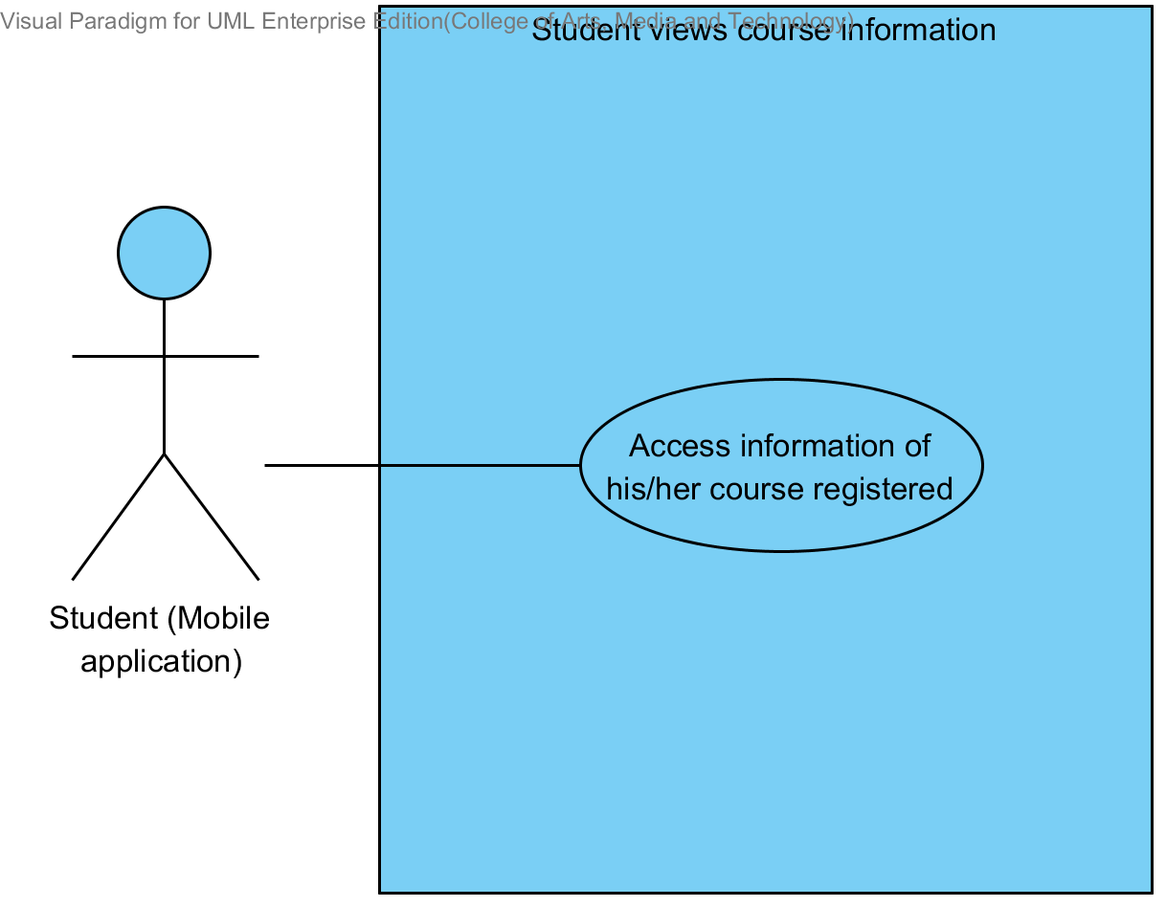

Use Case ID: | UC 8.2
Use Case Name: | Student views course information.
Created By: | Mr.Tanadol Parn-ong |  | Last Updated By: | Mr.Tanadol Parn-ong
Date Created: | 10/05/2014 |  | Last Revision Date: | 10/05/2014
Actors: |  | Student
Description: |  | This use case is provided for Student views his/her course information on the mobile application.
Trigger: |  | Student enters to Overall course page.
Preconditions: |  | Student must logged in to the system.
Post conditions: |  | Student sees the course information on the mobile application.
Normal Flow: |  | - Student enters to Overall course page.  - The system redirects to Overall course page on the mobile application.  - The system provides all courses name in Course management page on the mobile application which were studied by finding from student ID.  - Student selects a course that want to view.  - Student submits selecting course form.  - Student enters to Course main page.  - The system redirects to Course main page on the mobile application  - Student submits viewing course information form.  - The system redirects to Course information page interface on the mobile application, including course name, course credit, course description, lecturer name, a list of students in the course.  - The system fetches the course information from the system to display into Course information page on the mobile application.
Alternative Flows: |  | N/A
Exceptions: |  | N/A
Includes: |  | N/A
Frequency of Use: |  | Often
Assumptions: |  | N/A
Notes and Issues: |  | N/A

URS 8.2 Student can view courses information.
Student can view a course information into the mobile application.
Actor: Student
Prerequisite: Student must have logged.
Input: None
Flow of Execution:
- Student enters to Overall course page.
- Student selects a course that want to view.
- Student submits selecting course form.
- Student enters to Course main page.
- Student submits viewing course information form.

System Requirement Specification of URS 8.2

SRS 7-4.2: The system shall redirects to Course information page interface on the mobile application, including course name, course credit, course description, lecturer name, a list of students in the course.
SRS 7-5.2: The system shall fetch the course information from the system to display into Course information page on the mobile application.
SRS 8-1.2: The system shall redirect to Overall course page on the mobile application.
SRS 8-2.2: The system shall provide all courses name in Overall course page on the mobile application which were studied by finding from student ID.
SRS 8-3.2: The system shall redirects to Course main page on the mobile application.

4.9 Lecturer assigns assignments or quizzes (UC 9.2)

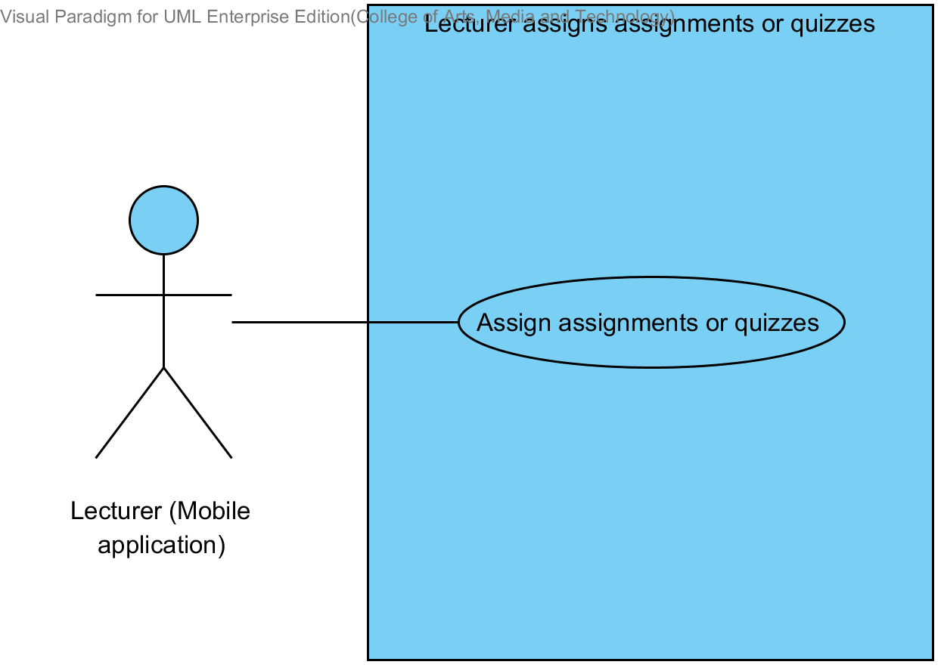

Use Case ID: | UC 9.2
Use Case Name: | Lecturer assigns assignments or quizzes.
Created By: | Mr.Tanadol Parn-ong |  | Last Updated By: | Mr.Tanadol Parn-ong
Date Created: | 10/05/2014 |  | Last Revision Date: | 10/05/2014
Actors: |  | Lecturer
Description: |  | This use case is provided for Lecturer assigns assignments or quizzes on the mobile application.
Trigger: |  | Lecturer enters to Overall testing page.
Preconditions: |  | Lecturer must logged in to the system.
Post conditions: |  | The system displays “Creating Assignment Successful” message on the mobile application
Normal Flow: |  | - Lecturer enters to Overall testing page.  - The system redirects to Overall testing page on the mobile application.  - Lecturer submits addition testing form.  - The system redirects to Addition testing page on the mobile application.  - The system provides Addition testing page interface on the mobile application, including testing name, a type of testing, an amount of questions, a testing score, student name, randomize order of the question status, and posting status.  - Lecturer provides testing information which consist testing name, a type of testing, an amount of questions, a testing score, student name, randomize order of the question status, and posting status into the Addition testing page.  - Lecturer submits testing information into mobile application.  - The system validates testing information from Lecturer.  - Lecturer enters to Assign assignment and quiz page on the mobile application.  - The system redirects to Assigning assignment and quiz page on the mobile application.  - The system provides Assign assignment and quiz page interface on the mobile application, including a type of question, question description, choice description, a solution, and a question point for Lecturer assigns assignments or quizzes into the system.  - Lecturer provides assignment or quiz information which consist a type of question (Multiple choices), question description, choice description, a solution, and a question point.  - Lecturer submits assignment or quiz information into mobile application.  - The system validates assignment or quiz information from Lecturer.  - The system redirects to confirm creating testing page.  - Lecturer submits creating testing form.  - The system stores the testing information from Lecturer into the system.  - The system stores assignment or quiz information from Lecturer into the system.  - The system displays “Creating Assignment Successful” message on the mobile application
Alternative Flows: |  | 8A when the amount of questions format is wrong. The system provides the error message as followed:  1. The system displays “Amount of questions must be number only” on the mobile application.  2. Use Case resumes on step 16 of normal flow.  8B when the testing score format is wrong. The system provides the error message as followed:  1. The system displays “Testing score must be number only” on the mobile application.  2. Use Case resumes on step 16 of normal flow.  11A if Lecturer provides type of question is true/false question.  1. Lecturer provides question description, choice description, a solution, and a question point.  2. Lecturer submits assignment or quiz information into mobile application  3. Use Case resumes on step 24 of normal flow.  11B if Lecturer provides type of question is short answer.  1. Lecturer provides question description, and a question point.  2. Lecturer submits assignment or quiz information into mobile application  3. Use Case resumes on step 24 of normal flow.  14A when the multiple choices answer format is wrong. The system provides the error message as followed:  1. The system displays “Answer must be a, b, c, and d only” on the mobile application.  2. Use Case resumes on step 22 of normal flow.  14B when the true/false answer format is wrong. The system provides the error message as followed:  1. The system displays “Answer must be a and b only” on the mobile application.  2. Use Case resumes on step 22 of normal flow.  14C when the question point format is wrong. The system provides the error message as followed:  1. The system displays “Question point must be number only” on the mobile application.  2. Use Case resumes on step 16 of normal flow  19A if Lecturer assigns quizzes, the system provides the error message as followed:  1. The system displays “Creating Quiz Successful” message on the mobile application
Exceptions: |  | N/A
Includes: |  | N/A
Frequency of Use: |  | Often
Assumptions: |  | N/A
Notes and Issues: |  | N/A

URS 9.2 Lecturer can assign assignments or quizzes which are multiple choices question, true/false question, and short answers.
Lecturer can assign assignments or quizzes into the mobile application. Lecturer can limit access to the assignment or quiz of authority. Lecturer must provide testing name, type of testing, an amount of questions, testing score, type of question, question information, student name, randomize order of the question status, and posting status.
Lecturer must provide question information by separating from type of questions.
- Lecturer can assign multiple choices questions which provide type of question, question description, choice description, a solution, and question poing.
- Lecturer can assign true/false questions which provide type of question, questions description, choice description, a solution, and question point.
- Lecturer can assign short answers which provide type of question, questions description, and question point.
Actor: Lecturer
Prerequisite: Lecturer must have logged.

Input:
Name | Description | Example | Remarks
testing name | Can be any character only. | Math testing
type of testing | The system provides two types of testing which are assignment and quiz. Lecturer must select one type only. | Assignment
amount of question | Only number is allowed. | 3
testing score | Only number is allowed | 100
student name | Lecturer adds a list of students for limiting access to the assignment or quiz. | 542115099,  542115091
randomize order of the question status | This status is showing status of random order of the question to student. | random
Posting status | Status is an available and not available. | available

Multiple choices question
Name | Description | Example | Remarks
type of question | The system provides three types of question which are multiple choices, true/false question, and short answer. Lecturer must select one type only. | Multiple choices
question description | Can be any character is allowed. | What is an answer of 1+1?
choice description | Choices must have four choices. Can be any character is allowed. | a. 2  b. 1  c. 3  d. 5
solution | Only “a, b, c, d” is allowed. | a
question point | Only number is allowed. | 1

True/false question
Name | Description | Example | Remarks
type of question | The system provides three types of question which are multiple choices, true/false question, and short answer. Lecturer must select one type only. | True/false question
question description | Can be any character is allowed. | Answer of 1+1 is 2.
choice description | Choices must have two choices. Can be true and false is allowed. | a. false  b. true
solution | Only “a, b, c, d” is allowed. | b
question point | Only number is allowed. | 1

Short answer
Name | Description | Example | Remarks
type of question | The system provides three types of question which are multiple choices, true/false question, and short answer. Lecturer must select one type only. | Short answer
question description | Can be any character is allowed. | What is an answer of 1+1? You must explain how to find the answer.
question point | Only number is allowed. | 1

Flow of Execution:
- Lecturer enters to Overall testing page.
- Lecturer submits addition testing form.
- Lecturer provides testing information which consist testing name, a type of testing, an amount of questions, a testing score, student name, a randomize order of the question status, and posting status into the Addition testing page.
- Lecturer submits testing information into mobile application.
- Lecturer enters to Assign assignment and quiz page on the mobile application.
- Lecturer provides assignment or quiz information which consist a type of question (Multiple choices), question description, choice description, a solution, and a question point.
- Lecturer submits assignment or quiz information into mobile application.
- Lecturer submits creating testing form.

Alternative Flow:
4A. if Lecturer input data in the wrong format, the system should provide the error message as followed:
  - The wrong amount of questions format: The error message is “Amount of questions must be number only”
4B. if Lecturer input data in the wrong format, the system should provide the error message as followed:
  - The wrong testing score format: The error message is “Testing score must be number only”

6A. Lecturer provides type of question is true/false question.
- Lecturer provides question description, choice description, a solution, and a question point.
- Lecturer submits assignment or quiz information into mobile application.
- Flow of execution resumes to step 14.

6B. Lecturer provides type of question is short answer.
- Lecturer provides question description, and a question point.
- Lecturer submits assignment or quiz information into mobile application.
- Flow of execution resumes to step 14.
7A if Lecturer input data in the wrong format in multiple choices answer the system should provide the error message as followed:
  - The wrong answer format: The error message is “Answer must be a, b, c, and d only”

7B if Lecturer input data in the wrong format in true/false answer the system should provide the error message as followed:
  - The wrong answer format: The error message is “Answer must be a and b only”

7C. if Lecturer input data in the wrong format, the system should provide the error message as followed:
  - The wrong question point format: The error message is “Question point must be number only”

8A if Lecturer creates a quiz is completed, the system should provide the Successful massage as followed:
  - The system display “Creating Quiz Successful” message.

8B if Lecturer creates an assignment is completed, the system should provide the Successful massage as followed:
  - The system display “Creating Assignment Successful” message.

System Requirement Specification of URS 9.2
SRS 9-1.2: The system shall redirect to Overall testing page on the mobile application.
SRS 9-2.2: The system shall redirect to Addition testing page on the mobile application.
SRS 9-3.2: The system shall provide Addition testing page interface on the mobile application, including testing name, a type of testing, an amount of questions, a testing score student name, randomize order of the question status, and posting status for Lecturer adds an assignment or quiz into the system.
SRS 9-4.2: The system shall validate testing information from Lecturer.
SRS 9-5.2: The system shall redirect to Assigning assignment and quiz page on the mobile application.
SRS 9-6.2: The system shall provide Assign assignment and quiz page interface on the mobile application, including a type of question, question description, choice description, an answer, and a question point for Lecturer assigns assignments or quizzes into the system.
SRS 9-7.2: The system shall validate assignment or quiz information from Lecturer.
SRS 9-8.2: The system shall store the testing information from Lecturer into the system.
SRS 9-9.2: The system shall store assignment or quiz information from Lecturer into the system.
SRS 9-10.2: The system shall display “Amount of questions must be number only” message when the amount of questions format is wrong.
SRS 9-11.2: The system shall display “Answer must be a, b, c, and d only” message when the multiple choices answer format is wrong.
SRS 9-12.2: The system shall display “Answer must be a and b only” message when the true/false answer format is wrong.
SRS 9-13.2: The system shall display “Testing score must be number only” message when the testing score format is wrong.
SRS 9-14.2: The system shall display “Question point must be number only” message when the question point format is wrong.
SRS 9-15.2: The system shall display “Creating Assignment Successful” message when Lecturer assign an assignment is successful.
SRS 9-16.2: The system shall display “Creating Quiz Successful” message when Lecturer assign a quiz is successful.
SRS 9-17.2: The system shall redirect to confirm creating testing page.

4.10 Lecturer edits course information (UC 10.2)

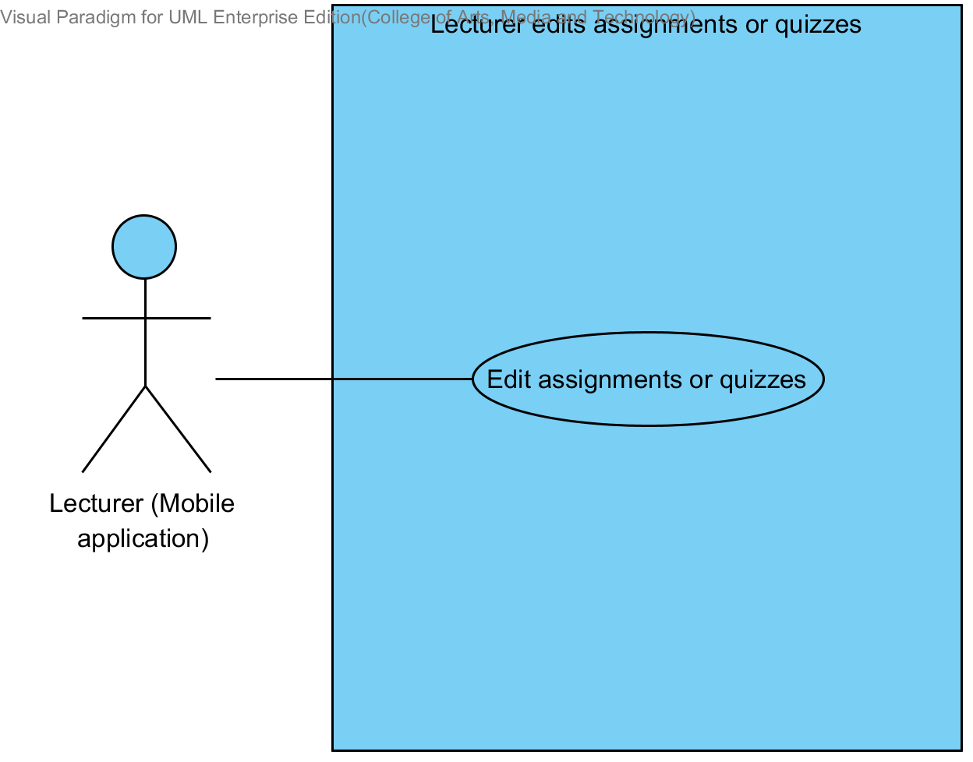

Use Case ID: | UC 10.2
Use Case Name: | Lecturer edits assignments or quizzes.
Created By: | Mr.Tanadol Parn-ong |  | Last Updated By: | Mr.Tanadol Parn-ong
Date Created: | 10/05/2014 |  | Last Revision Date: | 10/05/2014
Actors: |  | Lecturer
Description: |  | This use case is provided for Lecturer edits assignments or quizzes on the mobile application.
Trigger: |  | Lecturer select a testing that want to edit.
Preconditions: |  | Lecturer must logged in to the system.
Post conditions: |  | The system displays “Editing Assignment Successful” message on the mobile application.
Normal Flow: |  | - Lecturer select a testing that want to edit.  - Lecturer submits edition testing form.  - The system redirects to Edition testing page on the mobile application.  - The system provides Edition testing page interface on the mobile application, including testing name, a type of testing, an amount of questions, a testing score, student name, randomize order of the question status, and posting status.  - The system fetches the testing information from the system to display on Edition testing page on the mobile application.  - Lecturer provides testing name, type of testing, an amount of questions, a testing score, student name, randomize order of the question status, and posting status into the testing page.  - Lecturer submits testing information into mobile application.  - The system validates testing information from Lecturer.  - Lecturer enters to Edition assignment and quiz page on the mobile application.  - The system redirects to Edition assignment and quiz page on the mobile application.  - The system fetches the assignment or quiz information from the system to display on Edition assignment and quiz page on the mobile application.  - The system provides Edition assignment and quiz page interface on the mobile application, including a type of question, question description, choice description, a solution, and a question point.  - Lecturer provides type of question (Multiple choices), question description, choice description, a solution, and a question point.  - Lecturer submits assignment or quiz information into mobile application.  - The system validates assignment or quiz information from Lecturer.  - The system redirects to confirm edition testing page.  - Lecturer submits editing testing form.  - The system updates the testing information from Lecturer into the system.  - The system updates assignment or quiz information from Lecturer into the system.  - The system displays “Editing Assignment Successful” message on the mobile application.
Alternative Flows: |  | 8A when the amount of questions format is wrong. The system provides the error message as followed:  1. The system displays “Amount of questions must be number only” on the mobile application.  2. Use Case resumes on step 18 of normal flow.  8B when the testing score format is wrong. The system provides the error message as followed:  1. The system displays “Testing score must be number only” on the mobile application.  2. Use Case resumes on step 18 of normal flow.  13A if Lecturer provides type of question is true/false question.  1. Lecturer provides question description, choice description, a solution, and a question point.  2. Lecturer submits assignment or quiz information into mobile application  3. Use Case resumes on step 27 of normal flow.  13B if Lecturer provides type of question is short answer.  1. Lecturer provides question description, and a question point.  2. Lecturer submits assignment or quiz information into mobile application  3. Use Case resumes on step 27 of normal flow.  15A when the multiple choices answer format is wrong. The system provides the error message as followed:  1. The system displays “Answer must be a, b, c, and d only” on the mobile application.  2. Use Case resumes on step 25 of normal flow.  15B when the true/false answer format is wrong. The system provides the error message as followed:  1. The system displays “Answer must be a and b only” on the mobile application.  2. Use Case resumes on step 25 of normal flow.  15C when the question point format is wrong. The system provides the error message as followed:  1. The system displays “Question point must be number only” on the mobile application.  2. Use Case resumes on step 25 of normal flow  20A if Lecturer edits quizzes, the system provides the error message as followed:  1. The system displays “Editing Quiz Successful” message on the mobile application
Exceptions: |  | N/A
Includes: |  | N/A
Frequency of Use: |  | Often
Assumptions: |  | N/A
Notes and Issues: |  | N/A

URS 10.2 Lecturer can edit assignments or quizzes information which are multiple choices question, true/false question, and short answers.
Lecturer can edit assignments or quizzes information into the mobile application. Lecturer can limit access to the assignment or quiz of authority. Lecturer must provide testing name, type of testing, an amount of questions, testing score, type of question, question information, student name, randomize order of the question status, and posting status.
Lecturer must provide question information by separating from type of questions.
- Lecturer can edit multiple choices questions which provide type of question, question description, choice description, a solution, and a question point.
- Lecturer can edit true/false questions which provide type of question, questions description, choice description, a solution, and a question point.
- Lecturer can edit short answers which provide type of question, questions description, and a question point.
Actor: Lecturer
Prerequisite: Lecturer must have logged.

Input:
Name | Description | Example | Remarks
testing name | Can be any character only. | Math testing
type of testing | The system provides two types of testing which are assignment and quiz. Lecturer must select one type only. | Assignment
amount of question | Only number is allowed. | 3
testing score | Only number is allowed | 100
student name | Lecturer adds a list of students for limiting access to the assignment or quiz. | 542115099,  542115091,  542115092
randomize order of the question status | This status is showing status of random order of the question to student. | random
Posting status | Status is an available and not available. | Available

Multiple choices question
Name | Description | Example | Remarks
type of question | The system provides three types of question which are multiple choices, true/false question, and short answer. Lecturer must select one type only. | Multiple choices
question description | Can be any character is allowed. | What is an answer of 1+1?
choice description | Choices must have four choices. Can be any character is allowed. | a. 2  b. 1  c. 3  d. 5
solution | Only “a, b, c, d” is allowed. | a
question point | Only number is allowed | 1

True/false question
Name | Description | Example | Remarks
type of question | The system provides three types of question which are multiple choices, true/false question, and short answer. Lecturer must select one type only. | True/false question
question description | Can be any character is allowed. | Answer of 1+1 is 2.
choice description | Choices must have two choices. Can be true and false is allowed. | a. false  b. true
solution | Only “a, b, c, d” is allowed. | b
question point | Only number is allowed | 1

Short answer
Name | Description | Example | Remarks
type of question | The system provides three types of question which are multiple choices, true/false question, and short answer. Lecturer must select one type only. | Short answer
question description | Can be any character is allowed. | What is an answer of 1+1? You must explain how to find the answer.
question point | Only number is allowed | 1

Flow of Execution:
- Lecturer selects a testing that want to edit.
- Lecturer submits edition testing form.
- Lecturer provides testing name, type of testing, an amount of questions, testing score, student name, randomize order of the question status, and posting status into the testing page.
- Lecturer submits testing information into mobile application.
- Lecturer enters to Edition assignment and quiz page on the mobile application.
- Lecturer provides type of question (Multiple choices), question description, choice description, a solution, and question point.
- Lecturer submits assignment or quiz information into mobile application.
- Lecturer submits editing testing form.

Alternative Flow:
4A. if Lecturer input data in the wrong format, the system should provide the error message as followed:
  - The wrong amount of questions format: The error message is “Amount of questions must be number only”

4B. if Lecturer input data in the wrong format, the system should provide the error message as followed:
  - The wrong testing score format: The error message is “Testing score must be number only”

6A. Lecturer provides type of question is true/false question.
- Lecturer provides question description, choice description, a solution, and question point.
- Lecturer submits assignment or quiz information into mobile application.
- Flow of execution resumes to step 15.

6B. Lecturer provides type of question is short answer.
- Lecturer provides question description, and question point.
- Lecturer submits assignment or quiz information into mobile application.
- The system validates testing information from Lecturer.
- Flow of execution resumes to step 15.

7A if Lecturer input data in the wrong format in multiple choices answer the system should provide the error message as followed:
  - The wrong answer format: The error message is “Answer must be a, b, c, and d only”

7B if Lecturer input data in the wrong format in true/false answer the system should provide the error message as followed:
  - The wrong answer format: The error message is “Answer must be a and b only”

7C. if Lecturer input data in the wrong format, the system should provide the error message as followed:
  - The wrong question point format: The error message is “Question point must be number only”

8A if Lecturer edits a quiz is completed, the system should provide the Successful massage as followed:
  - The system display “Editing Quiz Successful” message.

8B if Lecturer edits an assignment is completed, the system should provide the Successful massage as followed:
  - The system display “Editing Assignment Successful” message.

System Requirement Specification of URS 10.2

SRS 9-4.2: The system shall validate testing information from Lecturer.
SRS 9-7.2: The system shall validate assignment or quiz information from Lecturer.
SRS 9-10.2: The system shall display “Amount of questions must be number only” message when the amount of questions format is wrong.
SRS 9-11.2: The system shall display “Answer must be a, b, c, and d only” message when the multiple choices answer format is wrong.
SRS 9-12.2: The system shall display “Answer must be a and b only” message when the true/false answer format is wrong.
SRS 9-13.2: The system shall display “Testing score must be number only” message when the testing score format is wrong.
SRS 9-14.2: The system shall display “Question point must be number only” message when the question point format is wrong.
SRS 10-1.2: The system shall redirect to Edition testing page on the mobile application.
SRS 10-2.2: The system shall redirects to Edition assignment and quiz page on the mobile application.
SRS 10-3.2: The system shall fetch the testing information from the system to display on Edition testing page on the mobile application.
SRS 10-4.2: The system shall fetch the assignment or quiz information from the system to display on Edition assignment and quiz page on the mobile application.
SRS 10-5.2: The system shall provide Edition testing page interface on the mobile application, including testing name, a type of testing, an amount of questions, a score testing, student name, randomize order of the question status, and posting status for Lecturer adds an assignment or quiz into the system.
SRS 10-6.2: The system shall provide Edition assignment and quiz page interface on the mobile application, including a type of question, question description, choice description, an answer, and a question point for Lecturer assigns assignments or quizzes into the system.
SRS 10-7.2: The system shall update the testing information from Lecturer into the system.
SRS 10-8.2: The system shall update assignment or quiz information from Lecturer into the system.
SRS 10-9.2: The system shall display “Editing Assignment Successful” message when Lecturer edits an assignment is successful.
SRS 10-10.2: The system shall display “Editing Quiz Successful” message when Lecturer edits a quiz is successful.
SRS 10-11.2: The system shall redirect to confirm edition testing page.

4.11 Lecturer deletes course information (UC 11.2)

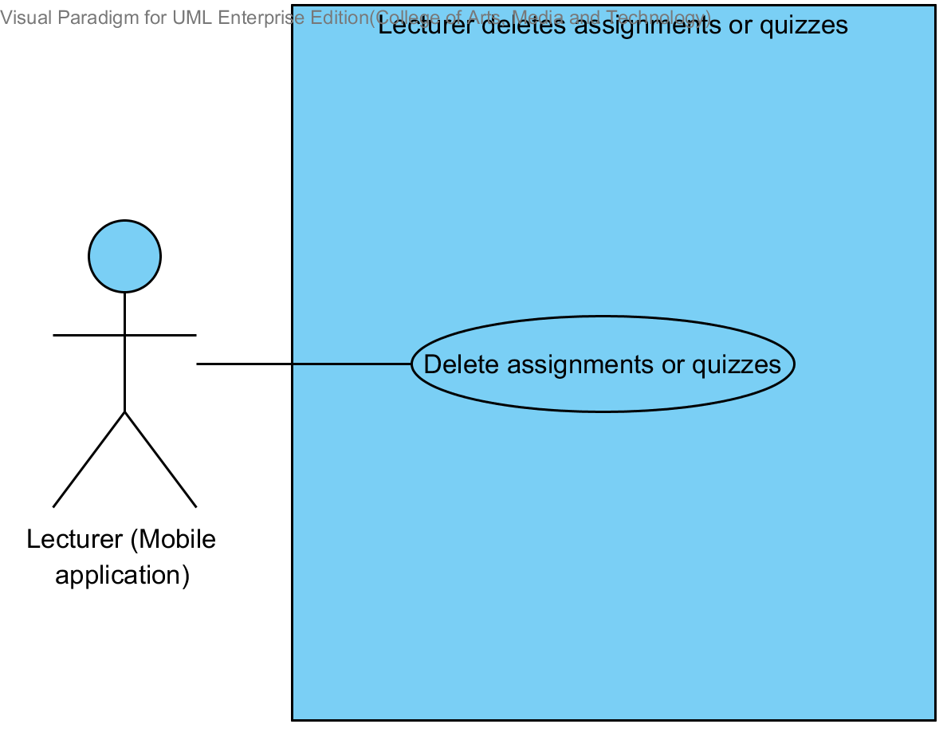

Use Case ID: | UC 11.2
Use Case Name: | Lecturer deletes assignments or quizzes.
Created By: | Mr.Tanadol Parn-ong |  | Last Updated By: | Mr.Tanadol Parn-ong
Date Created: | 10/05/2014 |  | Last Revision Date: | 10/05/2014
Actors: |  | Lecturer
Description: |  | This use case is provided for Lecturer deletes assignments or quizzes on the mobile application.
Trigger: |  | Lecturer select a testing that want to delete.
Preconditions: |  | Lecturer must logged in to the system.
Post conditions: |  | The system shall display “Deleting Assignment Successful” message on the mobile application.
Normal Flow: |  | - Lecturer select a testing that want to delete.  - Lecturer submits deleting testing form.  - The system deletes the testing information from the system.  - The system deletes assignment or quiz information from the system.  - The system shall display “Deleting Assignment Successful” message on the mobile application
Alternative Flows: |  | 5A if Lecturer deletes a quiz, the system provides the error message as followed:  1. The system displays “Deleting Quiz Successful” message on the mobile application
Exceptions: |  | N/A
Includes: |  | N/A
Frequency of Use: |  | Often
Assumptions: |  | N/A
Notes and Issues: |  | N/A

URS 11.2 Lecturer can delete assignments or quizzes which are multiple choices question, true/false question, and short answers.
Lecturer can delete assignments or quizzes into the mobile application.

Actor: Lecturer
Prerequisite: Lecturer must have logged.
Input: None
Flow of Execution:
- Lecturer select a testing that want to delete.
- Lecturer submits deleting testing form.

System Requirement Specification of URS 11.2

SRS 11-1.2: The system shall deletes the testing information from the system.
SRS 11-2.2: The system shall deletes assignment or quiz information from the system.
SRS 11-3.2: The system shall display “Deleting Assignment Successful” message when Lecturer deletes an assignment is successful.
SRS 11-4.2: The system shall display “Deleting Quiz Successful” message when Lecturer deletes a quiz is successful.

4.12 Lecturer marks the point for student’s short answer. (UC 12.2)
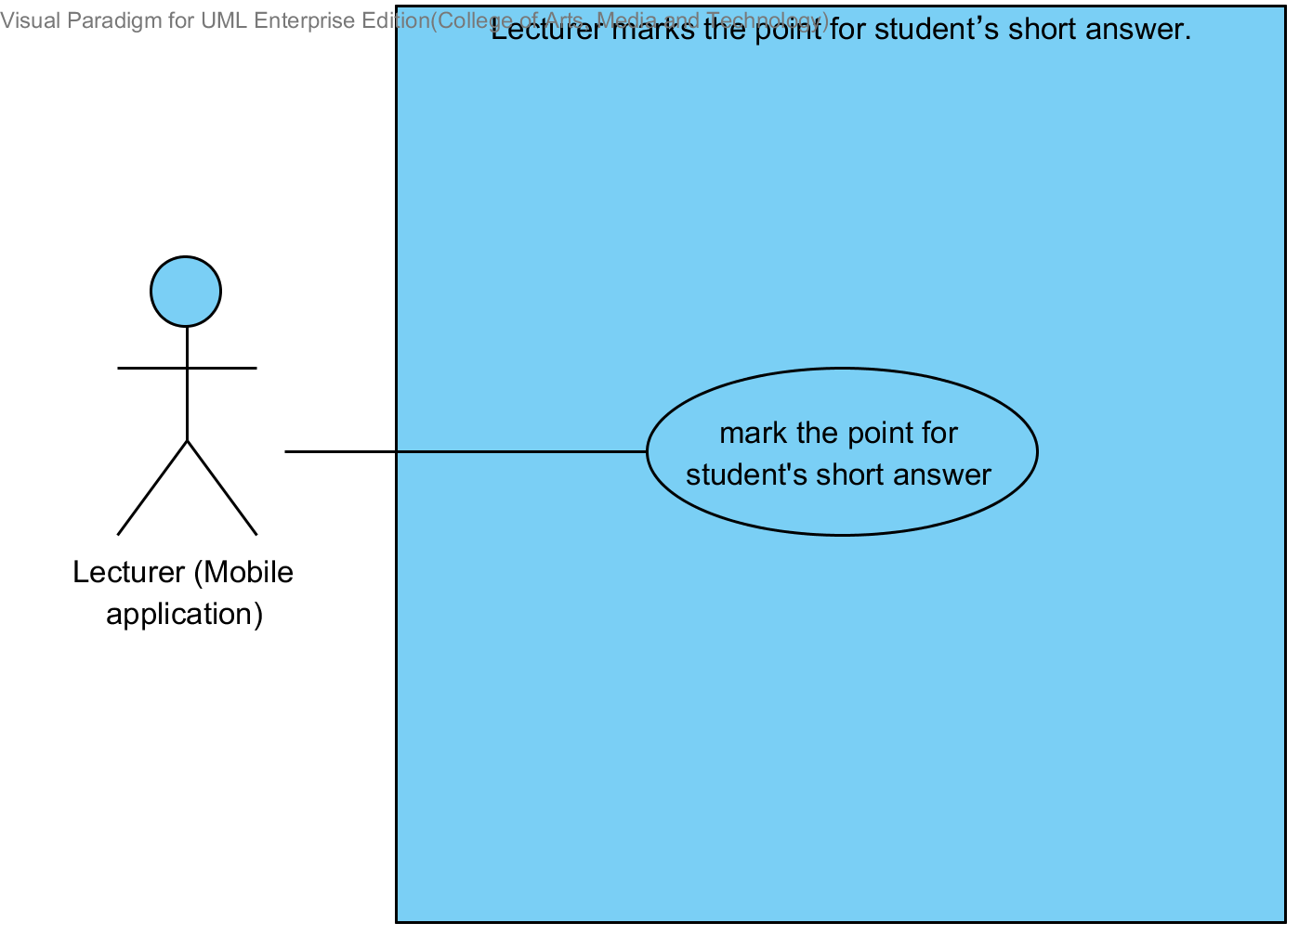

Use Case ID: | UC 12.2
Use Case Name: | Lecturer marks the point for student’s short answer.
Created By: | Mr.Tanadol Parn-ong |  | Last Updated By: | Mr.Tanadol Parn-ong
Date Created: | 10/05/2014 |  | Last Revision Date: | 10/05/2014
Actors: |  | Lecturer
Description: |  | This use case is provided for Lecturer marks the point for student’s short answer.
Trigger: |  | Lecturer selects a testing that want to mark the point for student’s short answer.
Preconditions: |  | Student have already finished taking the assignment or quiz and the answers are recorded in the system.
Post conditions: |  | The system displays “Marking point is successful” message on the mobile application.
Normal Flow: |  | - Lecturer selects a testing that want to mark the point for student’s short answer.  - Lecturer submits Marking the point page form.  - Lecturer enters to Marking the point for student’s short answer page.  - The system redirects to Marking the point for student’s short answer page on the mobile application.  - The system fetches short answer question and student’s short answer from the system.  - The system displays short answer question and student’s short answer in Marking the point for student’s short answer page on the mobile application.  - Lecturer marks points of student in each short answer question.  - Lecturer submits marking point form.  - The system validates question point format from Lecturer  - The system stores point of student into the system.  - The system displays “Marking point is successful” message in Marking the point for student’s short answer page on the mobile application.
Alternative Flows: |  | 8A when the point of student format is wrong, the system provides the error message as followed:  1. The system displays “Point of student must be number only” message on the mobile application
Exceptions: |  | N/A
Includes: |  | N/A
Frequency of Use: |  | Often
Assumptions: |  | N/A
Notes and Issues: |  | N/A

URS 12.2 Lecturer marks the point for student’s short answer.
Lecturer can mark the point for student’s short answer in each assignment or quiz.

Actor: Lecturer
Prerequisite: Lecturer must have logged.
Input:
Name | Description | Example | Remarks
point of student | Only number is allowed | 1 | question point

Flow of Execution:
- Lecturer selects a testing that want to mark the point for student’s short answer.
- Lecturer submits Marking the point page form.
- Lecturer enters to Marking the point for student’s short answer page.
- Lecturer marks point of student in each short answer question.
- Lecturer submits marking point form.

Alternative Flow:
5A. if Lecturer input data in the wrong format, the system should provide the error message as followed:
  - The wrong point of student format: The error message is “Point of student must be number only

System Requirement Specification of URS 12.2

SRS 12-1.2: The system shall redirect to Marking the point for student’s short answer page on the mobile application.
SRS 12-2.2: The system shall fetch short answer question and student’s short answer from the system.
SRS 12-3.2: The system shall display short answer question and student’s short answer in Marking the point for student’s short answer page on the mobile application.
SRS 12-4.2: The system shall validate question point format from Lecturer.
SRS 12-5.2: The system shall store point of student into the system.
SRS 12-6.2: The system shall display “Marking point is successful” message in Marking the point for student’s short answer page on the mobile application.
SRS 12-7.2: The system shall display “Point of student must be number only” message when the point of student format is wrong.

4.13 Lecturer reviews student’s answer in chart (UC 13.2)

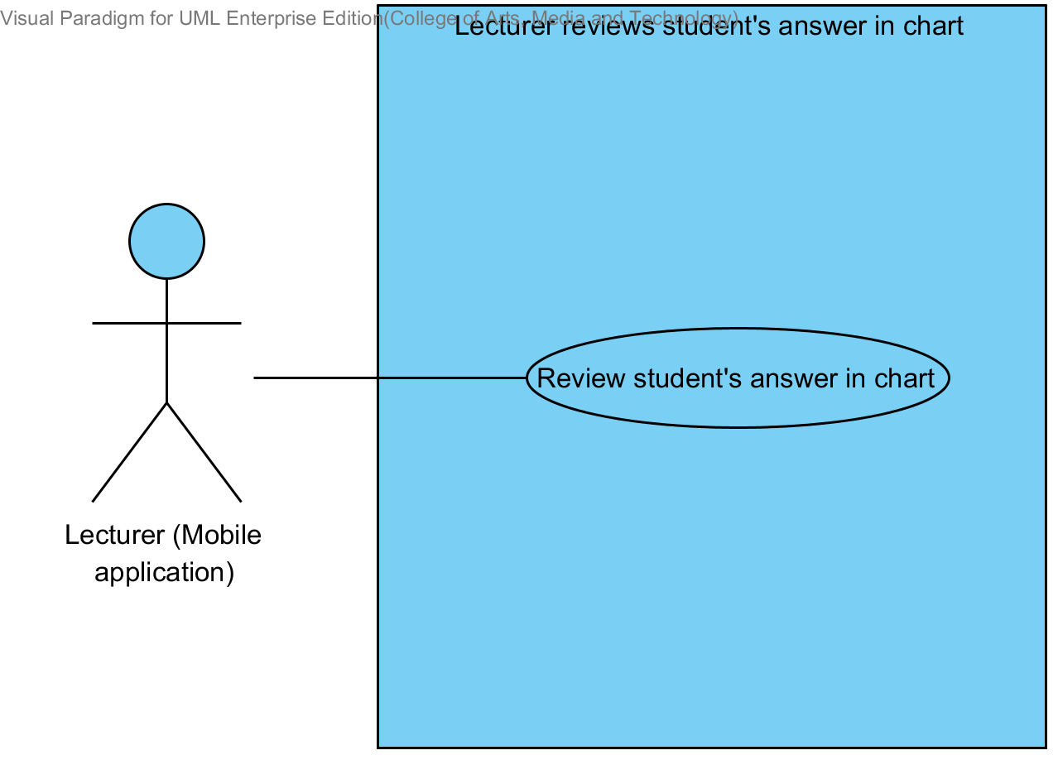

Use Case ID: | UC 13.2
Use Case Name: | Lecturer reviews student’s answers in chart
Created By: | Mr.Tanadol Parn-ong |  | Last Updated By: | Mr.Tanadol Parn-ong
Date Created: | 10/05/2014 |  | Last Revision Date: | 10/05/2014
Actors: |  | Lecturer
Description: |  | This use case is provided for Lecturer reviews student’s answers in chart on the mobile application.
Trigger: |  | Lecturer select a testing that want to review overall student’s answer in each choice of assignment or quiz in chart format.
Preconditions: |  | Student have already finished taking the assignment or quiz and the answers are recorded in the system.
Post conditions: |  | The system displays overall student’s answer in each choice of assignment or quiz in chart format into Chart format of student’s answer page on the mobile application.
Normal Flow: |  | - Lecturer select a testing that want to review overall student’s answer in each choice of assignment or quiz in chart format.  - Lecturer submits chart format of student’s answer form.  - The system redirects to Chart format of student’s answer page on the mobile application.  - The system fetches the assignment or quiz information from the system.  - The system displays overall student’s answer in each choice of assignment or quiz in chart format into Chart format of student’s answer page on the mobile application.
Alternative Flows: |  | N/A
Exceptions: |  | N/A
Includes: |  | N/A
Frequency of Use: |  | Often
Assumptions: |  | N/A
Notes and Issues: |  | N/A

URS 13.2 Lecturer can review overall student’s answer in each choice of assignment or quiz in chart format.
Lecturer can review overall student’s answer in each choice of assignment or quiz in chart format into the mobile application. Which Lecturer can analyze thinking of students in decision choose answers.

Actor: Lecturer
Prerequisite: Lecturer must have logged.
Input: None
Flow of Execution:
- Lecturer select a testing that want to review overall student’s answer in each choice of assignment or quiz in chart format.
- Lecturer submits chart format of student’s answer form.

System Requirement Specification of URS 13.2
SRS 13-1.2: The system shall redirect to Chart format of student’s answer page on the mobile application.
SRS 13-2.2: The system shall fetch the assignment or quiz information from the system.
SRS 13-3.2: The system shall display overall student’s answer in each choice of assignment or quiz in chart format into Chart format of student’s answer page on the mobile application.

4.14 Lecturer checks student’s assignment or quiz submission (UC 14.2)

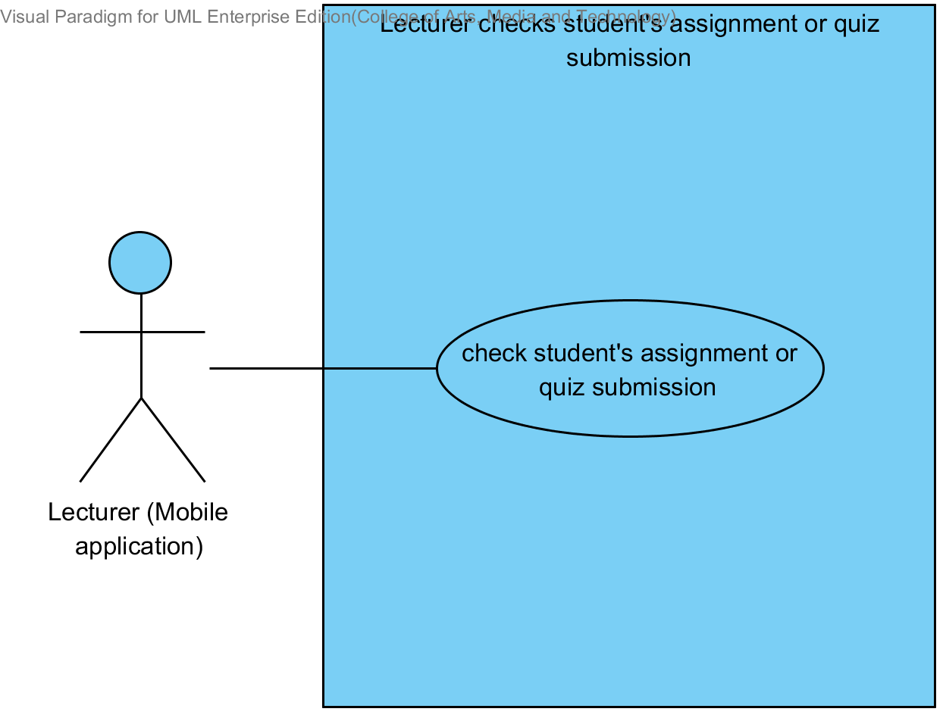

Use Case ID: | UC 14.2
Use Case Name: | Lecturer checks student’s assignment or quiz submission.
Created By: | Mr.Tanadol Parn-ong |  | Last Updated By: | Mr.Tanadol Parn-ong
Date Created: | 10/05/2014 |  | Last Revision Date: | 10/05/2014
Actors: |  | Lecturer
Description: |  | This use case is provided for Lecturer checks student’s assignment or quiz submission on the mobile application.
Trigger: |  | Lecturer select a testing that want to check students that submit assignments in time.
Preconditions: |  | Student have already finished taking the assignment or quiz and the answers are recorded in the system.
Post conditions: |  | Lecturer can checks student’s assignment or quiz submission.
Normal Flow: |  | - Lecturer select a testing that want to check students that submit assignments in time.  - Lecturer submits assignment status form.  - The system redirects to testing submission page on the mobile application.  - The system fetches the testing submission information from the system.  - The system displays testing submission information into testing submission page on the mobile application which consist student name, student ID.
Alternative Flows: |  | N/A
Exceptions: |  | N/A
Includes: |  | N/A
Frequency of Use: |  | Often
Assumptions: |  | N/A
Notes and Issues: |  | N/A

URS 14.2 Lecturer can check whether the assignments are submitted in time.
Lecturer can check whether who submitted an assignment or quiz in time into the mobile application. Also, who didn’t submit an assignment or quiz in time.

Actor: Lecturer
Prerequisite: Lecturer must have logged.
Input: None
Flow of Execution:
- Lecturer select a testing that want to check students that submit assignments in time.
- Lecturer submit assignment status form.

System Requirement Specification of URS 14.2

SRS 14-1.2: The system shall redirect to testing submission page on the mobile application.
SRS 14-2.2: The system shall fetch the testing submission information from the system.
SRS 14-3.2: The system shall display testing submission information into testing submission page on the mobile application which consist student name, student ID.

4.15 Student takes assignments or quizzes (UC 15.2)

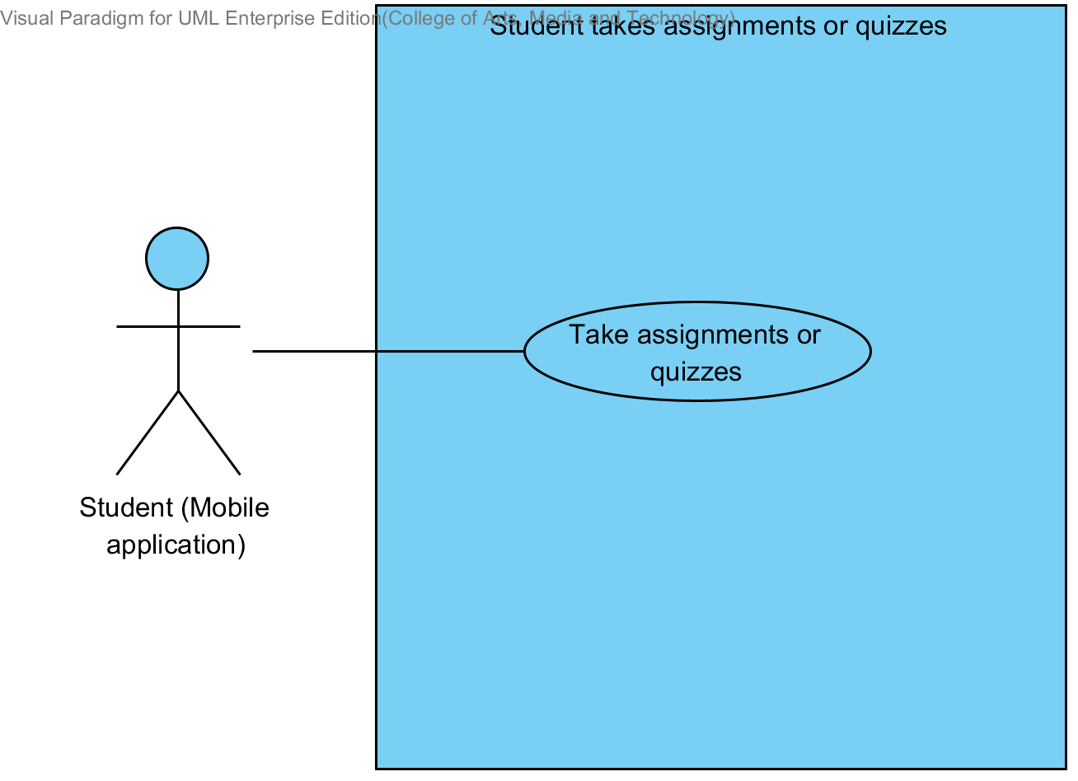

Use Case ID: | UC 15.2
Use Case Name: | Student takes assignments or quizzes
Created By: | Mr.Tanadol Parn-ong |  | Last Updated By: | Mr.Tanadol Parn-ong
Date Created: | 10/05/2014 |  | Last Revision Date: | 10/05/2014
Actors: |  | Student
Description: |  | This use case is provided for Student takes assignments or quizzes on the mobile application.
Trigger: |  | Student enters to Overall testing page.
Preconditions: |  | Student must logged in to the system.
Post conditions: |  | The system stores answers of taking an assignment or quiz into the system.
Normal Flow: |  | - Student enters to Overall testing page.  - The system redirects to Overall testing page on the mobile application.  - Student select a testing that want to take an assignment or quiz.  - Student submit taking assignment or quiz form.  - Student enters to Assignment or quiz page.  - The system redirects to Assignment or quiz page on the mobile application.  - The system fetches the assignment or quiz information from the system.  - The system displays the assignment or quiz information into Assignment or quiz page on the mobile application.  - Student provides answers in every question.  - Student submit answers.  - The system stores answers of taking an assignment or quiz into the system.
Alternative Flows: |  | N/A
Exceptions: |  | N/A
Includes: |  | N/A
Frequency of Use: |  | Often
Assumptions: |  | N/A
Notes and Issues: |  | N/A

URS 15.2 Student can take assignments or quizzes which are multiple choices, true/false questions, short answers.
Student can take assignments or quizzes which are multiple choices, true/false questions, short answers by using mobile application.
Student must provide answer information by separating from type of questions.
- Student can take multiple choices questions which provide one answer only in each order of questions.
- Student can take true/false questions which provide one answer only in each order of questions.
- Student can take short answers which provide characters or texts.
Actor: Student
Prerequisite: Student must have logged.
Input:
Multiple choices question
Name | Description | Example | Remarks
multiple choices answer | Only “a, b, c, d” is allowed. | a

True/false question
Name | Description | Example | Remarks
true/false answer | Only “a, b, c, d” is allowed. | b

Short answer
Name | Description | Example | Remarks
short answer | Can be any character is allowed. | From the picture is a dog.

Flow of Execution:
- Student enters to Overall testing page.
- Student select a testing that want to take an assignment or quiz.
- Student submit taking assignment or quiz form.
- Student enters to Assignment or quiz page.
- Student provides answers in every question.
- Student submit answers.

System Requirement Specification of URS 15.2

SRS 15-1.2: The system shall redirect to Overall testing page on the mobile application.
SRS 15-2.2: The system shall redirect to Assignment or quiz page on the mobile application.
SRS 15-3.2: The system shall fetch the assignment or quiz information from the system.
SRS 15-4.2: The system shall display the assignment or quiz information into Assignment or quiz page on the mobile application.
SRS 15-5.2: The system shall store answers of taking an assignment or quiz into the system.

